 | Land and Environment Court  New South Wales

Case Name: | Henroth Pty Ltd v Canterbury-Bankstown Council
Medium Neutral Citation: | [2024] NSWLEC 1700
Hearing Date(s): | 17-21 June 2024; final conditions received 28 June 2024
Date of Orders: | 29 October 2024
Decision Date: | 29 October 2024
Jurisdiction: | Class 1
Before: | Dixon SC
Decision: | The Court directs:  (1) The parties are to confer and settle the conditions in accordance with my reasons for judgment and to provide a copy to the Court by 7 November 2024.  (2) Upon receipt of the agreed conditions after review if they are acceptable, I will make final orders.
Catchwords: | APPEAL – development application – redevelopment of shopping centre – concept plan and Stage 1 DA – characterisation of land use – meaning of “development standard” – clause 4.6 variation
Legislation Cited: | Conveyancing Act 1919, s 88K  Environmental Planning and Assessment Act 1979, ss 4.5, 4.15, 8.7  Interpretation Act 1987, s 35  Bankstown Local Environmental Plan 2015, cll 4.3, 4.4, 4.5, 4.6, 6.14  Canterbury-Bankstown Local Environmental Plan 2023, cl 1.8A  Penrith Local Environmental Plan 2010, cl 7.11  State Environmental Planning Policy (Biodiversity and Conservation) 2021  State Environmental Planning Policy (Building Sustainability Index: BASIX) 2004  State Environmental Planning Policy (Planning Systems) 2021, s 2.19; Sch 6 s 2  State Environmental Planning Policy (Resilience and Hazards) 2021  State Environmental Planning Policy (Transport and Infrastructure) 2021, s 2.122, 3.23  State Environmental Planning Policy No 65—Design Quality of Residential Apartment Development  Yass Valley Local Environmental Plan 2013, cll 4.1, 4.1B, 4.18
Cases Cited: | Alramon Pty Ltd v City of Ryde Council [2022] NSWLEC 108  Argyropoulos v Canterbury Municipal Council (1988) 66 LGRA 202  Australian Unity Funds Management Ltd in its capacity as Responsible Entity of the Australian Unity Healthcare Property Trust v Boston Nepean Pty Ltd & Penrith City Council [2023] NSWLEC 49  Ballina Shire Council v Palm Lake Works Pty Ltd [2020] NSWLEC 41  Baulkham Hills Shire Council v O’Donnell (1990) 69 LGRA 404  Blue Mountains City Council v Laurence Browning Pty Ltd (2006) 150 LGERA 130; [2006] NSWCA 331  Canterbury Bankstown Council v Dib [2022] NSWLEC 79  Chamwell Pty Ltd v Strathfield Council (2007) 151 LGERA 400; [2007] NSWLEC 114  Elimatta Pty Ltd v Read [2021] NSWLEC 75  Foodbarn Pty Ltd v Solicitor-General (1975) 32 LGRA 157  Goldberg v Waverley Council [2008] NSWLEC 49  Initial Action Pty Ltd v Woollahra Municipal Council (2018) 236 LGERA 256; [2018] NSWLEC 118  Kentucky Fried Chicken Pty Ltd v Gantidis (1979) 140 CLR 675  Landcorp Australia Pty Ltd v The Council of the City of Sydney [2020] NSWLEC 174  Maygood Australia Pty Ltd v Willoughby City Council [2013] NSWLEC 142  NCV Enterprises Pty Ltd v Tweed Shire Council [2024] NSWLEC 14  North Sydney Council v Michael Standley & Associates Pty Ltd (1998) 43 NSWLR 468  Pet Carriers Botany Bay City Council v Pet Carriers International Pty Limited [2013] NSWLEC 147  Randall Pty Ltd v Willoughby City Council (2005) 144 LGERA 119; [2005] NSWCA 205  R.I.G. Consulting Pty Ltd v Queanbeyan-Palerang Regional Council (2021) 249 LGERA 377; [2021] NSWCA 130  Rockliff Estate Pty Ltd v Liverpool City Council [2023] NSWLEC 1725  Saffioti v Kiama Municipal Council [2019] NSWLEC 57  Site Plus Pty Limited v Wollongong City Council [2011] NSWLEC 1371  Site Plus Pty Ltd v Wollongong City Council [2014] NSWLEC 125  Strathfield Municipal Council v Poynting (2001) 116 LGERA 319; [2001] NSWCA 270  Tomasic v Port Stephens Council [2021] NSWLEC 56  The Uniting Church in Australia Property Trust (NSW) v Parramatta City Council [2018] NSWLEC 158  Wehbe v Pittwater Council (2007) 156 LGERA 446; [2007] NSWLEC 827  Zhang v Canterbury City Council (2001) 115 LGERA 373; [2001] NSWCA 167
Texts Cited: | Canterbury-Bankstown Council, Community Participation Plan  Canterbury-Bankstown Development Control Plan 2023  Child Care Planning Guideline  NSW Environment Protection Authority, Development Near Rail Corridors and Busy Roads – Interim Guideline (2008)  NSW Environment Protection Authority, Road Noise Policy (March 2011)
Category: | Principal judgment
Parties: | Henroth Pty Ltd (Applicant)  Canterbury-Bankstown Council (Respondent)
Representation: | Counsel:  A Galasso SC (Applicant)  G Farland / T Poisel (Respondent)  Solicitors:  Mills Oakley (Applicant)  Canterbury-Bankstown Council (Respondent)
File Number(s): | 2023/128962
Publication Restriction: | Nil

TABLE OF CONTENTS
TABLE OF CONTENTS
JUDGMENT
Introduction
The proposal
The Class 1 appeal
Decision
Facts
The statutory framework
Expert evidence
Contentions
Contention 1 – The permissibility of the proposed road over 87 Norfolk Road
Council’s position
Henroth’s position
Contention 1 - Considerations and findings
Contention 2 – Is cl 6.14 of LEP 2015 a development standard?
Council’s position
Henroth’s position
Finding – cl 6.14(4) is a development standard
Contention 5 - Non-compliance with LEP 2015 and Contention 6 - Non-compliance with the draft LEP
Driveway/public road connection to Norfolk Road
Contention 5 – Finding
Contention 6 - Non-compliance with cl 6.14 of LEP 2015
Clause 6.14(4)(a) – Proposed consolidation – No issue, capable of compliance
Clause 6.14(4)(b) - Insufficient commercial floorspace
Council’s position
Henroth’s position
Clause 6.14(4)(b) - Finding
Clause 6.14(4)(c) - Insufficient southern setback
Council’s position
Henroth’s position
Clause 6.14(4)(c) - Finding
Clause 6.14(4)(d) - Insufficient eastern setback
Council’s position
Henroth’s position
Clause 6.14(4)(d) - Finding
Clause 6.14(4)(f) - Adverse environmental impacts on Norfolk Reserve
Clause 4.6 written request to vary cl 6.14(4)(c) and (4)(d) - Consideration and Findings
Southern setback
Eastern setback
Clause 6.14(4) of LEP 2015 – Compliance
Contention 8 – Childcare centres
Contentions 39 and 41 - Ecology issues
Contentions 48 and 49 - Public submissions and Public interest
Contention 50 - Economic impact of the DCP
Finding – Economic evidence is relevant
Contention 13 - Likely impacts of the development
Contention 16 - Non-compliance with the DCP
Council’s position
Henroth’s position
Findings – Consistency with the DCP
Conditions
Conclusion and directions

JUDGMENT

Introduction
- Despite having undergone successive upgrades, the Chullora Marketplace shopping centre, operating from a site at 355-353 Waterloo Road, Greenacre since 1982, still bears the hallmarks of a traditional standalone, car-based centre.
- In May 2018, Henroth Group Pty Ltd (Henroth), lodged a planning proposal (PP-2020-358) (PP) for an increase in the allowable building height on the shopping centre site, and the adjacent residential lot at 353 Waterloo Road. The PP was gazetted on 12 February 2021 by way of amendment to the Bankstown Local Environmental Plan 2015 (LEP 2015), and site-specific clauses inserted. In short, the amendments included:
- The rezoning of No. 353 Waterloo Road to B2 Local Centre, to enable its inclusion into the Chullora Marketplace site, and its removal from the Lot Size Map.
- The retention of the 1:1 floor space ratio (FSR) across the whole site whilst introducing a minimum 0.35:1 FSR for commercial floorspace by inserting a site-specific clause at cl 4.4 of LEP 2015.
- A maximum building height of 20m, with a lower 14m limit at the eastern and western boundaries and 9m limit at the southern boundary
- With the commencement of the Canterbury-Bankstown Local Environmental Plan 2023 (LEP 2023) on 23 June 2023, LEP 2015 was repealed. However, by operation of the savings provision in cl 1.8A, the repealed instrument continues to apply to Henroth’s development application DA (91/2023) (DA) - with appropriate consideration to be given to the LEP 2023 as a proposed instrument under s 4.15(1)(a)(ii) of the Environmental Planning and Assessment Act 1979 (EPA Act): Maygood Australia Pty Ltd v Willoughby City Council [2013] NSWLEC 142 at [29].
- The development control plan applying to the site is the Canterbury-Bankstown Development Control Plan 2023 (DCP). As with cl 6.14 of LEP 2015, Chapter 11.10 relates entirely to the subject site. It describes the “desired future character for the Chullora Local Centre” as a “vibrant mixed-use commercial destination with generous green and public open spaces ...”. Consistent the Council’s Local Strategic Statement ‘Connective City 2036’.
- The DCP envisages centres like the Chullora Marketplace as:
“… hubs of community life, with high quality public, civic and community spaces and places. … places for pedestrians … well designed terrace houses, shop top housing, residential flat buildings and mixed-use buildings with new pedestrian-oriented streets and civic places”.
- Stated key objectives of the DCP, seek to ensure the ongoing viability of the shopping centre during its redevelopment, with particular emphasis upon the retention of the existing commercial floor space (DCP Staged development p 6).
- To that end, the DCP contemplates a staged development process involving an indicative concept plan (applying to the whole site) at the lodgement of the first development application and at every stage thereafter to ensure each stage is consistent with the overarching key design principles and desired character outlined in the DCP (DCP p 6). Although, the DCP expressly acknowledges that the Council may need to consider amendments to the indicative concept plan at each stage where required to be consistent with the desired character and key design principles for the centre.
- The indicative structure plan (ISP) from the DCP is reproduced below.
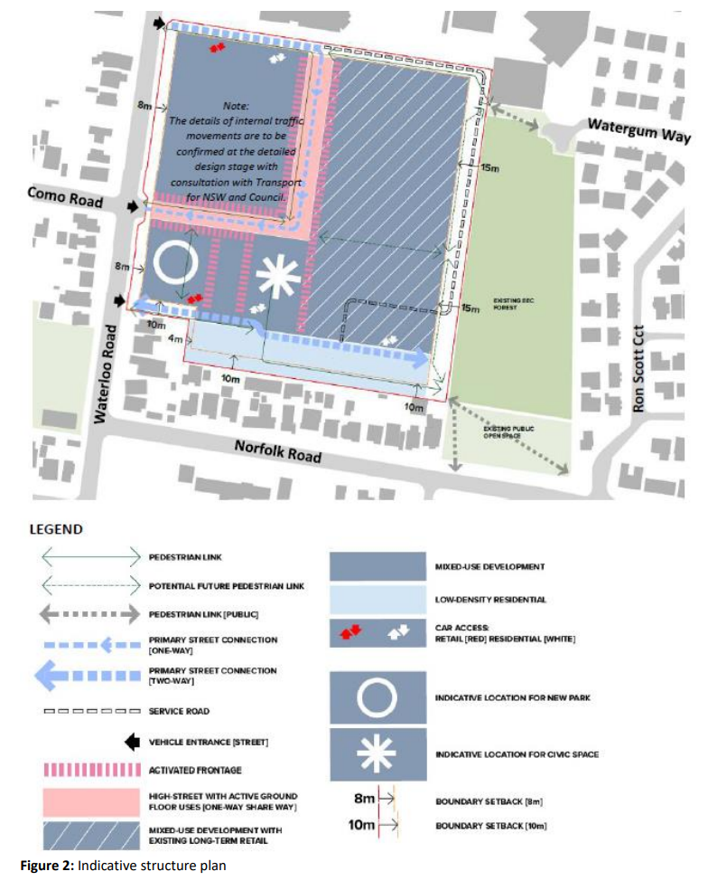

The proposal
- The DA (DA 91/2023) at issue was lodged by Henroth on 22 February 2023. A summary of the salient parts of the concept DA was contained in a statement of agreed facts that was admitted into evidence, and comprises:
- a concept DA – for Stages 1 and 2 for public roads and public domain layout, building envelopes for retail, residential and a childcare centre (approximately 39,768m2 of gross floor area (GFA)), 570 parking spaces on the shopping centre site and a new private road over 87 Norfolk Road (Concept DA); and
- a detailed DA for Stage 1 for a new mixed-use development including: 295 parking spaces within two basement levels and at-grade parking for visitor parking along Norfolk Lane; 90 residential units within a 2-6 storey residential flat building; a 130-place childcare centre (exclusive of detailed fit out); demolition of existing dwelling at 87 Norfolk Road to allow for the construction of a new road; landscaping and associated civil works and services (Stage 1 DA). As the Concept Plan above identifies, vehicular access for proposed Stage 1 of the development will be via the existing Waterloo Road, as well as a new private road off Norfolk Road. In the second stage of the development, the roads will then connect via the entry in Waterloo Road.
- The Stage 1 DA lot includes the construction of a new loading dock for Aldi and a new Mini Major that forms part of the alteration and additions to the existing Chullora Marketplace building. Access to the loading dock will be via the northernmost access from Waterloo Road, along the northern boundary and then along the eastern boundary. Thereafter service vehicles will no longer be travelling along the southern boundary. They will exit the site in forward direction using the proposed turning circle and exit via the northern-most access point on Waterloo Road (Statement of Environmental Effects (SEE) p 25 Figs 35 and 36).
- A “concept” approval for Stage 2 includes a mixed-use development comprising: two x 6-storey buildings containing 82 residential units; 342 car parking spaces across three levels of basement; three retail tenancies; a communal plaza; a park; and a new access driveway from Waterloo Road.
- Figure 1 below shows the general layout of Stages 1 and 2 as proposed (Turner Studio; Ex E Tab 4, p 2).
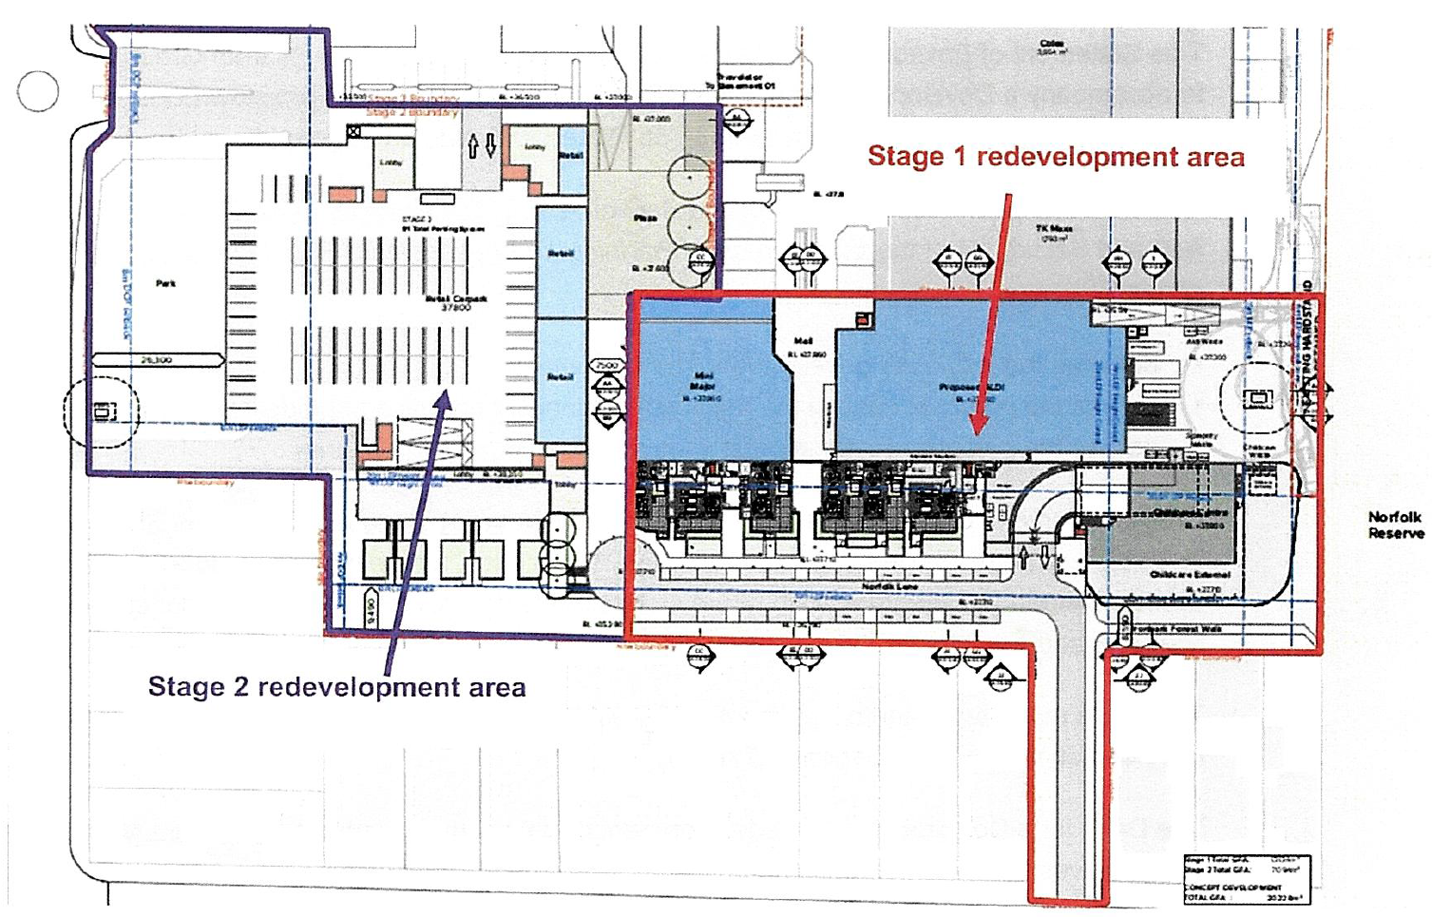
- As the capital investment value of the development is estimated to be more than $30 million, the development is regionally significant development under s 2.19(1) and s 2 of Sch 6 to State Environmental Planning Policy (Planning Systems) 2021 (PS SEPP). Consequently, under s 4.5(b) of the EPA Act, the Sydney South Planning Panel (Panel) is the consent authority for this DA.

The Class 1 appeal
- Before the Panel determined the DA, Henroth, on 21 April 2023, commenced these proceedings on a deemed-to-have-been-refused basis under s 8.7 of the EPA Act.
- As expected, on 15 June 2023, the DA submitted was formally refused by the Panel.
- Responding to the criticisms made of the application with respect to Stages 1 and 2 of the Concept DA and of Stage 1 of the DA, various amendments were made to the drawings and documents associated with and supporting that DA.
- The resulting amended DA is said to better address the site-specific planning controls contained in the Council’s LEP, while still achieving a high level of consistency with the site-specific Chapter 11 of the Council’s DCP. It is further claimed that it offers a contemporary fit-for-purpose response to the redevelopment needs.
- A key driver of Henroth’s response and the justification for seeking approval for alternate solutions to strict DCP compliance, is the need represented for a staged development that ensures the ongoing viability of the shopping centre - a key design principle of Chapter 11 (Ex D Addendum SEE p 17; DCP Staged development p 6; and key design principle (b)). The variations proposed are said to be appropriate and necessary. They are necessary in order to prioritise the commercial viability of traders in the existing shopping centre and to ensure accessibility into and through the site for both retail and commercial parking, as well as improving the amenity of the low density, residential properties. Starting work in the south of the site, as proposed, will allow existing tenants to operate and seamlessly shift into the new space when the first stage is completed.
- Despite the amendments to the DA on 8 February 2024, 3 April 2024 and 17 June 2024, the Council remains adamant that the development is impermissible for four specific reasons (Council’s final written submissions (CFWS) at par 1). They include the characterisation of the proposed road – that is the permissibility of the road over the residential lot known as 87 Norfolk Road. The Council also raises the height of the building and the controls in cl 6.14 of LEP 2015 that relate to it, and the development’s performance in relation to the DCP controls.

Decision
- For the reasons that follow, I have decided to grant consent to the amended DA subject to the imposition of the conditions of consent as drafted by the Council and amended in accordance with these reasons for judgment. Upon receipt of the amended conditions, I will make final orders disposing of the appeal.

Facts
- The following facts taken from the Council’s Second Amended Statement of Facts and Contentions (SASOFC) dated 17 June 2024 are uncontroversial.
- The site comprises three separate lots, being legally described as:
- Lot 9 in Deposited Plan 10945 with a street address of 353 Waterloo Road, Greenacre;
- Lot 41 in Deposited Plan 1037863 with a street address of 355 Waterloo Road, Greenacre; and
- Lot 24 in Deposited Plan 10945 with a street address of 87 Norfolk Road, Greenacre.
- Part of the site (353-355 Waterloo Road) is zoned B2 Local Centre with the other part (87 Norfolk Road) being zoned R2 Low Density Residential under LEP 2015.
- The three sites are collectively irregular in shape and have a total area of 5.76536 ha (57,653.6m2).
- The site has a frontage of 213.91m to Waterloo Road to the west, a rear (eastern) boundary of 217.34m, 235.68m to the northern boundary and 193.62m to the southern boundary (not including 87 Norfolk Road). In addition, the proposal includes 87 Norfolk Road which has a frontage of 15.24m to that road and side boundary length of 45.72m.
- The site is bounded on the south by Norfolk Road (and residential properties), on the east by Norfolk Reserve, on the west by Waterloo Road and on the north by Malek Fahd Islamic School.
- The east of the site is bounded by Norfolk Reserve which is mapped as having biodiversity values associated with three threatened fauna species and two threatened flora species.
- The site is mapped as flood prone land with a medium risk level.
- The site is listed as a local heritage item of archaeological significance associated with the former Cumberland Pottery and Tile Works. The State Heritage Inventory provides the following:
- The former Liebentritt Pottery site is historically significant as the location of one of metropolitan Sydney’s foremost and influential potteries producing clay products for the building industry. Historically the site is of state significance for this reason. Part of the site was the location of one of Sydney’s first drive-in theatres, which opened in December 1956. The site is associated with the Liebentritt family, significant pottery manufacturers from the middle of the nineteenth century through to the second half of the twentieth century. The site is almost certain to contain relics and evidence from the time of Liebentritt’s pottery making activities. It is considered to be relatively rare in terms of its archaeological potential and is considered to have been representative of pottery manufacturing sites during the second half of the nineteenth century and into the twentieth century.
- The application was notified in accordance with the Council’s Community Participation Plan for 21 days from 7 March to 28 March 2023 and readvertised for a further 21 days from 16 March to 6 April 2023 due to an error in the first exhibition period.
- Sixteen submissions were received in response to the notification periods which relate to:
- overdevelopment of the site;
- traffic congestion;
- privacy;
- building mass;
- lack of open space and landscaping;
- overshadowing;
- building height;
- schedule of colours and finishes; and (amongst other things)
- parking.
- The application was referred to Transport for NSW (TfNSW) for comment in accordance with the requirements of s 2.122 of State Environmental Planning Policy (Transport and Infrastructure) 2021 (T&I SEPP). Consequent conditions were provided to the Council on 27 March 2023.

The statutory framework
- The principal environmental planning instruments applying to the DA are as follows:
- LEP 2015 (Council’s Bundle Vol 1 Item 1, 1-56)
- DCP 2023 (as a proposed instrument) (Council’s Bundle Vol 4 Item 12, 701-761)
- State Environmental Planning Policy (Biodiversity and Conservation) 2021 (Council’s Bundle Vol 2 Item 2, 425-427)
- State Environmental Planning Policy (Building Sustainability Index: BASIX) 2004 (Council’s Bundle Vol 2 Item 5, 438-441)
- PS SEPP (Council’s Bundle Vol 2 Items 6a and 6b, 442-445)
- State Environmental Planning Policy (Resilience and Hazards) 2021 (Council’s Bundle Vol 2 Item 7, 446)
- T&I SEPP (Council’s Bundle Vol 2 Item 8, 447-468)
- State Environmental Planning Policy No 65—Design Quality of Residential Apartment Development (Council’s Bundle Vol 2 Item 10, 514-518)

Expert evidence
- The following experts provided expert evidence in the proceedings:
Expertise | Applicant | Respondent | Joint Expert Reports
Contamination | Paul Gorman | Emmett Burns | Ex 2
Acoustic | Tom Aubusson | Emmett Burns | Ex 3
Waste | James Cosgrove | James Ellinson | Ex 4
Engineering | Nick Wetzlar | Daniel Hoang | Ex 5
Ecology | Michael Sheather-Reid | Cameron Crawford | Ex 6  Ex 18 (Suppl.)
Landscaping | Rod Iyer | Cilla Mengee | Ex 7
Traffic | Joshua Hollis | Matthew McCarthy | Ex 8  Ex 19 (Suppl.)
Urban Design | Shaun Carter | Peter Smith | Ex 9
Planning | David Ryan | Kate Bartlett | Ex 10
Urban Design and Planning | Shaun Carter  David Ryan | Peter Smith  Kate Bartlett | Ex 11  Ex 20 (Suppl.)
Economic and Planning | Peter Leyshon  David Ryan | Brian Haratsis  Kate Bartlett | Ex 12

Contentions
- In the SASOFC, the Council raises 19 contentions. Contentions 1-2 are jurisdictional, and the remainder are merit matters. I will deal first with the jurisdictional issues.

Contention 1 – The permissibility of the proposed road over 87 Norfolk Road

Council’s position
- The first jurisdictional issue is the permissibility of the proposed road over 87 Norfolk Road. In addressing this issue, the Council invites me to consider the relevant zoning tables in the LEP and its Dictionary.
- Relevantly, in the R2 zone “roads” are permitted with consent and “residential flat buildings” are an innominate prohibited use.
- LEP 2015 defines the word “road” as meaning: “a public road” or “private road” within the meaning of the Roads Act 1993 and includes “a classified road”.
- The Roads Act defines “private road”, “public road” and “road” as follows:
- “private road” means any road that is not a public road;
- “public road” means:
(a) any road that is opened or dedicated as a public road, whether under this or any other Act or law, and
(b) any road that is declared to be a public road for the purposes of this Act.
- “road” includes:
(a) the airspace above the surface of the road, and
(b) the soil beneath the surface of the road, and
(c) any bridge, tunnel, causeway, road-ferry, ford or other work or structure forming part of the road.
- Having regard to the above definitions, the Council submits that the proposed development is a “driveway”. It contends that the development cannot be characterised as a “road” because it is for the purpose of a “residential flat building” which is an innominate prohibited use. Therefore, it cannot meet the definition of “private road”.
- In support of its position, the Council relies on the often-cited principles of characterisation in Chamwell Pty Ltd v Strathfield Council (2007) 151 LGERA 400; [2007] NSWLEC 114 (Chamwell) at [27]-[28], [34], [36] and [45] which it summaries as follows:
- In planning law, use must be for a purpose. The purpose is the end to which the land is seen to serve. It describes the character which is imparted to the land at which the use is pursued: Chamwell at [27].
- In determining whether land is used for a particular purpose, an enquiry into how that purpose can be achieved is necessary. The use of land involves no more than the “physical acts by which the land is made to serve some purpose”: Chamwell at [28].
- It also relies on the reasoning in Pet Carriers Botany Bay City Council v Pet Carriers International Pty Limited [2013] NSWLEC 147 (Pet Carriers), outlined by Preston CJ, at [26], [28]-[30], with particular emphasis on the observation that:
“The inquiry is whether the development can be characterised as being for a purpose that the EPI identifies as being permissible with consent and not for a purpose that the EPI identifies as being permissible without consent or as being prohibited. The focus of the inquiry is whether the development is within a nominate or innominate purpose. [32]” (CFWS par 39).
- Next, the Council analyses specific cases dealing with the characterisation of a road or access driveway, starting with the outlier Argyropoulos v Canterbury Municipal Council (1988) 66 LGRA 202 (Argyropoulos). It then invites me to distinguish Argyropoulos on the facts for the following reasons.
- Firstly, in Argyropoulos, the access handle was constructed and used as a road within the ordinary meaning of that word citing Chamwell at [47], [49] and [89]. Whereas, in this case, the Council contends that the proposed access driveway along 87 Norfolk Road is not a road and has not been constructed as a road within the ordinary meaning of that word.
- Secondly, the Council identifies that in Argyropoulos, the only means of access to the light industrial zoned land was via the proposed “road” as is evident from the extracted plan below.
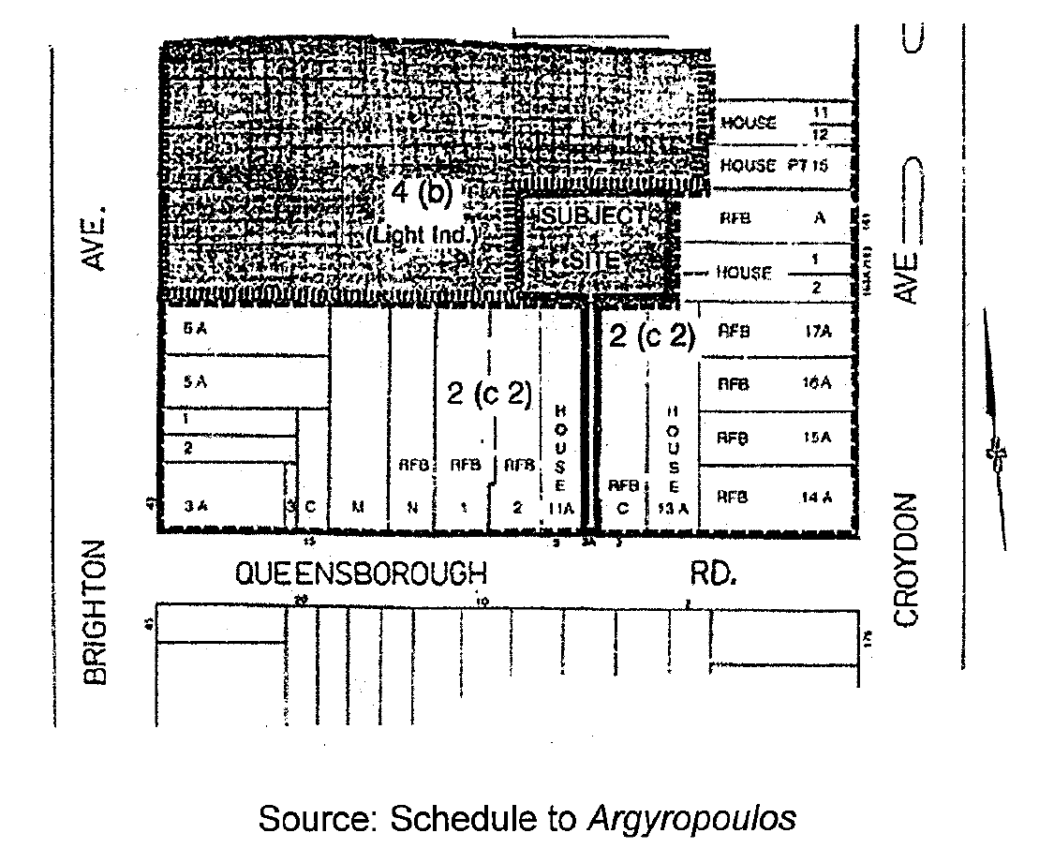
- Whereas in the present case, the part of the site on which the existing Chullora Marketplace is situated (at 353-355 Waterloo Road) has direct access to Waterloo Road which is a regional public road. The subject site is not a land lock situation as in the case of Argyropoulos, and this feature is significant as an approval of this DA (and certainly, in Stage 1) will mean that the proposed residential apartments will only be able to be accessed via 87 Norfolk Road and be known by that separate address (i.e. being the location of the driveway).
- It is also submitted that the “road” in Argyropoulos was “linear and separate/severable from the light industrial development”. Whereas, in this case the access driveway is not separable/severable from the proposed residential flat building the subject of the Stage 1 DA. Its design is integral to the design of the development, particularly the residential flat building. As such, the access driveway is commingled with and indivisible from the residential flat building in the Chamwell sense: Chamwell at [40].
- Lastly, it is submitted that Argyropoulos does not stand for the proposition that the “road” must be characterised as a “road” under the scheme. The Council submits that the Court held that the respondent council in that appeal had the power to approve or refuse consent and, in determining the application, may consider the manner of use of the “road”. As such, it was a matter of fact to be determined by the respondent council.
- Ultimately, the Council submits that the facts in Chamwell are closer to the case at hand. In Chamwell, the applicant sought development consent for the erection and use of a building as a mixed-use development comprising a supermarket and multiple-unit housing with basement car parking: at [1]. The respondent council submitted that the following parts of a building were to be used for the purpose of the retail development of the supermarket which was prohibited on the relevant land (at [18] and [20]):
- entry and exit driveways at ground level;
- pedestrian ramps at ground level and basement car park;
- a pond and recreation area at ground level;
- travelators at ground level and basement car park; and
- circulation isles in the basement car park.
- While those parts might be utilised for the proposed residential uses in the building, they were anticipated to be used significantly for and were a fundamental means of access to both the commercial retail space and the commercial car parking spaces: at [19]. The applicant argued that those parts were properly characterised as “roads” which were permitted with consent: at [21] and [23]. It submitted that the fact that parts of the building would be used by pedestrians and vehicles to access the retail components of the building did not cause the purpose to become a shop, and thereby prohibited, relying on the findings in Argyropoulos: at [24].
- Relevantly, Preston CJ held that:
- The purpose of retail development (in that case, a supermarket) could only be achieved by the physical acts of constructing not only the space in which the retailing takes place but also the spaces for the associated activities: at [29].
- The use of the land for the supermarket involved the construction of (at [30]):
- the building in which the supermarket and its associated stock room and loading dock can be provided;
- basement car parking for customers who wish to shop at the supermarket;
- driveways providing vehicular access from the public road to the basement car park and passageways, travelators and pedestrian ramps providing pedestrian access between the public road, the car park and the supermarket; and
- the landscaped, supermarket forecourt area that provides passive recreation and access for customers.
- The physical acts involved in the erection of the building including the construction of the car park, driveways, access ways and landscaped forecourt were the means by which the land is made to serve the retail purpose of the supermarket - which could not function on the land without the car park, driveways, access ways and landscaped forecourt: at [31].
- The car park, driveways, access ways and landscaped forecourt were each designed to serve the end of enabling the supermarket to be carried on: at [35].
- The retail development of the supermarket constitutes one integrated and indivisible business or activity. It was not capable of subdivision or sectionalisation into the retail section (comprising the supermarket and its associated stockroom and loading dock) and the non-retail section (comprising parts of the building used by customers of the retail section): at [38].
- The activities that would be carried on by the retail customers in those parts of the building (such as parking their cars in the basement) were day-to-day activities of the supermarket and they were impossible to treat as separate or severable from the retail business. Rather those activities were “so commingled in time, place or circumstances with the actual exercise or carrying on” of the retail uses of supermarket “that in a practical sense one cannot conceive of the one being carried out without the other”: at [40].
- The integral relationship between those parts of the building and the supermarket meant that it was not appropriate to characterise the uses as being for the purpose of roads: at [42].
- Even if those parts of the building could be seen to be for the purpose of roads, that purpose would be subordinate to the purposes of shop and multiple-unit housing: at [42].
- It was unnecessary to determine if Argyropoulos had been incorrectly decided as it was distinguishable on the facts. In that case, the access handle was constructed and used as a road in the ordinary meaning of that word. The access handle was separate to the land on which the light industrial use was to be carried on: at [49].
- The Council contends that the Court’s findings in Chamwell reproduced above demonstrate the similarity between how the structures associated with the supermarket were to be used in that case, to the access driveway in the present case. The access driveway is commingled with and indivisible from the residential flat building in the Chamwell sense: Chamwell at [40].
- The Council distinguishes the decision in Goldberg v Waverley Council [2008] NSWLEC 49 (Goldberg), which adopted the reasoning in Argyropoulos, on its particular facts. In Goldberg, the applicant sought consent to subdivide the land into two allotments, and to construct a driveway on an unmade section of public road to provide access to the land: at [1]. The land was zoned residential, and the unmade section of public road was zoned open space: at [2]-[3]. The unmade section of public road already provided pedestrian access to the land and two other properties: at [3]. The respondent council contended that the development was not a “road” but rather a “driveway” to provide access to the residential subdivision which was for a purpose that was prohibited in the open space zone: at [4]. However, Lloyd J did follow Argyropoulos and held:
“50 On the basis of the decision in Argyropoulos, Mr Galasso SC submits that a road use is contemplated by the LEP as a separate use and that the use of the local road reserve for a road, being an exempted use under cl 43 and Sch 4, does not become a prohibited use because the start and/or destination of vehicles passing over the road is residential land. Conversely, the LEP does not require a council, when determining an application for use of land, to conclude that if the users of the road are proceeding to or from land zoned as residential there is such a nexus between the use of the local road reserve and the use of the residential land that the council has no power to grant its consent to the application. I respectfully agree with these submissions. Indeed, the decision in Argyropoulos compels such a conclusion.
51 The proposition that the use of a road is separate and not ancillary to its end use is reinforced in the present case by the fact that the land on which the driveway is to be constructed is legally separate from the residential land and is a road within the meaning of the Roads Act.
52 …
59 I concur with Mr Galasso SC that the present factual circumstances are very different from those in Chamwell. The latter presented a situation where there were two distinct uses served by the car park and its other features, namely the supermarket and the multi-unit housing. The Court was thus confronted with deciding which of these uses was predominantly served by the car park. In the present case, akin to Argyropoulos, the driveway is the single feature and its only purpose is to serve the abutting land.”
(Emphasis added)
- The Council submits that in Goldberg, the fact that the new driveway would be constructed on an existing public road meant it clearly fell within the meaning of the Roads Act. Whereas in the present case, the access driveway on 87 Norfolk Road is not proposed on an existing public road. Furthermore, if approved, the address for the residential flat building will relate to 87 Norfolk Road – being another public road.
- Another distinguishing feature between the present appeal and in Goldberg, is said to be the fact that the unmade section of public road where the new road was proposed already provided pedestrian access to the land and two other properties. Whereas in this case, the land on which the access driveway is proposed has a separate dwelling, with boundary fencing and provides no direct access to the site at 353-355 Waterloo Road.
- The Council also relies on Site Plus Pty Limited v Wollongong City Council [2011] NSWLEC 1371 (Site Plus), to support its case. In that appeal, the Court held that the nature of access over the two other lots was to serve the industrial purpose rather than as a “road”: at [35]. In so finding, the Commissioner held that the use of the two other lots had similar characteristics to that in Chamwell and that Argyropoulos could be distinguished: at [36].
- On a 56A appeal in Site Plus Pty Ltd v Wollongong City Council [2014] NSWLEC 125, Craig J held:
“63 Related to its reliance upon the decision in Argyropoulos, the Applicant submits that the Commissioner erred when he characterised the use of Lots 41 and 42 by reference to the use of Lot 2. According to the submission, this involved a failure to consider the present and permissible use of part of Lots 41 and 42 as a road.
64 That submission, so it seems to me, fails to take into account the relevant provisions of LEP 2009. By cl 2.3(3) it is provided that reference in the Land Use Table "to a type of building or other thing is a reference to development for the purposes of that type of building or other thing" (emphasis added). Further, while the Land Use Table for the E3 Zone nominates "roads" as being permissible with consent, it also nominates "industries" as a prohibited form of land use.
Applying these provisions to the development being assessed necessitated consideration of both forms of land use in order to determine whether they were, in truth, independent purposes or, in the language of Foodbarn one subserved the other so that the dominant purpose became the purpose relevant to be considered in accordance with the Land Use Table.”
- The Council distinguishes the decision in Ballina Shire Council v Palm Lake Works Pty Ltd [2020] NSWLEC 41 which adopted the reasoning in Argyropolous - on the basis that the Court at first instance had relied upon the fact “the Council had accepted that ‘any type of access way on private land could be categorised as a private road’”: at [77]. Albeit, emphasising that the Council makes no such concession in this case.
- The Council also relies on the decision in Alramon Pty Ltd v City of Ryde Council [2022] NSWLEC 108 (Alramon). In that case, the Court considered a development application for a childcare centre (in Class 1 proceedings), and an application for an easement under s 88K of the Conveyancing Act 1919 (in Class 4 proceedings): at [1]. The development application relied on access from the respondent council’s car park which adjoined the applicant’s land: at [1]. The applicant sought an easement in the form of a right of carriageway over the respondent council’s car park for the purpose of access to its land: at [1]. The respondent council’s car park was zoned SP2 Infrastructure in which roads were permitted with consent and development that was not permitted with or without consent was prohibited: at [16] and [153]. As such, a centre-based childcare facility was an innominate prohibited use on the respondent council’s car park: at [153].
- The Court held that the primary purpose of the easement was to serve the purpose of the proposed childcare centre and the applicant’s land generally: at [164]. In the circumstances, the use fell within the category of prohibited development: at [164]. In so doing, her Honour held that:
- The decision in Argyropoulos was distinguishable because the respondent council car park was not a road and was never constructed as a road within the ordinary meaning of that word: at [165] and [173].
- The purpose of the childcare facility could only be achieved by the physical acts of constructing not only the space in which the childcare would take place but also the spaces for the associated activities, such as parking and vehicular access: at [165].
- The physical acts involved the erection of the childcare centre including the construction of the car park, driveways and access ways are a means by which the land is made to serve the childcare purpose: at [165].
- The childcare could not function without the car park, driveways and access ways: at [165].
- The end to which the right of carriageway was to serve was not a road and, as such, was integrated and indivisible from that of the childcare centre: at [165].
- Palm Lake did not assist the applicant because, in that case, the respondent council accepted that any type of access way on private land could be categorised as a private road and conceded that the access could be for a road - with no such concession given by the respondent council in Alramon: at [172].
- The easement was designed to serve the childcare centre unlike a regular road: at [174]. Her Honour accepted the respondent council’s submission that there was no physical definition of the area intended to be a road and the design, shape, intended use and terms of the easement are not reflective of a road use, rather it is a carriageway serving the childcare centre: at [174].
- The Council contends that the proposed access driveway on 87 Norfolk Road in the Stage 1 DA serves the purpose of the residential flat building rather than a separate purpose of road for the same reasons that the access driveway in Alramon served a childcare centre. It submits that the access driveway only serves the residential flat building and has been designed only for that purpose. The roadway is essential to enabling the proposed residential flat building development because, without the physical act of constructing the roadway, the development could not be achieved.
- The decision in Rockliff Estate Pty Ltd v Liverpool City Council [2023] NSWLEC 1725 (Rockliff) is also said to be of assistance to the Council’s case. In that appeal, the Court considered whether a roadway, which provided access to a proposed industrial and warehouse estate, was characterised as a “road” (which was a nominate permissible use) or “warehouse and or distribution centre” (which was a nominate prohibited use): at [11].
- Commissioner Walsh held that the roadway was not a “road” because it served the purpose of providing access to the warehouse buildings - being “the end” to which the roadway served: at [37]. Further, that the roadway was essential to enabling the proposed industrial and warehouse development because, without the physical act of constructing roadway, the development could not be achieved: at [37].
- The Council submits that the findings in Rockliff support a conclusion in this case that the proposed access driveway on 87 Norfolk Road the subject of the Stage 1 DA is not a “road” but rather serves the purpose of a residential flat building which is prohibited in the R2 zone. The Council arguing that the physical attributes/physical acts on the 87 Norfolk Road site demonstrate attributes/acts which serve the purpose of a residential flat building on 355 Waterloo Road namely:
- The original Ground Level Architectural Plan contains the following details for the proposed driveway (see Ex 17, Concept Development GA Plans, Ground Level, Drawing DA-030-004 Rev 1):
- The words “Residential Carpark Entry and Exit” at the southern boundary of 87 Norfolk Road where it connects to Norfolk Road (Ex 17 is superseded by subsequent plans).
- A “Hydrant Booster” is shown inside that boundary.
(And, while it concedes that the current set of architectural plans does not contain an equivalent plan showing the above details the Council relies on the evidence of Mr Ryan in cross-examination, when he said that it was his understanding that the plan remained current in terms of showing the interface between the proposed access driveway and Norfolk Road (Tcpt, 20 June 2024, pp 151(5)-152(6)).
- The SEE relevantly states (see Ex E, Class 1 Application, Vol 1, Tab 4):
- “A new road, Norfolk Land, will be created through no. 87 Norfolk Road to provide a new entry/exit point for the residential apartments proposed in Stages 1 & 2. This road will have the visual appearance of a ‘driveway’, which will deter retail shoppers and childcare users from accessing the site from this new access point” (see Section 2.11.2).
- “Norfolk Lane will have the appearance of a driveway, which will be consistent with the appearance, form and function of the adjoining residential dwellings on Norfolk Road” (see Section 6.5.1).
- The legal advice of Mills Oakley which is premised on the basis that the proposed driveway would be constructed on 87 Norfolk Road “for access to the also proposed residential flat building development at the adjoining Chullora Marketplace land at 353-355 Waterloo Road, Greenacre”: Ex G, Class 1 Application, Vol 3, Tab 33, p 1.
- The Civil Engineering Plans for the Stage 1 DA before the Court show:
- A substantial below ground on-site detention system, including a rainwater tank, with a volume of 90m3 on 87 Norfolk Road: Ex A, Ex M-03, Tab 4, Drawings 22J17_DA_C102 Rev 7, 22J17_DA_C103 Rev 7 and 22J17_DA_C202 Rev 4. This stormwater infrastructure is serving the proposed residential flat building (at least).
- The proposed driveway is to “match existing footpath level and width” on the other side of the southern boundary of 87 Norfolk Road: Ex A, Ex M-03, Tab 4, Drawing 22J17_DA_C103 Rev 7.
- The proposed vehicular footway crossing (VFC) where the proposed driveway adjoins Norfolk Road is to be “in accordance with Bankstown City Council's Standard Drawing S-008, refer C150 for details”: Ex A, Ex M-03, Tab 4, Drawing 22J17_DA_C103 Rev 7. The details of Council's Standard Drawing S-008 are set out in a later plan and relate to a standard medium duty VFC: Ex A, Ex M-03, Tab 4, Drawing 22J17_DA_C150 Rev 2.
- The Council’s Development Engineering Standards provides that the “minimum pavement thickness design for the driveway within the development must be in accordance with Council’s VFC Standard Drawings S-007 to S-009, whichever is required by the development consent”: Council’s Bundle, Item 14, 796. Clause 8.7 of the Standards contains the requirements for VFC design and construction which applies to the following uses: residential and dual occupancy; medium density residential; high density residential (flats); commercial, industrial and institutional development: Council’s Bundle, Item 14, 791. Table 8.1 of the Standards provides the following requirements for medium and high-density residential developments: minimum width of VFC at boundary of 3.5m; maximum width of VFC at boundary of 6m; minimum standard of VFC as heavy duty.
- On the other hand, Table 8.1 of the Standards provides the following requirements for a dual occupancy (with single access to both dwellings): minimum width of VFC at boundary of 3.5m; maximum width of VFC at boundary of 5.5m; minimum standard of VFC as medium duty.
- The Council says that the Civil Engineering Plans have used the incorrect requirements in Table 8.1 by using the requirements for dual occupancies rather than medium and high-density residential developments. This discrepancy has been corrected in the conditions. In any event, the use for which the VFC is being designed is for a residential use (as distinct from the design of a road).
- The Landscape Plans for the Stage 1 DA before the Court show trees on both sides of the access driveway on 87 Norfolk Road with a notation “mass planting in deep soil to provide visual privacy and screening to adjacent properties”: Ex A, Ex AA-03, Tab 3, Drawing 2022020-LD-DA020 Rev 4. In those Plans, the access driveway on 87 Norfolk Road is marked as a “new driveway” and being 6m wide: Ex A, Ex AA-03, Tab 3, Drawing 2022030-LD-DA411 Rev 3. The width is inconsistent with the Civil Engineering Plans which show the access driveway as being 5.5m wide. (CFWS par 77)
- Paraphrasing the reasoning of Pain J in Alramon, the Council submits:
- The decision in Argyropoulos was distinguishable because the dwelling house in this case was never a road and was never constructed as a road within the ordinary meaning of that word, rather, Henroth seeks to repurpose an ordinary house block to achieve a new street (Norfolk Lane) address for its proposed residential flat building: see [165] and [173] of Alramon.
- The purpose of that residential flat building can only be achieved by the physical acts of constructing not only the residential flat building, including its parking but also vehicular access to that parking: at [165] of Alramon.
- The physical acts involved the erection of the residential flat building included the construction of the driveway/access ways, being a means by which the land is made to serve the residential flat building purpose: at [165] of Alramon.
- The residential flat building could not function without the access ways: at [165] of Alramon.
- The end to which the right of carriageway was to serve was not a road and, as such, was integrated and indivisible from that of the residential flat building: at [165] of Alramon.
- Palm Lake did not assist the applicant because, in that case, the respondent council accepted that any type of access way on private land could be categorised as a private road and conceded that the access could be for a road - with no such concession given by the council in Alramon, nor here: at [172] of Alramon.
- The easement in Alramon was designed to serve the childcare centre unlike a regular road: at [174]. In this case, a different entity owns 87 Norfolk Road, and that property cannot be consolidated with the shopping centre lot in any event. Henroth has not explained by what right the occupiers of the residential flat building will use the adjoining Lot 24. Here the Court would accept that, although there is a physical definition of the area to be used here, the design including the VFC, the OSD, and the tree-lined access, all demonstrate the intended use is not reflective of a road use, rather it is a carriageway serving the residential flat building: at [174] of Alramon.
- For all those reasons, the Council submits the access driveway is integrated and indivisible from the residential flat building, and plainly serves the sole purpose of a residential flat building which is prohibited in the R2 zone. Therefore, the DA should be refused. It is also submitted that this outcome is consistent with the DCP, which proposes all residential access for new development on 353-355 Waterloo Road from Waterloo Road. I will deal with this merit issue in due course.

Henroth’s position
- Henroth describes the development over 87 Norfolk Road as a new “private road” and cautions against any reliance on labels in the plans or documents before the Court.
- Instead, it invites an interrogation of the physical form of the development and submits that the proposed development is, by its form (architectural and engineering detail), a road that falls within the definition of “road” under LEP 2015. A form that it submits can be understood from the plans in Ex 17 – which shows the extent of the road to Norfolk Road, and the engineering detail in plan DA C103, and the landscape plan DA 200 which picks up the footpath.
- Henroth contends that the relevant facts in this case are analogous to those in Argyropoulos and Palm Lake and are different to the facts considered by the Court in Chamwell and Site Plus. A “road”, which includes a “private road”, is a nominated permissible use under the Land Use Table for the R2 zoned Norfolk Road Lot and “residential flat buildings” are an innominate prohibited use in that zone. Both roads and residential flat buildings are a permissible use in the adjoining B2 Chullora Marketplace site. The purpose of the proposed road is as described in Argyropoulos “for the re-passing of vehicles” to another permitted land use.
- The development, by its engineering and design, appears as a road in the ordinary sense. It is not integrated and indivisible from the proposed residential flat building – commingled on the same lot as was the case in Chamwell. The proposed road is on a separate lot. It is a permissible use. As such, it is distinct and separate from the proposed residential flat building standing on the adjoining Chullora Marketplace lot. Therefore, it is appropriate to characterise the proposed road on the Norfolk Road Lot as an independent use as a road. The fact that the road might be characterised as serving the residential flat building in the development or providing access to the limited public car parking spaces on Norfolk Lane fronting the townhouses is irrelevant. The fact that the road may facilitate drainage from the residential flat building development to the public drainage system, has guttering, and contains a fire hydron at the frontage and landscaping or not is also irrelevant to its characterisation. So too are the rights attached to the road. It is not an ancillary use to a primary residential flat building use in the sense argued in Baulkham Hills Shire Council v O’Donnell (1990) 69 LGRA 404 (O’Donnell).
- Henroth points out that line of authority in Argyropoulos is predicated on a different basis. That is, a permissible use of a road for the purpose of a road. A conveyance over the private road lot onto Norfolk Lane on the adjoining site with access from there to the entry portal for the proposed residential flat building basement parking. It may be used by those that are accessing the residential component but there is nothing inconsistent with the finding that the proper characterisation of the road is as a road. The independence of the proposed road is an independence of its characterisation, it is not an independence of factual relationship to another use on a separate lot.
- Henroth relies on the reasoning of the Court in O’Donnell at p 409:
“It does not follow that a use which can be said to be ancillary to another use is thereby automatically precluded from being an independent use of land. It is a question of fact and degree in all the circumstances of the case, whether such a result ensues”,
to submit the proposed use is a use of land that is capable of being an independent use - a road - specifically a permissible use. It is not deprived of that quality because it is ancillary to or related to or interdependent with another use. It is still a road as a matter of operation and fact on a separate lot.

Contention 1 - Considerations and findings
- As is clear from the parties’ submissions as summarised above, the permissibility of the development over the R2 zoned Norfolk Road Lot rests upon how it should be characterised. Whether it should be characterised as being used for the purpose of a road, or as a driveway serving the purpose of the proposed residential development on the adjoining supermarket site. The latter being a prohibited use in the R2 zone.
- The case law referred to makes it plain that the answer to the question is largely based on the specific facts of the case: Chamwell, Site Plus, Alramon and Rockliff. In that regard, the principles set out at [174] of Alramon which include the zoning of the land, and whether the design, shape and intended use of the area is properly characterised as a road are relevant to determining characterisation.
- The pertinent facts in this case include the following:
- The Chullora Marketplace Lot is zoned B2 Local Centre under LEP 2015, while the Norfolk Road Lot is zoned R2 Low Density Residential under the LEP.
- Residential flat buildings are a nominate use in the B2 zone and a prohibited use in the R2 zone.
- Roads are a nominate permissible use in both the B2 and the R2 zones under LEP 2015.
- No part of the residential flat building is proposed to be constructed on the Norfolk Road Lot.
- The road is on a separate lot to the Chullora Marketplace site where the residential flat building will stand.
- The road will be a private road as it is not going to be dedicated to Council.
- The road will function to permit the passing and repassing of vehicles to the Chullora Marketplace Lot in the Stage 1 design and thereby facilitate access to the portal entry to the proposed residential flat building Basement Level 02 car park. The car park entry will be controlled by security measures to preclude public parking.
- The road will have the visual appearance of a driveway which is intended to deter retail shoppers and childcare users from accessing the site from this new access point (Ex E - SEE p 23). It will be engineered to the Council’s specifications in accord with the proposed draft conditions.
- When dealing with characterisation of a use generally, the well-known passages from Chamwell at [27] and [34] are a useful starting point.
“27 In planning law, use must be for a purpose: Shire of Perth v O’Keefe (1964) 110 CLR 529 at 534-535 and Minister Administering the Crown Lands Act v New South Wales Aboriginal Land Council (1993) 80 LGRA 173 at 188. The purpose is the end to which land is seen to serve. It describes the character which is imparted to the land at which the use is pursued: Shire of Perth v O’Keefe (1964) 110 CLR 529 at 534.
…
34 However, the nature of the use needs to be distinguished from the purpose of the use. Uses of different natures can still be seen to serve the same purpose: see Shire of Perth v O’Keefe (1964) 110 CLR 529 at 534, 535 and Warringah Shire Council v Raffles (1978) 38 LGRA 306 at 308.”
- It is also accepted that the use of land can have multiple purposes. Therefore, when characterising use there needs to be some consideration as to whether a particular purpose is subordinate or ancillary to another purpose: Foodbarn Pty Ltd v Solicitor-General (1975) 32 LGRA 157 (Foodbarn). Mindful, that a use which is ancillary to another use may still be an independent use: O’Donnell.
- To my thinking, the facts in this case are not dissimilar to those discussed in Argyropoulos. In that case, the battle axe access handle was zoned residential and proposed to be used for the purpose of a road to access an industrial facility on an adjacent separate industrial zoned lot. “Roads” were a nominated permissible use on the residential land, however, the industrial use was an innominate prohibited use within that zone. The planning scheme in Argyropoulos contemplated a “road” use as a separate permissible use in the residential zone like the case at hand. The Court held, for the purpose of characterisation of the proposed development on the residential land, that the question of the innominate prohibited industrial use did not arise. It reasoned that:
“The function of a road is to permit the passing and repassing of vehicles. The use of the handle for a ‘road’ which is a nominate, permissive use under the relevant residential zoning does not become an innominate prohibited use because the start and/or destination of vehicles passing over the road is light industrial land”.
- The same can be said in the present case. The use of the road, which is a nominate, permissive use under the R2 zone does not become an innominate prohibited use because the start and/or destination of vehicles passing over the road is to a residential flat building located on a separate B2 zoned lot and “co-mingled” in the Chamwell sense.
- In the present case, I find that the facts are akin to those in the case of Argyropoulos. The driveway is a single feature and its only purpose is to serve the abutting land (at [51]). The proposition that the use of a road is separate and not ancillary to its end use is reinforced by the fact that the land on which the driveway is to be constructed is legally separate from the B2 zone lot and is a road within the meaning of the Roads Act: Goldberg.
- In Chamwell, the Court dealt with Argyrouplous as being potentially inconsistent by identifying the fact that the use of the road in Chamwell was essentially blended with the car park and the supermarket itself. As distinct from a separate road as is the case at hand. Henroth’s plans show a road on the Lot for 87 Norfolk Road land. The entry portal to the car park of the residential flat building is from a different private road on the supermarket Lot. It may well be argued that the laneway sitting on the shopping centre land is in the Chamwell “blended sense” able to be characterised as being for the purpose of the residential flat building as both the road and residential buildings are permissible on the same lot but the same cannot be said for the road on the separate Norfolk Road Lot. The facts of each case are different.
- The decision in Alarmon can also be distinguished on its facts. In Alarmon, the Court was plain in finding that the decision in Argyropoulos was distinguishable because the respondent council car park in Alarmon was not a road and was never constructed as a road within the ordinary meaning of that word: at [165] and [173]. The road on the Norfolk Road Lot will have the features of a private road in the ordinary sense of the word. The street address of 87 Norfolk Road does not of itself preclude the development being characterised as a private road. As Henroth submits, it is the “independence of the use for the purpose of characterisation, not an independence of fact from any other use” such as - access the residential flat building.
- It is the fact that here we have a road for the purpose of a road. It is not deprived of that quality because it might be considered in some practical way as ancillary to the residential flat building on the separate lot: O’Donnell. The Court’s reasoning in Site Plus can be distinguished on its facts. The definition of “residential flat building” or the parent definition of “residential accommodation” in the Council’s LEP in this case does not contain any reference to transportation, as was the factual circumstance with the extended definition of “industry” in Site Plus.
- Accordingly, for those reasons I find that permission may be granted to use the R2 zoned lot as a “road” notwithstanding the fact that vehicles may proceed to and from the adjoining innominate prohibited residential flat building use on the adjoining shopping centre Lot.

Contention 2 – Is cl 6.14 of LEP 2015 a development standard?

Council's position
- The Council contends that the DA cannot be approved as it does not comply with the requirements outlined in cl 6.14(4) of LEP 2015. Furthermore, that those requirements are not subject to variation under cl 4.6, for the following reasons.
- Under cl 4.3 and the Height of Buildings Map of LEP 2015, the maximum building height controls for the site are 11m - for 353-355 Waterloo Road, and 9m for 87 Norfolk Road. However, Henroth has sought to take advantage of the additional height of buildings allowed for the site by cl 6.14(2) and (3) of LEP 2015.
- Clause 6.14 of LEP 2015 relevantly provides as follows:
6.14 Exception to maximum height of buildings—Chullora Marketplace
(1) This clause applies to Lot 9, DP 10945 and Lot 41, DP 1037863, 353–355 Waterloo Road, Greenacre, known as Chullora Marketplace.
(2) Despite clause 4.3, development consent may be granted to development on land to which this clause applies with a maximum height of—
(a) for development on Lot 41, DP 1037863—20 metres, or
(b) for development on Lot 9, DP 10945—14 metres.
(3) However, development consent must not be granted to development on Lot 41, DP 1037863 that results in a building with a height greater than—
(a) 14 metres if the building is—
(i) within 46 metres of Waterloo Road, Greenacre, or
(ii) within 41.5 metres of the eastern boundary adjoining 67 Norfolk Road and 11 Watergum Way, Greenacre, or
(b) 9 metres if the building is within 30.5 metres of the southern boundary adjoining 81–105 Norfolk Road, Greenacre.
(4) Also, development consent must not be granted to development that results in a building with a height greater than the maximum height shown for the land on the Height of Buildings Map unless the consent authority is satisfied of all of the following—
(a) Lot 9, DP 10945 and Lot 41, DP 1037863 have been consolidated into a single lot,
(b) without exceeding the floor space ratio otherwise applying to the land, the development includes floor space used for the purposes of commercial premises that is equivalent to a floor space ratio of at least 0.35:1,
(c) the development has a building setback of at least 10 metres from the southern boundary adjoining 81–105 Norfolk Road and 351 Waterloo Road, Greenacre,
(d) the development has a building setback of at least 15 metres, including a 6 metre wide deep soil zone, from the eastern boundary adjoining Norfolk Reserve,
(e) the development will not result in Norfolk Reserve receiving less than 4 hours of direct sunlight between 9am and 3pm on 21 June,
(f) the development avoids overshadowing of, and other adverse environmental impacts on, the endangered ecological communities and habitats of threatened species in Norfolk Reserve,
(g) a development control plan that provides for the matters specified in subclause (6) has been prepared for the land.
(5) The consent authority may seek and consider advice from a suitably qualified ecologist in determining whether the consent authority is satisfied of the matters set out in subclause (4)(e) and (f).
(6) The development control plan is to provide for the following—
(a) building envelopes and built form controls, including storeys and setbacks at both ground floor and upper storeys, and bulk, massing and modulation of buildings,
(b) appropriate access to, capacity of, and vehicle and pedestrian safety on, the surrounding road network, particularly Waterloo Road,
(c) improved pedestrian and cyclist connectivity,
(d) sustainable transport, including strategies to encourage increased use of public transport, walking and cycling, and by providing for appropriate car parking,
(e) the transition to surrounding land, including low density development, through built form, deep soil planting and additional landscaping,
(f) mitigation of environmental impacts, including overshadowing and impacts on solar access and visual and acoustic privacy,
(g) improvements to landscaped areas and the introduction of new public open spaces, including a central plaza,
(h) an indicative structure plan and key design principles in support of the plan,
(i) application of the Crime Prevention Through Environmental Design principles.
(7) In this clause—
Crime Prevention Through Environmental Design principles means principles of the planning, design and structure of cities and neighbourhoods to reduce opportunities for crime, including through natural surveillance, access control, territorial reinforcement and space management.
Norfolk Reserve means the following land in Greenacre—
(a) Lot 3, DP 546653, 67 Norfolk Road,
(b) Lot 21, DP 836445, 67A Norfolk Road,
(c) Lot 200, DP 843319, 11 Watergum Way.
- Accepting that cl 6.14 must be read as a whole and in its context, the Council submits that the meaning of the clause is plain:
- By operation of cl 6.14(1), the provision only applies to two separate parcels of land, that is, part of the site comprising 353-355 Waterloo Road. The provision does not apply to 87 Norfolk Road.
- Clause 6.14(2) is permissive and provides an exception to the height control contained in cl 4.3 on the terms contained in cl 6.14. To this end, a specific height limit is allotted to each parcel of land.
- Clause 6.14(3) provides a further limitation in relation to one parcel of land - that is, 355 Waterloo Road. This provision operates to limit the 20m height limit in cl 6.14(2)(a) for 355 Waterloo Road.
- Clause 6.14(4) contains requirements that must be met for the exception in cl 6.14(2) to apply including:
- consolidation of the two separate parcels of land - that is, 353-355 Waterloo Road (subcl (a));
- a FSR control that provides for at least 0.35:1 of commercial floor space (subcl (b));
- a building setback from the southern boundary (subcl (c));
- a building setback from the eastern boundary (subcl (d));
- the avoidance of adverse environmental impacts on the endangered ecological communities and habitats of threatened species in Norfolk Reserve (subcl (f)); and
- a development control plan has been prepared that provides for the matters specified in cl 6.14(6) (subcl (g)).
- Clause 6.14(5) also provides for a consent authority to seek and consider advice from a suitably qualified ecologist in determining whether the consent authority is satisfied of the matters set out in subcll (e) and (f).
- Clause 6.14(6) then specifies matters that the site-specific development control plan must provide for.
- In the context, the Council contends the DA does not meet several of the above requirements, and as those matters are not development standards, they cannot be varied under cl 4.6 of LEP 2015. As such, the additional heights cannot be approved and the DA must be refused.
- Before dealing with each requirement, the Council makes the following submissions in support of its position that none of the paragraphs of cl 6.14(4) constitute a development standard.
- It refers me to the definition of the term “development standard” as defined in s 1.4(1) of the EPA Act which provides as follows:
development standards means provisions of an environmental planning instrument or the regulations in relation to the carrying out of development, being provisions by or under which requirements are specified or standards are fixed in respect of any aspect of that development, including, but without limiting the generality of the foregoing, requirements or standards in respect of-
(a) the area, shape or frontage of any land, the dimensions of any land, buildings or works, or the distance of any land, building or work from any specified point.
(b) the proportion or percentage of the area of a site which a building or work may occupy,
(c) the character, location, siting, bulk, scale, shape, size, height, density, design or external appearance of a building or work.
- Adopting the accepted principles of statutory construction relating to a local environmental plan, as summarised by Robson J in Elimatta Pty Ltd v Read [2021] NSWLEC 75 (Elimatta) at [43]-[45]; and cited in Australian Unity Funds Management Ltd in its capacity as Responsible Entity of the Australian Unity Healthcare Property Trust v Boston Nepean Pty Ltd & Penrith City Council [2023] NSWLEC 49 (Australian Unity) at [55], the Council submits that the requirements in cl 6.14 are not development standards but preconditions which must be satisfied to attain the additional height limits in cll 6.14(2) and (3).
- The Council argues that they are not development standards because the requirements in cl 6.14 do not fix an aspect of the development. Rather, the aspect which is fixed by cl 6.14 is height, or more accurately, several heights. Therefore, the seven enumerated requirements in cl 6.14(4) are preconditions which enable any height more than the 11m control to be achieved on the site.
- As such, the Council submits that there is no opportunity to separate those requirements as “aspects of the development” as this puts a strain on the language of the clause and ignores its purpose.
- Accepting the demarcation line that distinguishes between a provision that may be properly characterised as a development standard and a provision that controls development in some other way is far from clear (Strathfield Municipal Council v Poynting (2001) 116 LGERA 319; [2001] NSWCA 270 at [95]), Canterbury Bankstown Council v Dib [2022] NSWLEC 79 (Dib) at [57] per Preston CJ), the Council refers me to the reasoning of the Court in Elimatta and submits that I am bound by it based on the facts in this case.
- In Elimatta, there was a dispute as to whether cl 4.1B of the Yass Valley Local Environmental Plan 2013 (Yass LEP), which provided development consent may be granted to subdivide land in Zone RU1 if certain conditions were satisfied, constituted a development standard: at [221]. For the purpose of cl 4.1B, the proposed subdivision did not comply with one of the conditions of cl 4.18(3) because the average area of all of the lots to be created was less than the minimum size (40ha): at [27]. The Court held that cl 4.1B of the Yass LEP was not a development standard, and therefore, could not be varied through the operation of cl 4.6. In forming that view, Robson J provided the following reasons (at [48]):
- Clause 4.1(3) provides a minimum lot size of 40ha for the subdivision of land and, prima facie, prohibits the granting of development consent to a subdivision which does not comply with that size: at [49].
- Clause 4.18(3) of the Yass LEP creates an exception to the development standard in cl 4.1 provided that all of the requirements in paragraphs (a), (b) and (c) are satisfied: at [50]-[51] and [58]-[59].
- The words “despite clause 4.1” at the beginning of cl 4.18(3) indicate that the exception in cl 4.18(3) is to prevail notwithstanding the terms of cl 4.1(3), such that development consent to subdivide land may be granted if the requirements of cl 4.18(3) are met, despite not meeting the requirements of cl 4.1(3) (citing R.I.G. Consulting Pty Ltd v Queanbeyan-Palerang Regional Council (2021) 249 LGERA 377; [2021] NSWCA 130 (R.I.G. Consulting) at [22]): at [52].
- Having regard to the definition of “development standards”, cl 4.18(3) does not itself specify or fix anything - rather it provides an exception to those requirements which are otherwise specified by cl 4.1(3): at [53].
- The requirements of cl 4.18(3) are better conceptualised as “integers” in a formula which determines the “availability” of the exception for the grant of development consent: at [55].
- The fact that the heading for Pt 4 (“Principal development standards”) of the Yass LEP, within which cl 4.18 is situated, is part of the Yass LEP (under s 35 of the Interpretation Act 1987) is not determinative of the issue: at [64].
- As cl 4.18(3) is not a development standard, it cannot be varied under cl 4.6: at [65].
- In Australian Unity, the Court considered a challenge to the validity of a development consent for a hotel and distinguished the decision in Elimatta. The applicant contending that the respondent council acted beyond power in granting the consent because the building exceeded the maximum building height controls mandated for the relevant land under cll 4.3(2) and 7.11(3) of the Penrith Local Environmental Plan 2010 (Penrith LEP): at [2]. The developer argued that the respondent council had power to grant consent based on variations to either or both controls under cl 4.6 of the Penrith LEP: at [3].
- In dismissing the appeal, the Court held that the relevant controls were development standards and were properly varied by the consent authority for the following reasons (at [4]):
- The maximum height limit for the subject site was 18m under cl 4.3(2) of the Penrith LEP: at [56].
- Clause 4.3(2) is a precondition to the exercise of statutory power to grant consent to the proposed development: at [56].
- Clause 7.11(3) of the Penrith LEP provides for the granting of development consent to development that exceeds the maximum permissible height (18m) by up to 20% (21.6m) provided that the statutory precondition is met - namely, the floor-to-ceiling height of both the ground and first floors must be equal to or greater than 3.5m: at [63]-[64].
- Clause 7.11 is a provision relating to the carrying out of development on that land for the purposes of a hotel by regulating the circumstance in which development consent can be granted to that development despite the exceedance of the maximum building height control: at [101]-[102].
- Clause 7.11 is a “development standard” as defined in the EPA Act because it squarely concerns the height of a proposed development: at [104].
- Although urged to conclude that Elimatta was plainly wrong, her Honour did not need to do so on the basis that it was distinguishable because it concerned a subdivision and not building height: at [108]. However, her Honour did note that the conclusion in Elimatta appeared to be inconsistent with the remarks in R.I.G. Consulting that a similar provision to cl 7.11 was a development standard (citing R.I.G. Consulting at [53] and [681]): at [108].
- The purpose of the words “despite clause 4.3” ensures that the operation of cl 7.11 is unaffected by cl 4.3 and, in particular, cl 4.3(2): at [110]-[111].
- There are two requirements contained in cl 7.11(3) of the Penrith LEP that must be established in order to enliven the power contained in the provision- namely, the floor-to-ceiling height of both the ground floor and the first floor be equal to or greater than 3.5m, and the height of any building not exceed the maximum building height by more than 20%: at [112].
- Clause 7.11 operates as a separate development standard in its own right and not as an exception to the development standard contained in cl 4.3(2): at [113].
- In addressing the difference between the reasoning of Pepper J in Australian Unity and Robson J in Elimatta, the Council endorsed the reasoning of Robson J for the following reasons:
- In accord with the conclusion in Elimatta, it is the specific relationships between each of those provisions which lead to the conclusion that, considered in that context, the matters recited above are collectively “integers”, which if satisfied, allow the exception to be applied. Having regard to the various “integers” in that clause, it is clear that the provision is not a development standard but a separate and clear regime for development on the lots the subject of the clause to reach a particular height.
- The preconditions for cl 6.14(4) to apply are comprehensive (including the requirement for a specific development control plan). When taken in context, the requirements are an “essential element” for the increased height to be available, by analogy to the test applied by Basten JA in Blue Mountains City Council v Laurence Browning Pty Ltd (2006) 150 LGERA 130; [2006] NSWCA 331 at [77]. Notwithstanding, the observation by Preston CJ in Dib, that the “essential element” approach to determining whether a provision is a development standard is not without its difficulties: at [57], the Council maintains that it remains an appropriate interpretation tool in this case.
- Thirdly, the Council submits “…rather than being requirements ... specified or standards are fixed in respect of any aspect of that development” as the definition of “development standards” provides, the preconditions for the exception to cl 6.14(4) are themselves requirements and criteria (or integers, to use the term adopted by Robson J in Elimatta, not the other way around). It submits that collectively the requirements, provide a holistic approach to built form on 353-355 Waterloo Road.
- Australian Unity, can be distinguished because cl 7.11 of the Penrith LEP provided that exceedance of the height control by up to 20% was permissible if a certain floor to ceiling height was achieved. Therefore, the conditions for exceedance (the wall height) directly related to the overall height of the development being increased, and so were dealing with “an aspect of the development”, as provided in the definition of “development standards”.
- Even if cll 6.14(2) and (3) contained development standards that are separate from the development standard in cl 4.3, the Council submits that it does not follow that all of the requirements contained in cl 6.14(4) are development standards.
- Lastly, there is a strong textual indicator that cl 6.14(4) does contain development standards by operation of cl 6.14(5) which enables a consent authority to seek and obtain expert advice on two such matters.
- For those reasons, the Council says that the provision in the requirements contained in cl 6.14(4) are not development standards and, therefore, are not amenable to a cl 4.6 variation request.
- Consequently, as the application does not comply with cl 6.14(4) of LEP 2015 (for the reasons explained in Contention 6), the exception to the height control in cl 4.3 is not available, and the DA must be refused.

Henroth’s position
- Henroth rejects the Council’s argument that each paragraph in subcl 6.14(4) is a precondition or fixed integer that, collectively, allow the exception to be taken as reasoned by Robson J in Elimatta. It submits that the structure of cl 6.14, while not identical, is similar to that considered by Pepper J in Australian Unity and as her Honour did in that case, distinguished the determination made in Elimatta by reason of the difference in the provisions presently being considered.
- As Henroth submits and I accept, cl 6.14 addresses the height control of buildings on Lots 9 and 41, as those Lots are identified in subcl (1) of the clause. The prefix to the operation of subcl (2) “Despite clause 4.3”, operates so that the provisions of the subclause, so far as they specify the respective maximum heights for a building on each of Lot 9 and Lot 41, prevail over the provisions of cl 4.3 so far as that clause otherwise specifies the maximum height of a building on each of those Lots. Subclause (3) qualifies the maximum height for a building on Lot 41, as specified in subcl (2), by limiting that height if the building is located within the distances there nominated from identified road or property boundaries of that Lot.
- Subclause (4) of cl 6.14 operates by reference to a different set of integers pertaining to the height of a building on the two nominated Lots. Its provisions operate by reference to the height control imposed by cl 4.3 and the Height of Buildings Map identified in that clause. This follows by use of the word “also” as the opening word of subcl (4). As Henroth submitted, if the building proposed on Lots 41 and 9 “exceeds by one centimetre” the maximum height of a building on those Lots by reference to the Height of Buildings Map, the consent authority must be satisfied as to each of the matters addressed in pars (a)-(g) of subcl (4) in order to consent to any exceedance. That is, an evaluative judgment is able to be made by the consent authority to permit the height exceedance provided it is satisfied by reference to the integers identified in pars (a)-(g) of the subclause.
- Henroth then addresses Elimatta where Robson J found that the clause in that case operated as preconditions to the exercise of the discretion to vary a control upon development which his Honour found was not therefore a development standard. Relevantly, Henroth submits that there is a structural difference between the Elimatta clause and cl 6.14(4). Next, the decision of Pepper J in Australian Unity was addressed in which her Honour considered a clause not dissimilar to that in Elimatta. Her Honour distinguished Elimatta in a way that Henroth submits is entirely consistent with the way that cl 6.14 is to be construed.
- Henroth submits that the critical passage of the judgment in Elimatta commences at [53]. There, reference is made to the definition of “development standard” in s 1.4 of the EPA Act, namely “provisions of a planning instrument …in relation to the carrying out of development, being provisions by or under which requirements are specified or standards are fixed in respect of any aspect of that development”, noting that in the provision being considered it must, by its terms, clearly specify a requirement or fix a standard. Robson J then observed that the definition of “development standard” is directed to the outcome of the provision in question. His Honour then concluded that the clause being considered by him (cl 4.1B(3)) did not itself specify or fix anything; rather it provided an exception to those requirements which were otherwise specified in determining the minimum lot size for subdivision (cl 4.1) of the land in question. His Honour found that the opening words of cl 4.1B(3) being “Despite clause 4.1”, clearly indicated that cl 4.1B(3) did not operate alone but instead leveraged off the controlling provision of cl 4.1(3) in those zones to which cl 4.1B(3) applied.
- Henroth then submits that the form of cl 4.1B(3) in Elimatta at [21]; [50] is very different to cl 6.14 in this case. For the same reasons articulated by Pepper J in Australian Unity, the decision in Elimatta can be distinguished on that basis. I also note the observation by Pepper J that the ultimate decision in Elimatta appears to be inconsistent with the decision of the Court of Appeal in R.I.G Consulting at [53], albeit that Elimatta does not appear to have been cited in that case.
- Whilst acknowledging that case law has moved on from the “essential element” test of a prohibition, Henroth simply submits that cl 6.14 is clearly neither a prohibition nor a zoning control of the kind identified in North Sydney Council v Michael Standley & Associates Pty Ltd (1998) 43 NSWLR 468. Rather, the provisions of cl 6.14 are “requirements for an aspect of development” able to be carried out on Lots 9 and 41, namely the height of buildings on those lands. As I have indicated, it submits that a building of the height authorised the cl 4.3 up to the boundary, can, in theory, be achieved but an exceedance of 1cm requires a 10m setback from the boundary (cl 6.14(4)). A provision in those terms is “specifying a requirement” for a building that is greater in height than that limited by cl 4.1; so understood, it is a “development standard”.

Finding – cl 6.14(4) is a development standard
- For present purposes, the focus is on pars (c) and (d) of cl 6.14(4). It is not necessary to characterise each paragraph of cl 6.14(4) homogenously; some of the paragraphs in subcl (4) satisfy the description of a development standard and some do not. If they do, then clearly they are amendable to the flexibility provided by cl 4.6 because they are development standards, independently of subcl (2).
- The height of building control, the development standard in cl 4.3 is modified by cl 6.14. Furthermore, cl 6.14 only applies to Lots 9 and 41 within the site.
- I accept the submissions advanced on behalf of Henroth that cl 6.14(4)(c) and (d) are a development standard. In seeking to summarise those submissions I have added observations or matters that I consider relevant to Henroth’s contentions, relieving me of the need to repeat what has already been addressed in these reasons. In particular, to the extent that the Council sought support for its submissions on this issue from the decision in Elimatta, I consider the provisions cl 6.14 and its interrelationship with cl 4.3 of LEP 2015, can properly be distinguished from those considered in Elimatta. The reasoning in Australian Unity seems to me, with respect, to be apt to the provisions presently being considered. It is not a choice between the reasoning in Elimatta or Australian Unity as the Council submits (CFWS at pars 34, 99); the form of the clause is different and, in this instance, Australian Unity is relevant.
- Accordingly, for the reasons submitted by Henroth I find that in operation the subparagraphs in cl 6.14(4)(c) and (d) cannot be construed as anything other than a development standard. Thereby, it is amenable to variation under cl 4.6 of LEP 2015.

Contention 5 - Non-compliance with LEP 2015 and Contention 6 - Non-compliance with the draft LEP

Driveway/public road connection to Norfolk Road
- The planning experts are agreed that 87 Norfolk Road will provide access to the residential accommodation parking (basement), and for limited vehicular access and on street parking along Norfolk Lane.
- Ms Bartlett gave evidence that the “road” to the residential basement is contrary to the R2 zone objectives for several reasons (Ex 10 par 42).
“a. The proposal will remove a low-density residential dwelling and replace it with a new access road/driveway singularly to serve a mixed use and high density residential development, thus reducing the housing needs of the community.
b. The location of ‘Norfolk Lane’ contravenes the Indicative Structure Plan of the DCP, which removes the ability for any genuine low or medium density housing to be created on the site, by placing a ‘road’ or ‘access’ point so far south that it prevents low-density buildings from fitting between ‘Norfolk Lane’ and the 10m southern boundary setback. Whilst the dwellings to the north of ‘Norfolk Lane’ are intended to appear as medium density ‘townhouses’, they are Class 2 buildings that form the podium of a larger, high-density, shop-top housing development.
c. The proposed access will not ‘enable other land uses that provide facilities or services to meet the day to day needs of residents. Local residents seeking to utilise either the local retail or childcare will either walk to the site, or drive to the main retail and other use parking area – they will not drive to ‘Norfolk Lane’, as it does not provide any improved direct access to retail uses than the primary vehicular access point on Waterloo Road. It will also have less certainty about parking given the limited on-street parking environment.
d. The proposed access way will create inappropriate additional environmental and amenity impacts on the R2 zone including noise, traffic, air quality, and visual and acoustic privacy. Primarily, these impacts will be from residents and visitors utilising ‘Norfolk Lane’ for either access to residential basement, or for the 14 on street visitor parking spaces. This is not compatible with the existing residential uses and adversely affects the living environmental and amenity of the area.
e. The access way will remove an existing low-density residential dwelling and will reduce surrounding local amenity. It will also reduce landscape outcomes on the site, which is contrary to the low-density character of the zone.”
- It is agreed that the development within the B2 (Local Centre) zone is generally consistent with the zone objectives. Albeit Ms Bartlett believes that the current proposal does not “maximise public transport patronage and encourage walking and cycling” due to its inconsistency with the DCP design principles and ISP.
- With respect to the draft LEP, Ms Bartlett gave evidence that the new road on the residential zoned lot is also inconsistent with the additional R2 zone objectives and the additional zone objective for the B2 land (Ex 10 par 44).
- Having considered her written and oral evidence in respect of this contention, I prefer Mr Ryan’s evidence in response to par 42 of the joint report for the following reasons.
- In removing one dwelling to construct the road the development provides access to a significant number of dwellings on the development site. These new dwellings are medium density form appropriate to the B2 zone. As a result of this development, the net housing supply is significantly improved without contradicting the relevant zone objectives in each zone (par 42(a)).
- The development includes medium density dwellings at a relatively low density in the southern part of the site designated for such in the ISP, and when compared to the rest of the site. The precise location of those dwellings and the BCA classification does not mean that they are not consistent with the intent of the DCP. The greater separation of the dwellings from the southern rear – being the boundary of the dwellings fronting Norfolk Road – provides a better outcome in terms of their impacts on the dwellings fronting Norfolk Road (par 42(b)).
- A road can be a facility that meets the day to day needs of residents by facilitating their access and connectivity needs (par 43(c)).
- I am satisfied on Henroth’s urban design, acoustic and traffic evidence that the living environment and amenity of the area is not adversely affected (par 42(d)).
- No. 87 Norfolk Road will be landscaped apart from the road carriageway if the Council prefers landscaping. However, the absence of landscaping or buildings does not detract from the low-density residential form of the zone (par 42(e)).
- Mr Ryan said that the consistency of roads with zone objectives should be considered in the context of LEP mapping protocols that now zone roads consistent with the adjoining land zoning. For example, the full extent of Waterloo Road is zoned R2. The fact that Waterloo Road carries significant traffic associated with the intensive industrial, commercial and other non-residential uses that front it, and the associated noise and other impacts it generates, could be considered at odds with some of the objectives of its R2 zoning. Therefore, it does not follow that development within road corridors such as Waterloo Road is inappropriate or should not be approved solely on the basis of the zone objectives.
- In relation to par 43 of Ms Bartlett’s evidence, Mr Ryan said that the development proposes a major new mixed-use residential, child care and publicly accessible recreational development with an enhanced retail offerings on a large site directly adjacent public bus stops. Future residents living on the site can be expected to utilise the commercial and community facilities on the site, which would reduce their need for private vehicle use and encourage walking.
- Furthermore, the VPA accompanying the application will include upgraded footpath within the Waterloo Road reserve and new bike paths from the site to Lockwood Park and to the north-south regional cycleway which runs along Maiden Street-Roberts Road. He believes all of these initiatives are likely to add to public transport patronage and/or encourage walking and cycling.

Contention 5 – Finding
- For those reasons, I find that there is no issue arising from LEP 2015 or the draft LEP. Contention 5 is resolved.

Contention 6 - Non-compliance with cl 6.14 of LEP 2015
- The Council contends that the following requirements of cl 6.14(4) are not complied with, and even if those requirements are development standards amenable to variation under cl 4.6, it submits that Henroth’s cl 4.6 written requests do not adequately demonstrate that compliance with the development standard is unreasonable or unnecessary or that there are sufficient environmental planning grounds to justify contravening the development standard.

Clause 6.14(4)(a) – Proposed consolidation – No issue, capable of compliance
- The requirement in cl 6.14(4)(a) for the consolidation of the two parcels of land comprising 353-355 Waterloo Road into one lot has not yet occurred. However, Henroth has lodged a plan of consolidation for registration with the NSW Land and Registry Services (Ex L) on 26 June 2024 (confirmed by email to the Court on 28 June 2024).

Clause 6.14(4)(b) - Insufficient commercial floorspace

Council’s position
- Clause 6.14(4)(b) requires the development to include “floor space used for the purposes of commercial premises that is equivalent to a floor space ratio of at least 0.35:1”.
- An Architectural Plan (GFA Diagrams, GFA and Parking Summary, Drawing DA-770-030 Rev F) states that the retail FSR for the Stage 1 DA is 0.37:1 on the basis that the existing retail on the site (comprising 24,575m2) is included. In isolation from the existing development on the site, the development the subject of the Stage 1 DA will result in retail GFA of 2,857m2, childcare GFA of 882m2 and residential GFA of 8,227m2 - as such, the retail GFA comprises 2,857m2 out of the proposed total GFA of 11,966m2 (representing an FSR of 0.24:1).
- In the Supplementary Urban Design and Planning JER (Ex 20), Mr Ryan’s evidence is that “FSR is measured across whole site in accordance with cl 4.5 of BLEP rather than a portion of that site. 0.35 is achieved based on cl 4.5”: at p 2. On the other hand, Ms Bartlett is of the opinion that “consistency needs to be applied to ‘the development’ and its application between basement in the southern setback and 0.35:1 FSR applicable across whole site”: at p 2.
- The Council says that the “development” in cl 6.14(4) must be the development the subject of the application for development consent having regard to the chapeau of that provision - that is, “development consent must not be granted to development”. The draftsperson could have substituted the word “development” for “site” if the intention had been for the retail FSR to be calculated across 353-355 Waterloo Road. The Council says that the consent authority is required by cl 6.14(4)(b) to be satisfied about retail FSR relevant to the present stage of the development (i.e. Stage 1 DA): NCV Enterprises Pty Ltd v Tweed Shire Council [2024] NSWLEC 14 at [75] per Pepper J. Further, the context indicates that the use of the words “results in a building” in the chapeau of cl 6.14(4) suggests that the retail FSR of an existing building on 353-355 Waterloo Road is not relevant to cl 6.14(4)(b) as it will not “result” from development the subject of the Stage 1 DA: Landcorp Australia Pty Ltd v The Council of the City of Sydney [2020] NSWLEC 174 (Landcorp) at [50]-[51] per Duggan J.
- The Council contends that the definition of “floor space ratio” in cl 4.5(2) of LEP 2015 is not relevant for the purpose of cl 6.14(4)(b) because that expression is not used in the words “includes floor space used for the purposes of commercial premises” and, to the extent that it is used, it is by reference to the “development” the subject of the Stage 1 DA.
- As the development does not comply with cl 6.14(4)(b), the Council submits that this non-compliance is fatal to the Stage 1 DA, in the absence of any cl 4.6 written request, if, contrary to Contention 2, the Court finds that the requirement is a development standard) and the DA must be refused consent.

Henroth’s position
- Henroth relies on the definition of “floor space ratio” in LEP 2015 for the purpose of cl 6.14(4)(b) and submits that there is no foundation to support the Council’s claim that the definition is irrelevant to this clause. The term “floor space ratio” is a “term of art” that depends, for its construction, on the definition in cl 4.5 of the LEP (Tcpt, 21 June 2024, p 248(17)). Without the formula in the definition Henroth contends that you cannot determine the FSR of anything on a site. And, where the formula depends for its denominator on the area of an allotment you cannot attempt to redefine its meaning when the phrase is used in wording of cl 6.14.
- In any event, Henroth submits that the Council has failed to clearly identify what the site area is for the purpose of cl 6.14 in the absence of the FSR definition in the LEP. Is it Stage 1 and 2 or a portion of Stage 1 in which the buildings are located?
- Henroth also claims that the Council’s use of the contextual reference to development as being equally used in the chapeau as it is in cl 6.14 as non-sensical. It submits that there is simply no point in defining FSR in the LEP unless it is relevant to the concept where it is used in the LEP including, in particular, in cl 6.14(4)(b).
- Applying the definition, Henroth submits that the development is more than compliant with cl 6.14(4)(b) as it includes a floor space used for the purpose of commercial premises that is equivalent to a FSR of at least 0.35:1 (Addendum SEE, Ex D p4 Table 1; EX A tab 2 DA 770-303; Tcpt, 20 June 2024, p 183(1-10)).

Clause 6.14(4)(b) - Finding
- For the reasons outlined by Henroth, I am satisfied that the development complies with cl 6.14(4)(b) as it includes floor space used for the purpose of commercial premises that is equivalent to a FSR of at least 0.35:1 (Addendum SEE, Ex D p 4 Table 1). Mr Ryan’s evidence in Table 1 is that Stage 1 will result in an overall FSR of 0.53:1 with a commercial FSR of 0.37:1.
- As Henroth identifies, the phrase “floor space ratio” is in the subclause, and absent any express exclusion of the LEP definition - the formula for calculating FSR logically applies.

Clause 6.14(4)(c) - Insufficient southern setback

Council’s position
- Clause 6.14(4)(c) requires the development to have “a building setback of at least 10 metres from the southern boundary adjoining 81-105 Norfolk Road and 351 Waterloo Road, Greenacre”. The Stage 1 DA proposes a new basement, which forms part of the proposed building, within the 10m setback in breach of this requirement.
- In the Planning JER (Ex 10), Mr Ryan says that it is arguable that the setback requirements only relate to building elements above ground level: at par 12. In the cl 4.6 written request (Ex B) (Request), he also relies on the findings of the Court in Landcorp to the effect that no new development encroaches within the setback and, therefore, compliance is not necessary: at p 7. It is an existing basement.
- Whereas Ms Bartlett says that development the subject of the Stage 1 DA is proposing “development” (as defined in the EPA Act) in the existing basement: Ex 10 at par 7. She also refers to the definition of “basement” in LEP 2015 which provides that it is “the space of a building”: Ex 10 par 8. It follows that no distinction can reasonably be drawn from the existing building and the proposed new building.
- For those reasons, the Council submits that non-compliance with cl 6.14(4)(c) is fatal to the Stage 1 DA in the absence of a satisfactory cl 4.6 written request (if, contrary to Contention 2, the Court finds that the requirement is a development standard).

Henroth’s position
- Henroth concedes that the basement is closer than 10m. However, its first proposition is that the chapeau to cl 6.14 is concerned with a consent that results in a building. Where the consent does not result in a building - because the building is already there, then cl 6.14(4)(c) has no application.
- Henroth’s second proposition is that the “development” referenced in subcl (c) must be the development as referenced in the chapeau to cl 6.14(4).
- The chapeau is referencing the height of the building. Therefore, if you have a subterranean part of the building then that part of the building is not relevant for the purposes of subcl (c).
- Henroth acknowledges that the definition of “building” in s 1.4 of the EPA Act refers to part of a building. However, it contends that s 1.4(1) invites a consideration of the context of the use of the word and provides “In this Act, accepting in so far as the context or the subject matter otherwise indicates or requires”. Therefore, the proper construction of cl 6.14(4) when talking about height is in a context where you are not concerned with something like a basement that is effectively underground.
- Henroth submits that if the Court does not accept the above arguments it relies on the Request (Ex B) to vary the development standard in cl 6.14(4)(c) in this case.

Clause 6.14(4)(c) - Finding
- Henroth’s evidence is that all new buildings are at least 10m from the southern boundary (Ex A DA 110-003; Addendum SEE Table 1). The encroachment only relates to the existing basement, not the new basement.
- I accept that the definition of “building” includes part of a building. However, the existing basement is not “development that results in a building with a height greater than the maximum height shown on the land on the Height of Buildings Map”: cl 6.14(4).
- The premise of the control is the height of the building: chapeau to subcl (4). “Height, as defined is the vertical distance from ground level to the highest point of the building.” A component of building located below ground has no impact on the height.
- Under the amended development scheme, no part of the proposed new building will encroach within the southern setback prescribed and cl 6.14(4)(c).
- As Henroth submits, the reasoning of the Court in Landcorp at [50] (per Duggan J) is relevant to the facts at hand. In that case, the Court found on the facts that:
“… This context indicates that where the building exists and there is no change to the sunlight impacts of that building from other development on the subject site … the provisions of the clause are not relevantly applicable to that development”.
- In the circumstances of the current development, I accept that no new development encroaches within the prescribed setback, and that setback does not apply to the existing “encroaching structure” - cl 6.14(4)(c) is complied with. To be clear, I find that the existing basement’s encroachment into the 10m southern setback is not relevant for the purposes of cl 6.14(4)(c). Therefore, that subclause is not infringed by this development and complied with.

Clause 6.14(4)(d) - Insufficient eastern setback

Council’s position
- Clause 6.14(4)(d) requires the development to have “a building setback of at least 15 metres, including a 6-metre-wide deep soil zone, from the eastern boundary adjoining Norfolk Reserve”.
- The Council is critical of Mr Ryan’s evidence that “…it is arguable that the setback requirements only relate to building elements above ground level”: at Ex 10 par 12. The breach of the setback requirement arises as a result of a new basement so Mr Ryan does not make the same argument that he made with respect to cl 6.14(4)(c) it arises from an existing encroachment.
- For those reasons, non-compliance with cl 6.14(4)(d) is fatal to the Stage 1 DA in the absence of a satisfactory cl 4.6 written request (if, contrary to Contention 2, the Court finds that the requirement is a development standard). Whether the written request is satisfactory is addressed below.

Henroth’s position
- The Stage 1 DA involves constructing a portion of Basement Level 01 and 02 into the 15m setback on the eastern part of the development. The encroachment is about 7.5m into the 15m setback. In any event, there is no satisfactory evidence that this encroachment will adversely affect the deep soil zone which runs north-south along the eastern boundary and has a width of 6m referred to in the standard. Henroth argues that the setback required by the clause only relates to building elements above ground for reasons as outline above. Mr Ryan submits this is a reasonable assumption given the purpose of the clause is to enable additional building height if certain requirements are achieved.

Clause 6.14(4)(d) - Finding
- For the reason identified earlier, I do not accept that the basement development below ground is relevant to this subclause. I also note that this encroachment does not affect the deep soil zone which runs north-south along the eastern boundary and has a width of 6m so therefore it is in my assessment acceptable.

Clause 6.14(4)(f) - Adverse environmental impacts on Norfolk Reserve
- In light of the agreement reached between the parties' ecologists, this aspect of the contentions is not pressed by the Council. I accept that it is complied with.

Clause 4.6 written request to vary cl 6.14(4)(c) and (4)(d) - Consideration and Findings
- In the event that I am wrong in my determination that the standard is complied with and cl 6.14(4)(c) and (d) applies to the existing basements, I am satisfied for the reasons outlined in the cl 4.6 written request prepared by Gyde Consulting dated 11 June 2024 (Ex B) that this development standard which concerns an aspect of the building; namely its height, can be varied under cl 4.6.
- Clause 6.14 is a site-specific development standard to provide additional height at the site, subject to compliance with a series of requirements, one of which is minimum setbacks to the southern and eastern boundaries.
- The Request seeks to vary the minimum setback to the southern and eastern side setbacks of the basement structure levels. The variation to the southern setback results from the retention of part of the existing basement structure at Basement Level 01, while the variation to the eastern setback results from an extension of the existing basement on Basement Level 01 and the construction of a new basement on Basement Level 02 to accommodate car parking spaces and plant. There is no encroachment into these setbacks above ground.
- The Request addresses the preconditions in cl 4.6 to enable consent to be granted to the application in circumstances should this be a variation to standards in cl 6.14(4)(c) and (d).
- The Request states that the SEE prepared by Glenn dated January 2023 accompanying the original DA demonstrates all other requirements of cl 6.14(4) have been met. As such, discretion is available to the Court to approve the additional height available under cl 6.14(2) subject to a variation being granted to the requirements of subcll (c) and (d). At p 12 the Request states that the revised drawings Stage 1 DA plan Basement Level 01 indicate the location and extent of the proposed setback variations being sought (Figs 4 and 5).
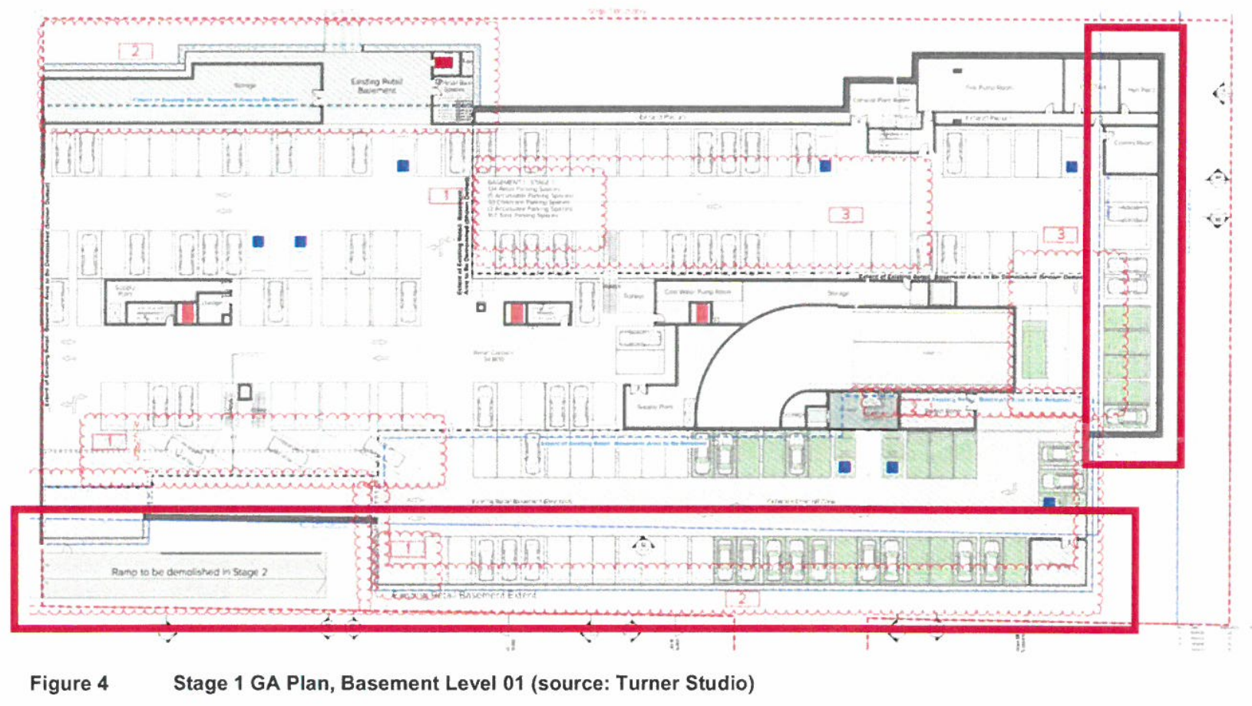
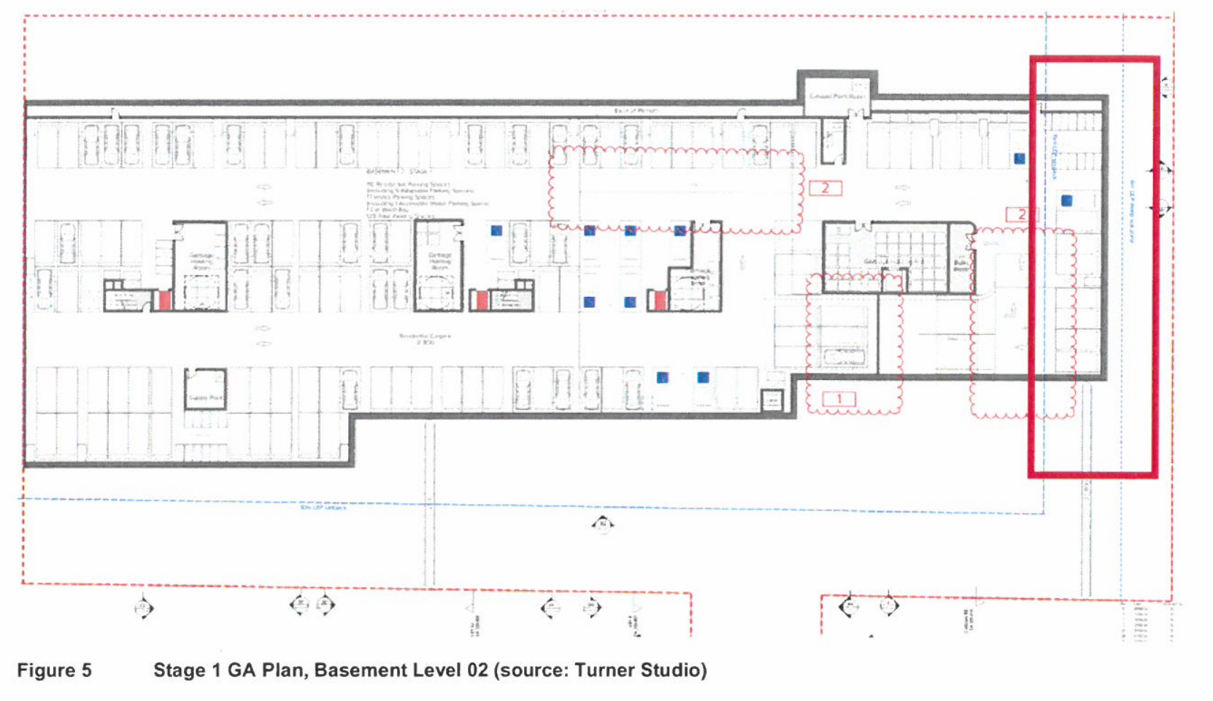
- The Request emphasises that the variations only relate to the basement levels. Above ground, the building are accepted to comply with the southern and eastern setback requirements cl 6.14(4)(c) and (d).

Southern setback
- A large portion of the existing basement structure is proposed to be retained as part of the Stage 1 DA works. Access to that basement is from the existing at-grade car park. The existing use for car parking and storage functions will continue.
- The encroachment of the existing basement level into the 10-metre setback varies between 6.4m and 7.6m. The basement level also encroaches into the setback at the southwestern corner between 2.8m and 2.9m (Fig 6). The encroachment results in a setback from the southern boundary that varies between 2.5m and 3.5m for the main basement structure and 7.2m for the southwestern variation.

Eastern setback
- The Stage 1 DA involves constructing a portion of Basement Level 01 and 02 into the 15m setback on the eastern part of the development. The encroachment is about 7.5m into the 15m setback (Figs 7 and 8). This encroachment does not affect the deep soil zone which runs north-south along the eastern boundary and has a width of 6m. The area of encroachment will be used as car parking for retail customers and childcare centre and plant on Basement Level 01 and car parking and storage for the residents of Stage 1 on Basement Level 02. The proposed eastern setback for both levels is 7.5m.
- Clause 6.14 does not specify any objectives, therefore the Request has inferred the objectives of the standard. The Request aligns the objectives with the objectives prescribed in cl 4.3 of LEP 2015 which deals with the maximum height of buildings. Table 1 assesses the development against the objectives in cl 4.3 and I accept that the assessment demonstrates that the proposed height of the Stage 1 DA achieves the inferred objectives of cl 6.14(4)(c) and (d) notwithstanding the non-compliances for the reasons stated in Table 1 (Request pp 16-18) as set out below:
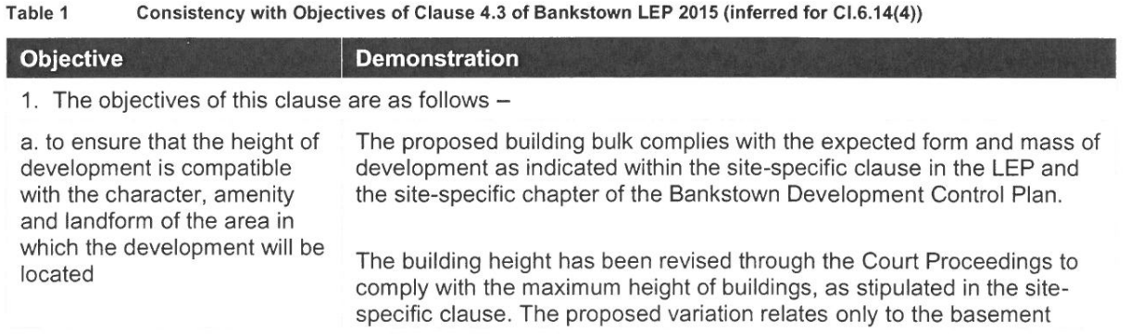
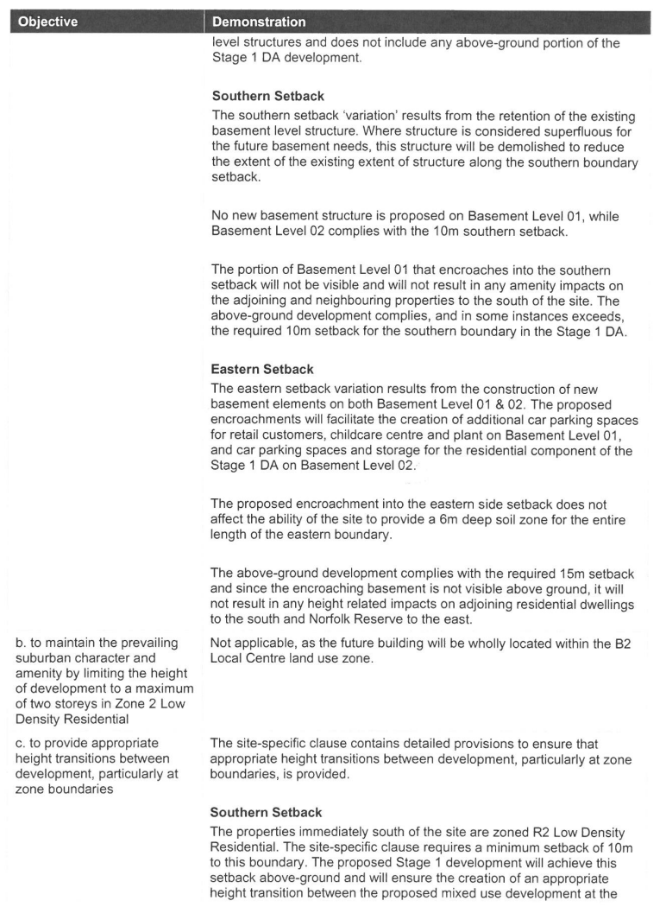
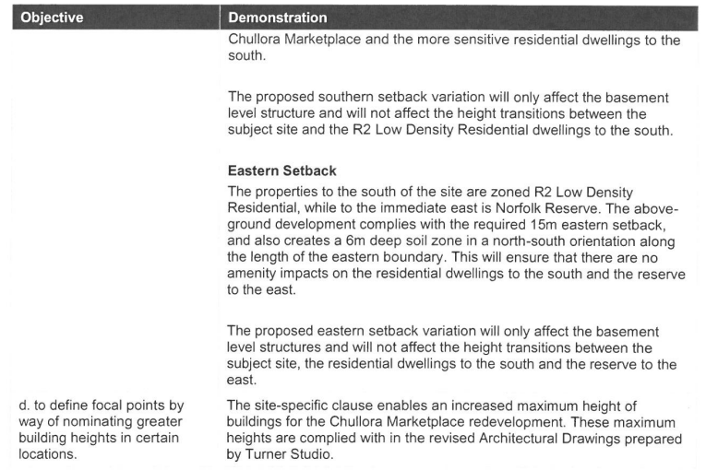
- Accordingly, as the inferred objectives are achieved in this case, I accept that compliance with the height of building development standard is demonstrated to be unreasonable and unnecessary in this case and cl 4.6(3)(a) is thereby satisfied: Wehbe v Pittwater Council (2007) 156 LGERA 446; [2007] NSWLEC 827 (Wehbe).
- The Request identifies that in the case of Initial Action Pty Ltd v Woollahra Municipal Council (2018) 236 LGERA 256; [2018] NSWLEC 118 at [118] Preston CJ observed that in order for there to be sufficient environmental planning grounds to justify a written request under cl 4.6 to contravene a development standard, the focus must be on the aspect or element of the development that contravenes the development standard, not on the development as a whole. Several environmental planning grounds are nominated in the Request to justify the departure from minimum building setbacks development standard in this case (p 20). They include:
- The noncompliance (aspect of the development) does not result in any identifiable adverse environmental impacts.
- The encroachments into the southern and eastern setbacks (aspects of the development) do not contribute any distinguishable bulk, scale or density as they are subterranean.
- The retention of the basement structure at Basement Level 01 is a sustainable response to demolishing a useful fit-for-purpose structure.
- The demolition of the existing basement structure and rebuilding it to comply with the southern setback requirements would not be a sustainable response to the redevelopment of the site.
- The extension of the basement levels toward the eastern side setback does not impact the provision of a 6m wide deep soil zone.
- Based on the above, I am satisfied that the Request has demonstrated that there are sufficient environmental planning grounds to justify contravening the development standard in this case: cl 4.6(3)(b). I am satisfied that the Request has adequately addressed the matters required to be demonstrated by subcl (3), and that the development will be in the public interest because it is consistent with the inferred objectives of the particular standard and the objectives of development within the for zone in which the development is proposed to be carried.
- In respect to the latter, I rely on the reasons set out in Table 2 (Request, p 21) which is reproduced below:
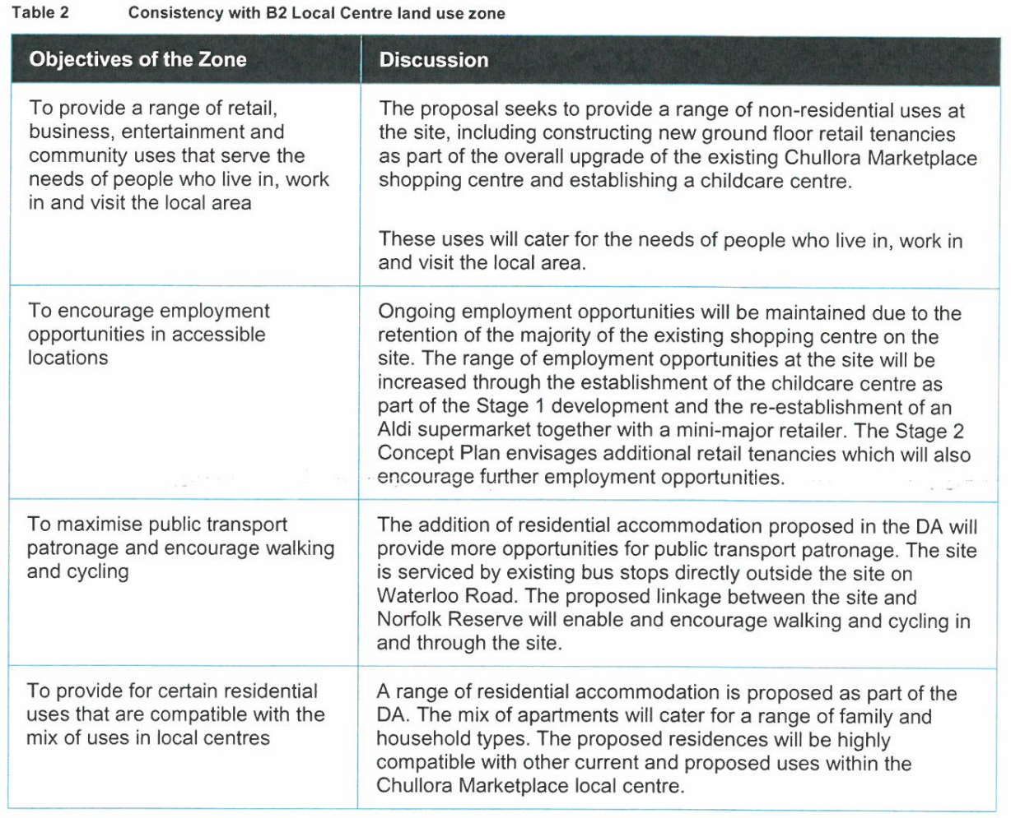
- As the development satisfies cl 4.6(4) and the Secretary’s concurrence to the variation as required under cl 4.6(5) can be assumed, I uphold the Request for variation of cl 6.14(4)(c) and (d) in this case.
- In forming that view, I have carefully considered the Council’s written and oral submissions and the planning evidence addressing the adequacy of the Request. In that regard, I do not accept the Council’s submission that the inferred objectives of the height control in cl 4.3 are irrelevant to the standard in cl 6.14 (4)(c) and(d) because the development standards in cl 6.14(4)(c) and (d) seek to vary the setbacks.
- Clause 6.14 is a site-specific clause that enables additional height at the site, subject to compliance with a series of requirements relevantly including setbacks. When read in context the development standards in cl 6.14(4)(c) and (d) sought to be varied concern setbacks for the purpose of an increase in building height. The request relies on the first test in Wehbe on the basis of the inferred objectives of the height control in cl 4.3 of LEP 2015. As I consider these objectives are relevant, the first test in Wehbe was available to Henroth to justify the variation of the standard. I reject the Council’s submission to the contrary.
- I also disagree with Ms Bartlett’s evidence, both oral and written (Ex 10), that the extent of the changes to the basements mean that they form part of the development and on that basis meet the definition of a “building” under LEP 2015 (Demolition plan - DA-051-001 Rev J (23.11.23)). Nor do I accept that the LEP and the DCP controls deliberately intended increased setbacks from the southern and eastern boundaries to include below and above ground development in order to manage, for example, the transition to surrounding land, including low density development through built form, deep soil planting and additional landscaping: cl 6.14(6)(e) (Ex 10 par 9(a)-(d)).
- The objectives of cl 4.6 are to provide an appropriate level of flexibility in applying a development standard to the development, to achieve better outcomes for and from the development. In this case, I am satisfied that the encroachment in the setbacks by the basements as proposed do just that – they achieve a better planning outcome for and from the development for the reasons outlined in the Request. The removal of parts of the existing basement to achieve compliance serves no useful positive planning purpose where appropriate deep soil planting and separation can be achieved irrespective of the breach and the buildings are otherwise compliant.

Clause 6.14(4) of LEP 2015 – Compliance
- Accordingly, for the above reasons I am satisfied of the matters in subcll 6.14(4)(a), (b), (c), (d), (e), (f) and (g) and note as the Council identified a site-specific DCP that specifies the matters in subcl (6).

Contention 8 – Childcare centres
- The planning experts agree that if Norfolk Lane is determined to be a road, it meets the definition of a cul-de-sac and its carriage way between kerbs can be less than 10m (Ex 10 par 28).
- They also agree that the design intent for vehicular access to the childcare centre is to be from Waterloo Road (Ex 10 par 27). This is evident by the car parking dedicated to the centre only being accessible from Waterloo Road.
- Clause 6.8 of the LEP 2015 provides:
Despite any other provision of this Plan, development consent must not be granted for the purpose of a centre-based child care facility on land if the vehicular access to that land is from—
(a) a classified road, or
(b) a cul-de-sac road or a road where the carriageway between kerbs is less than 10 metres.
- As Waterloo Road is neither a classified road or a cul-de-sac road - with a carriage way between kerbs of less than 10m, Mr Ryan said that cl 6.8 is complied with by this application.
- While Ms Bartlett expressed a concern about the use of 87 Norfolk Road for unauthorised childcare pick up and drop off in contravention of cl 6.8, she accepted that the imposition of a condition requiring signage or some other measure that prohibited vehicular access to the childcare centre from Norfolk Road would help resolve the issue.
- The Council has proposed such a condition, and it should be imposed.
- The Council has helpfully summarised in its CFWS that contentions 17, 18, 20, 22, 23, 26, 27 28 and 32 have been resolved by the Council’s proposed draft conditions of consent (forwarded to the Court on 28 June 2024).

Contentions 39 and 41 - Ecology issues
- The parties’ experts have agreed to amendments to the plans and documents to resolve this contention: Ex 18 at pp 3-4. Subject to those amendments, this contention is resolved.

Contentions 48 and 49 - Public submissions and Public interest
- Under s 4.15(1)(d) of the EPA Act, the Court is required to consider public submissions made in accordance with the EPA Act or the regulations in determining the DA.
- The public submissions in this case are included in the Council's List of Objectors (Ex 13). The Council submits that the DA should be refused having regard to those matters set out in those public submissions. In particular, the submissions made by residents of Norfolk Road (see Items 1c, d, e, g, i, I, m and n) concerning traffic impacts, and the suitability of 87 Norfolk Road as the driveway access to the development.
- Under s 4.15(1)(e) of the EPA Act, the Court is required to consider the public interest in determining the DA. The Council submits that the DA should be refused because the proposed development is not in the public interest having regard to the contentions in the SASOFC, and the matters raised in the public submissions.
- I have carefully considered the public submissions including those in relation to 87 Norfolk Road (SASOFC; Council bundle). I have also undertaken two site inspections - in the company of the parties, their lawyers, and the experts. These site and area inspections have allowed me to better understand the public submissions and the evidence more generally.
- As the planning evidence identifies, strict compliance with the DCP would result in small townhouses, which have limited setbacks with the residential properties on Norfolk Road. This proposal achieves greater separation between the existing low density residential properties on Norfolk Road and the mixed-use development adjoining. It will meaningfully transition the low density residential, by separating the high density residential flat buildings on the site to the single dwellings on Norfolk Road, and thereby generate a better amenity for both the existing residential properties along Norfolk Road and those proposed on the site.
- The development includes substantial landscape buffers, which will be managed and maintained by the shopping centre, and planted along the southern boundary adjoining the R2 Norfolk Road properties to achieve greater privacy for the existing residents.
- The above features of the design accord with the key design principle (g) of the DCP and have been included to minimise overlooking and overshadowing impacts; provide sufficient setbacks and landscape buffers where appropriate - address issues such as visual privacy, amenity and solar access to the surrounding properties and to protect the Norfolk Reserve.
- The acoustic experts have assessed the impact of the proposal on Norfolk Road against the NSW’s Environment Protection Authority’s Road Noise Policy (March 2011) and Development Near Rail Corridors and Busy Roads – Interim Guideline (2008) and has found it to meet the requirements. These experts are agreed that it is likely that the proposal will result in a lower acoustic impact from vehicle movements than what is existing for the following reasons:
- The existing car/heavy vehicle route is a path which wraps around the perimeter of the site, including the southern boundary adjacent to residents along Norfolk Road and connects to the wider retail car park. This includes a loading dock at approximately 15m setback and car parking spaces adjacent to the existing south boundary.
- The proposal will push all loading dock operations to a minimum of 30m setback from residences along Norfolk Road whilst providing additional shielding from the buildings. (Ex 3)
- I am satisfied that the proposal offers a more efficient and effective acoustic outcome by removing heavy vehicle and retail traffic from the southernmost part of the site.
- The evidence is that traffic from the Norfolk Road entry will be limited and has been assessed to be acceptable for the existing road network.
- While it is to be expected that the redevelopment of the site, especially during construction will be noisy, dusty, and inconvenient, the Council’s proposed conditions of consent will no doubt assist to manage those shorter-term negative impacts and any damage to adjoining properties during construction. That said, I accept that in the long term the amenity for many residents will be substantially improved by the design of the development. The improved acoustics, enhanced community spaces, landscaping and regeneration of the Norfolk Reserve are all positive outcomes of the approval of this DA which support a finding that the proposal is in the public interest.

Contention 50 - Economic impact of the DCP
- The Council contends that the DA should be refused because compliance with the DCP will not negatively affect retail uses on the site. It rejects Henroth’s economic evidence that Aldi cannot be provided in a compliant scheme in circumstances where that conclusion is based on evidence from the client (Henroth), and the client’s architect.
- The economic evidence referred to is Henroth’s report, “Review of Economic Effects of Alternative Redevelopment Scheme” prepared by Leyshon Consulting Pty Ltd dated February 2024 (Leyshon Report) submitted with the DA in support of the proposal. The stated purpose of the Leyshon Report is to “evaluate the economic implications of the proposed development compared with an alternative scheme of development which is fully ‘compliant’ with the Council's Development Control Plan (DCP) 2023 Structure Plan”: (Ex 12 at pp I and 1).
- The Leyshon Report identifies that the site contains 16,979m2 of occupied net leasable area (NLA) with three major national chain supermarkets, namely Woolworths (4,207m2), Coles (3,916m2) and Aldi (1,478m2): Ex 12 at p 2.
- In short, the Leyshon Report concludes that a “DCP compliant” scheme prepared by Turner Studio for Stages 1 and 2 (at Appendix B to the Leyshon Report) will result in “the inability to create a tenancy of a scale which would be viable as far as Aldi is concerned” due to a reduction in NLA of 1,965m2: Ex 12 at p 7. Aldi requires a minimum area of 1,400m2 and the “DCP compliant” scheme will “produce a maximum tenancy footprint approximately only 50% of the minimum required area”: Ex 12 at p 8.
- It is submitted that the loss of Aldi will “result in a number of significant negative outcomes”: Ex 12 at p 9.
- The Council objected to the Leyshon Report going into evidence because of relevance and it continues to agitate that point. It contends that reliance on the Report to justify a departure from the DCP based on a loss of competition in the shopping centre (Kentucky Fried Chicken Pty Ltd v Gantidis (1979) 140 CLR 675) and the identity of any user (Aldi) are not relevant considerations under s 4.15 of the EPA Act.
- The parties' town planning experts defer to the evidence of the economic experts as to whether the loss of a retail shop/precinct may have broader impacts and the extent of those impacts: Ex 12 at par 3. However, they disagree on whether Aldi can be retained or not.
- Ms Bartlett gave evidence that the non-residential floor space requirement in cl 6.14 of LEP 2015 acts as a minimum (rather than a maximum), and that there are alternative designs that would retain a functional Aldi in Stage 1 and provide a low-density interface with the R2 zoned land consistent with the ISP (i.e. Mr Smith at par 7 and Fig 1). She believes that Henroth has not demonstrated sufficiently that:
- the retention of Aldi cannot be delivered that complies with the new site-specific LEP and DCP requirements; or
- the requirement for Aldi would override the other planning, environmental and social objectives of the wider site-specific controls when assessing an application for the site's redevelopment.
- Whereas Mr Ryan gave evidence that the loss of Aldi in order to “strictly comply with the DCP would be contrary to” cl 6.14 of LEP 2015 and certain provisions of the DCP (Ex 12 par 14).
- Mr Ryan also takes issue with Mr Smith's Fig 7 alternative design. He said it does not “entirely comply” with the DCP in certain respects including road widths. And, based on advice from Henroth and its architect, Mr Ryan said that Mr Smith's alternative design “cannot be practically developed” because the new road would need to be constructed at the same time as Stage 1 in order for Aldi to have vehicular access from Waterloo Road: (Ex 12 pars 18-20). As such, he believes that this will cause disruption to existing car parking and could “potentially threaten” the continued operation of the existing centre: (Ex 12 pars 22-24). He believes that this will frustrate the stated key design principle of maintaining the ongoing viability of the centre during redevelopment and the existing operations.
- The economic experts found no point of agreement: (Ex 12 par 29). Mr Haratsis gave evidence that “…the Leyshon Report fails to assess the economic need for the Aldi on the site or that the existing centre requires three traditional supermarkets”: (Ex 12 pars 37-38) and also fails to “assess spend via a logical trade catchment to establish a need for an Aldi on the site in circumstances where there are seven existing supermarkets likely to compete with the existing centre (excluding 12 specialist Lebanese and Middle Eastern grocery stores)”: (Ex 12 pars 39-40). Mr Haratsis believes that if the Aldi was developed at a later stage, there would ultimately be no change in employment numbers: (Ex 12 par 41).
- Mr Leyshon accepted that the economic impacts in the Leyshon Report would be removed if Aldi is able to be retained in Stages 1 and 2 of the redevelopment: (Ex 12 par 48). However, he believes if Aldi were included in some future stage (e.g. Stages 3 or 4), the reduction from three to two supermarkets at the centre, for a considerable time during construction, would have a negative economic consequence for shoppers, tenants in the centre and Henroth: (Ex 12 par 49).
- While the “need” for Aldi within the Centre is not contested in the contention Mr Leyshon said its need is demonstrated by a range of factors: (Ex 12 pars 51-52). Therefore, the loss of Aldi in Stages 1 and 2 would in Mr Leyshon’s assessment result in the community losing a facility they currently value and would have significant and avoidable economic impacts: (Ex 12 par 54). The potential negative implications for the Chullora Marketplace generally, and its Aldi tenancy specifically are negative economic consequences for shoppers, other speciality tenants in the centre and the centre’s owners (Ex 12 p 10). As Mr Leyshon said, “It is an existing synergistic operation, and it should continue in that way”.
- Mr Ryan is of the opinion that the economic impact is entirely relevant in the determination of this DA. He said that the loss of Aldi – in order to strictly comply with the DCP would be contrary to cl 6.14 of LEP 2015. That is, cl 6.14 directs the creation of and the result of the DCP which in this case sponsors effectively the retention of as much of the shopping centre as possible. So, on that basis the economic evidence is entirely relevant.
- Whereas the Council contends that the economic impacts of the loss of Aldi is not a relevant consideration because that loss is entirely avoidable by a compliant development. And while not conceded, it ultimately submits any economic impact would be a direct result of the proposed development the subject of the DA (as opposed to a proposed development on other land).
- The Council also submits that Henroth has control over whether Aldi is put in jeopardy. And, to the extent that it is put in jeopardy in Stages 1 and 2, it could be made good by the proposed development the subject of the DA in later stages: Kentucky Fried Chicken Pty Ltd v Gantidis wherein the Court said that:
“if the shopping facilities presently enjoyed by a community or planned for it in the future are put in jeopardy by some proposed development, whether that jeopardy be due to physical or financial causes, and if the resultant community detriment will not be made good by the proposed development itself, that appears to me to be a consideration proper to be taken into account as a matter of town planning” (at 687 per Stephen J, with Gibbs, Mason and Aikin JJ agreeing).
- Ultimately, the Council contends that the economic issues raised in the Leyshon Report fall into the latter category in Randall Pty Ltd v Willoughby City Council (2005) 144 LGERA 119; [2005] NSWCA 205 at [39]. Therefore, when considering the scope of s 4.15(1)(b) of the EPA Act for that reason is not relevant to the determination of the DA.

Finding – Economic evidence is relevant
- The relevance of the economic evidence is made clear by Mr Ryan’s observation that the loss of the Aldi store, if the proposal were required to strictly comply with the DCP, would be contrary to cl 6.14 of LEP 2015.
- That is, to the extent that cl 6.14(6) of LEP 2015 directs the creation of and the result of the DCP, which sponsors effectively staged development “To ensure a viable ongoing operation of the existing shopping centre” (DCP, p 6), and heralds at p 5 “Retaining the existing commercial floor space in the future redevelopment of the Chullora Marketplace as important”, suggests that the economic evidence is entirely appropriate. As the maintenance of the shopping centre, clearly dovetails with the economic evidence. Moreover, the retention of Aldi demonstrates the consistency of the proposal with the DCP.
- Mr Haratsis' position, as expressed in Ex 12 par 37 is, effectively, that the Aldi can go and come back later but this does not make a lot of economic sense. It certainly does not make a lot of sense in terms of the “offer” to persons that are there, but, quite aside from that, it is in my assessment inconsistent with the sentiment that is expressed in the DCP. As Mr Smith, the Council’s expert, acknowledged in his design evidence – Henroth, or any developer of this site, is faced with commercial constraints to develop the site using complex staging in order to retain existing tenants operational and reduce impacts on the existing car parking during construction.
- To my thinking, that is exactly what the DCP prioritises in its stated key design principles, Staged development section of the DCP and the desired character for the Chullora Local Centre. There can be no criticism of Henroth’s decision to accommodate and prioritise that key DCP outcome by electing to start the works in the southeast corner and still offer a concept development that achieves primary access from Waterloo Road, facilitates better access to retail and a childcare centre, Civic plaza and complies with required setbacks where necessarily, and offers a design that has had the DCP key design principles and ISP as its focus.
- For these reasons, I accept that the need to design the proposal to accommodate Aldi in the early stage of the development is a relevant consideration under s 4.15(1)(b) of the EPA Act.

Contention 13 - Likely impacts of the development
- This contention is considered with contention 16.

Contention 16 - Non-compliance with the DCP

Council’s position
- The Council contends that the DA should be refused as it fails to comply with the requirements of Chapter 11.10 of the DCP. Chapter 11.10 is a site-specific development control plan that applies to 353-355 Waterloo Road (but not to 87 Norfolk Road).
- It submits that the relevant provisions of the DCP must be approached in accordance with the following principles.
“The provisions of a development control plan need to be taken into consideration, in determining a development application, as a ‘fundamental element’ in or a ‘focal point’ of the decision-making process: Zhang v Canterbury City Council (2001) 115 LGERA 373; [2001] NSWCA 167 (Zhang) at [75] and [771 per Spigelman CJ (with Meagher and Beazley JJA agreeing); Tomasic v Port Stephens Council [2021] NSWLEC 56 (Tomasic) at [34] per Preston CJ. A provision of a development control plan that is ‘directly pertinent’ to the development and the development application is entitled to ‘significant weight’ in the decision-making process, although it is not determinative: Zhang at [75]; Tomasic at [34].
Secondly, other factors will also increase the weight to be given to a development control as set out in Stockland Development Pty Ltd v Manly Council (2004) 136 LGERA 254; [2004] NSWLEC 472 at [87] including:
‘Consistency of decision-making must be a fundamental objective of those who make administrative decisions. That objective is assisted by the adoption of development control plans and the making of decisions in individual cases which are consistent with them. If this is done, those with an interest in the site under consideration or who may be affected by any development of it have an opportunity to make decisions in relation to their own property which is informed by an appreciation of the likely future development of nearby property.’”
- The Council submits that this is particularly important in the present case given that the Court's decision will be the first application of Chapter 11.10 of the DCP. If the provisions of the DCP are not correctly applied, there is the potential for its desired character and outcomes to be destroyed by the approval of the DA because there will not be an opportunity to correct any mistakes in the future and it may set a precedent for the determination of future applications relating to 353-355 Waterloo Road.
- Although the Council accepts that alternative solutions to achieve the objects of the provisions under s 4.15(3A)(b) of the EPA Act can be accommodated: Tomasic at [36]. It emphasises the following observations in Saffioti v Kiama Municipal Council [2019] NSWLEC 57:
“27 ….The ‘reasonable alternative solutions’ referred to in s 4.15(3A)(b) of the EPA Act are alternative solutions embodied in the development that is the subject of the development application. The development might not comply with certain of the standards set by the provisions of a development control plan with respect to aspects of the development but nevertheless the development might provide an alternative solution that does achieve the objects of those standards. If so, the consent authority is directed by s 4.15(3A) ‘to be flexible in applying those provisions and allow reasonable alternative solutions that achieve the objects of those standards for dealing with that aspect of the development’.
28 The onus is on the applicant for development consent to proffer, in the development application for the development, the alternative solutions that achieve the objects of the standards for dealing with the relevant aspects of the development. The consent authority can then evaluate whether the proffered alternative solutions are ‘reasonable alternative solutions’ that do ‘achieve the objects of those standards for dealing with that aspect of the development’.”
(Emphasis added)
- With these principles in mind, the Council highlights the following key provisions of Chapter 11.10 of the DCP:
- Desired character for the Chullora Local Centre:
- “Council's Local Strategic Planning Statement ‘Connective City 2036’ envisages centres like Chullora Marketplace as being ‘hubs of community life, with high quality public, civic and community spaces and places. They are places designed for pedestrians’” (p 4).
- “The new internal street network must be permeable, legible and provide 24-hour safe access to pedestrians and cyclists via inclusion of shared paths” (p 4).
- “WelI-designed terrace houses, shop top housing, residential flat buildings and mixed-use buildings with pedestrian-orientated streets and civic places will enhance the vitality and attractiveness of the local centre” (p 5).
- “New development will exhibit design excellence, provide appropriate articulation and architectural styles to add visual interest and avoid large blank walls along public domain” (p 5).
- Staged development:
- “To ensure a viable ongoing operation of the existing shopping centre, the future development of the site may be undertaken progressively and incrementally, consistent with an indicative concept plan (applying to the whole site) which is required to be lodged with Council at the lodgement of the first development application” (p 6). The “site” is 353-355 Waterloo Road (and does not include 87 Norfolk Road).
- Key design principles and ISP:
- “Deliver a Central Civic Plaza as a community hub ... The Central Civic Plaza must have active uses to at least two of its sides and linked to its surrounding with a network of pedestrian friendly internal streets” (p 6).
- “Create a vibrant local centre which protects and enhances existing commercial floor space: ... Retail and commercial use will continue to remain as the key land use of the local centre, having regard to the objectives of Zone B2 Local Centre” (p 6).
- “Improve permeability and access: Introduce a legible and permeable pattern of new streets which are publicly accessible 24 hours a day and responds to key connections within and adjacent neighbourhoods. All internal streets must consist of shared paths to prioritise access to pedestrians and cyclists” (p 7).
- “Primary retail and service access from Waterloo Road: Ensure the retail, service vehicles and residential vehicle accesses the site from Waterloo Road. The proposed access is to be highly legible, minimise traffic congestion and vehicle/pedestrian conflict. Major retail parking and servicing should not be provided from the Hight Street or adjacent to active retail frontages” (p 7).
- The ISP (Fig 2) shows (p 8):
- “Primary street connection (two-way)” running from Waterloo Road to the eastern boundary of 355 Waterloo Road, presumably being a cul­de-sac.
- To the south of the new connector road is “Low-density residential”.
- To the north of the new connector road around the middle is the “Indicative location for Civic Space”. The Civic Space is shown with “Activated frontages” to its west and east, a new “High-Street with active ground floor uses (one-way share way)” to its north, and the new connector road to its south.
- A number of “Pedestrian links” and “Potential future pedestrian link” within 353-355 Waterloo Road.
- A 10m setback from the southern boundary and a 15m from the eastern boundary.
- Section 2 - Central Civic Plaza and publicly accessible open spaces:
- The new Central Civic Plaza must have a minimum area of 950m2 and a minimum width of 25m, and be activated with retail uses on at least two sides, overlooking and facing the open space (Control 2.2, p 9).
- Section 3 - Access and movement:
- “New streets must be highly legible, permeable and publicly accessible 24 hours a day. New streets must respond to key connections within and adjacent neighbourhood. All internal streets must consist of shared paths to prioritise access to pedestrians and cyclists” (Control 3.2, p 11).
- “New streets and connections should generally be in accordance with the key design principles and indicative structure plan outlined in Section 1 and the typical street sections outlined in Fig 3. Provide new publicly accessible streets and pedestrian connections including:
- Minimum 20m wide internal streets for vehicles (two-way traffic)
- Minimum 15m wide internal streets for vehicles (one-way traffic)
- Minimum 12m wide for pedestrian only links” (Control 3.3, p 12).
- Figure 3 shows the typical street sections for residential and shop top housing streets measuring 20m wide (p 13).
- Section 4 - Land use and site layout:
- “Land use shall be designed and located in accordance with the indicative structure plan and key design principles” (Control 4.1, p 15).
- “Buildings which interface with low density properties to the south must be designed to:
- Maximise street activity through front gardens, terraces and the façade of the building.
- Be directly accessible from the new internal street.
- Minimise overlooking into the private open space of adjoining residential properties to the south” (Control 4.5, p 15).
- Section 5 - Built form:
- “A 10m minimum setback shall be provided to the rear boundary of properties facing Norfolk Road and to the northern side of 351 Waterloo Road” (Control 5.5, p 18).
- “Development must incorporate a minimum setback (buffer zone) of 15m along the eastern boundary of the site. Within this setback, a minimum 6m wide deep soil zone is required along the reserve” (Control 5.9, p 18).
- Section 8 - Landscaping and public domain:
- “Provide a green corridor through the site from Norfolk Reserve to Waterloo Road including substantial planted trees over 5m in mature height. This can be provided through street planting” (Control 8.1, p 22).
- It submits that it is clear from the above provisions of Chapter 11.10 of the DCP that the key outcomes envisaged by the controls are:
- A 950m2 Central Civic Plaza that has active uses on two sides and linked to its surrounding with a network of pedestrian friendly internal and publicly accessible streets.
- A 20m new connector two-way road from Waterloo Road to the eastern boundary of 355 Waterloo Road that provides a green corridor to and from Norfolk Reserve. That road should generally be in accordance with the key design principles and ISP.
- Low-density residential to the south of the new connector road to provide a suitable interface with the existing residential properties on Norfolk Road. That land use must be designed and located in accordance with the ISP and key design principles - cl 4.1. In this regard, the flexible approach that may be taken to the new connector road is not carried through to the design and location of land uses.
- A new internal street network that is permeable, legible and provide 24-hour safe priority access to pedestrians and cyclists via inclusion of shared paths.
- The Council contends that the proposed development for Stage 1 DA ignores those key outcomes, and this will undoubtedly have flow-on effects for future development on the site. It relies on the evidence of Mr Smith and Ms Bartlett as to the scope of the non-compliances with the DCP, and the consequences of those non-compliances: Ex 11 at pars 12-19 (Mr Smith's evidence) and 41-49 (Ms Bartlett's evidence) respectively.
- In particular, based on the urban design evidence of Mr Smith, the Council submit that the DA fails to provide:
- a connector road or street between Waterloo Road and the Norfolk Reserve, being one which:
- is “highly legible, permeable and publicly accessible 24 hours a day”,
- “consists of shared paths to prioritise access to pedestrians and cyclists”,
- “generally … in accordance with the key design principles and indicative structure plan”,
- residential vehicular access from Waterloo Road, and
- provides “a green corridor through the site from Norfolk Reserve to Waterloo Road”.
- Low density residential to the south of that new connector road, to interface with the R2 zoned properties, as shown in light blue on the ISP.
- Land use designed and located “in accordance with the indicative structure plan and key design principles”.
- The Council invites me to take into account the concessions made by Mr Ryan during cross-examination where he accepted:
- Clause 4.3 sets a height limit for 353-355 Waterloo Road of 11m.
- The (curious) effect of cl 6.14 of LEP 2015 is to increase the height limit of Lot 41 (i.e. 355 Waterloo Road) to 20m, however restrict the height limit along the southern boundary to 9m (i.e. lower than the cl 4.3 height limit of 11m) if the building is within 30.5m of that boundary. The effect of the reduction in height is that there will be less density and GFA/FSR.
- The light blue area on the ISP corresponds with the 9m height limit control for 355 Waterloo Road, which gives effect to the structure of LEP 2015.
- The light blue area provides less density in the 30.5m setback.
- The DCP expects built form in the proposed 30.5 m buffer and the proposed development is “manifestly different” to that expectation. The proposed development will result in a “public” interface (i.e. those using Norfolk Lane for access) with the backyards of the properties in Norfolk Road adjoining the site to the south rather than a private interface created by backyards to townhouses in the southern part of the site. However, Mr Ryan considered that the proposed development was better or at least equivalent in terms of planning outcome. Ms Bartlett strongly disagreed with this evidence.
- Future residents of the residential flat building proposed as part of the Stage 1 DA will get access to Waterloo Road via a basement as part of Stage 2 which will not be 24-hour public access as envisaged by the DCP.
- The Stage 1 DA is not proposing access off Waterloo Road for residents of the residential flat building proposed as part of the Stage 1 DA as envisaged by the DCP.
- The DCP does not contemplate access from Norfolk Road at all.
- Variations to the DCP are required because the proposed development does not provide low-density residential in the light blue area on the ISP or access to that area via Waterloo Road.
- The only vehicular connectivity provided as part of Stage 1 is through Norfolk Lane and the only pedestrian connectivity provided as part of Stage 1 is through to Norfolk Reserve. The connectivity cannot be extended further west as part of Stage 1 because of a 3m drop so the existing ramp is the option for pedestrians. (taken from CFWS)
- The Council refers to Mr Carter’s cross-examination, where he agreed:
- Figure 1 in the Urban Design JER (Ex 9) is agreed to be an optimal outcome which involves an additional property owned by Henroth.
- Figure 3 is an illustration prepared by Mr Smith which would allow for Aldi to remain in the Centre as part of Stage 1 and will have a road connecting to Waterloo Road as envisaged in the DCP.
- It is possible for the townhouses shown in Fig 3 around the location of the existing ramp to be staged so that they are constructed later to enable the ramp to remain in place until it is no longer required (noting that Mr Carter does not have construction expertise). While this may come at a cost, it was accepted that it would allow for the retention of Aldi. To this end, Mr Smith's and Ms Barlett's evidence was that the new connector road could be constructed as part of Stage 1 which would ameliorate any issue relating to the loss of parking during construction.
- Figure 3 is consistent with the ISP other than the width of the road which has been reduced from 20m to 15m but this was not how Henroth's architect designed the proposed development to meet the requirements of the DCP.
- All of the matters listed at par 39 of the Urban Design JER relating to the proposed Norfolk Lane would equally apply to the road shown in Fig 3 prepared by Mr Smith.
- In respect of Stage 2, the urban design experts agreed to the changes shown in Fig 7 of the Urban Design JER. Those changes were not incorporated into the amended architectural plans before the Court. Although it may be possible to condition these changes, Mr Smith said it would be preferrable to have amended plans for certainty because further development applications will need to be consistent with any approved concept plan.
- For the above reasons, the Council submitted that the DA should be refused due to its fundamental non-compliance and inconsistency with the standards and objectives of the DCP. It contends that the DCP has only been recently made and has an interrelationship with cll 4.3 and 6.14 of LEP 2015. It submitted that the DCP must be given significant weight and, due to the departures envisaged by the DA, the DA should be refused as other compliant options are available, without proper justification for the departures.
- Finally, the Council submits that the Court should reject the DA because Henroth has chosen the south-eastern corner of the site to commence its work based on a commercial imperative which is untenable given Mr Smith’s alternatives would balance the commercial constraints and urban design opportunities in accord with the DCP (Ex 9 par 12).

Henroth’s position
- While Mr Carter agreed in cross-examination with Mr Smith that the ISP in the DCP could be achieved by alternate designs, Mr Carter’s evidence is that he prefers the design before the Court including:
(a) a connection to Norfolk Road for Norfolk Lane as proposed,
(b) the western extension of Norfolk Lane along the face of the apartments of Stage 1, culminating in a turning head (roundabout), and
(c) the carpark entry & exit portal/ramp for basement carparking for the apartments.
- The proposal in his view offers a staged plan that manages the complexities of delivering the plan over four stages. In the joint report, Mr Carter expresses the view that:
“The definition of the public and private domain is generally skilfully managed when considering the complexity of the staging requirements of unlocking the site, minimising disruption, maintaining the shopping centre trade and associated loading and carparking while delivering quality housing” (Ex 11 par 21).
- In acknowledging that these sites are rarely “ideal” because the starting point is always what is existing and remains and continues to trade, Mr Carter said that ultimately “…the character will be significantly improved and defined as each stage is delivered, achieving the overarching vision for the site”. He describes the proposed change to the ISP as conceptionally minor, as can be seen from the small difference in graphical description of the plan (Fig 6 compared to Fig 1 in Ex 11).
- Mr Carter emphasised in his evidence that the ISP is just that an ‘indicative’ plan, and that meaning is supported by it being included in the DCP which although a focal point is a flexible guide for the development of this site. Despite its legal status, Mr Carter gave evidence that the proposal closely aligns with the ISP. He identified that the ISP envisaged a road to service (and address) the apartments to Stage 1 – a road that would require a turning head, as it only had one entry point and exit. And, as he identified in his evidence that is exactly what has been proposed albeit delivered from Norfolk Road not Waterloo Road. A road with a roundabout that makes sure the residential entries and childcare remain separate and distinct from the shopping centre traffic. A road consistent with the ISP offering the following benefits:
“a. consistency with the original Indicative Structure Plan (Figure 2.)
b. providing useful short-term parking for visitors to these homes,
c. a shared-way that allows for pedestrians, bicycles, etc., as well as car movements at slow speeds,
d. passive surveillance and safety (CPTED) by increasing activity and interaction.
e. easy and functional access for emergency vehicles to all residential entries and addresses (ie: fire trucks, ambulances, police vehicles).
f. a significant setback buffer between the rear fences of the adjoining Norfolk properties and the Terraces in the R2 zoned land of the proposal. This provides a satisfactory transition, meeting the spirt of the DCP and complying with the height controls.
g. …
h. a landscape screen between the shared-way and the rear fence of the existing neighbours (to the south). Which is a welcome green-screen interface between the existing and proposed. It also helps deal with level changes and privacy.” (Ex 9 par 39 a-f, h)
- In supporting the western extension of the Norfolk Road along the face of the apartments culminating in a roundabout, Mr Carter believes that it provides “…the apartments with a logical and easy to understand residential address” which “…makes simple everyday living events like pizza delivery, food and parcel deliveries and uber and taxi pickups and drop-offs easy and legible”. An outcome which Mr Carter described as a better urban design outcome (Ex 11 par 28). An outcome that is consistent with the original ISP (DCP Fig 2). Whereas he described the urban design outcome (Fig 5, Ex 9), the sketch that deleted Norfolk Road extension, as “not the best urban design outcome for this proposal” - for the reasons identified at pars 21-32 in Ex 11.
- The DCP states that new streets and connections should generally be in accordance with the key design principles and ISP outlined in Section 1 and the typical street sections outlined in Fig 3. With that in mind, Henroth contends that the Norfolk Road alternative access while not anticipated by the DCP still achieves the key objectives and provisions of the DCP in respect to the desired future character of the Chullora Local Centre, the staging of the works to ensure the ongoing viability of the centre and the other stated relevant stated key design principles as reflected in the ISP. In making that submission, Henroth refers to the note on the ISP that qualifies the indicative design by acknowledging that: “the details of internal traffic movements are to be confirmed at the detailed design stage and consultation with Transport for NSW and Council”.
- As the original SEE records, Henroth points out that the application went through a lengthy pre-DA consultation before its submission. This included the submission of written legal advice about the legality of the proposed Norfolk Road access. The application was referred and considered by TfNSW and TFNSW’s comments informed the Council’s draft conditions. Relevantly, there is no evidence of opposition to the proposed new road by TfNSW.
- Although some proposed streets are not exactly as described in the DCP, Henroth submits that the primary vehicular access to the site will be from Waterloo Road consistent with the DCP key design principles. Servicing will be undertaken from the northern-most access point, which enables the most direct route around the northern boundary to the eastern boundary to access the loading and servicing areas for the retail tenancies in the shopping centre. The existing Waterloo Road access point, adjacent to the roundabout, and the proposed new access point at the south-western corner of the site, will facilitate access to the retail, childcare centre and residential (in Stages 2-4) and parking facilities. The proposed Norfolk Road access point will only allow access to parking allocated for the residential uses in Stages 1 and 2.
- Henroth maintains that the amended scheme clarifies the access arrangements around the overall site, to ensure that the proposed internal roads and car park entrances are legible, resulting in a reduction of traffic congestion and vehicle/pedestrian conflict. It submits that the new road will provide a key connection and shared access for pedestrians and cyclists from Norfolk Road and Norfolk Reserve.
- The amount of traffic associated with the residential component of Stages 1 and 2 is accepted to be minor and will not unreasonably impact the traffic conditions on Norfolk Road or the wider road network (Traffic report accompanying the DA (Appendix H)). The entry to the Basement Level 02 car park will be secured and will not allow entry for public parking. The commercial and childcare parking spaces will be located on Basement Level 01 and this level of car parking will only be accessed via the existing basement level in the centre of the site. The amended landscaping will provide a visual and acoustic buffer for the existing residential dwellings fronting Norfolk Road. Albeit, no amenity contention has been raised by the Council with respect to the new road separate from the public submissions which I have addressed.
- Henroth emphasises that the DCP states that the key design principles and the ISP are an indictive guide to any future development applications for the site. They are “indicative” not “prescriptive”.
- While acknowledging that the DCP provisions are fundamental elements and focal points in the decision-making process: Zhang, Henroth submits there may be alternative solutions to achieve the objects of the provisions pursuant to s 4.15(3A)(b) of the EPA Act. It contends that it has simply taken up that opportunity and lodged a DA which offers a reasonable alternative design to that set out in the DCP yet still achieving the objects of the provisions. Subsection (3A) provides:
(3A) Development control plans If a development control plan contains provisions that relate to the development that is the subject of a development application, the consent authority—
(a) if those provisions set standards with respect to an aspect of the development and the development application complies with those standards—is not to require more onerous standards with respect to that aspect of the development, and
(b) if those provisions set standards with respect to an aspect of the development and the development application does not comply with those standards—is to be flexible in applying those provisions and allow reasonable alternative solutions that achieve the objects of those standards for dealing with that aspect of the development, and
(c) may consider those provisions only in connection with the assessment of that development application.
In this subsection, standards include performance criteria.
- Henroth rejects any claim that an approval of this DA will set an undesirable precedent for future development because Chapter 11.10 is relevant only to this site. Moreover, this application is only dealing with a particular portion of the site described as Stages 1 and 2. Therefore, the subsequent Stages 3 and 4 are not set in stone by a decision in this case; especially when the DCP expressly acknowledges that the Concept Plan can be revisited and amended at each stage by the Council, where necessary to achieve consistency with the desired future character and the key design principles of the DCP in Chapter 11.
- As the ramp to the existing car park has now been retained in the latest plans, Henroth submits that the opportunities going forward are not fixed. It is no longer a road to nowhere, as Council submitted, ending in Stage 1 with a 3-metre drop or in a cul-de-sac in Stage 2. Relying on Figs 3, 4 and 5 in Ex 9 being Mr Smith’s interpretation either of the DCP or modifications that he contemplates are within the scope of the DCP (Tcpt, 19 June 2024, pp 121(28)-138(9)), Henroth submits that Fig 3 is just as much a road to nowhere as it comes off Waterloo Road and requires a U-turn at the end near the reserve to go back out. And, while the Council can argue that Fig 4 is also a road that goes nowhere – it submits that the Norfolk Road is permissible albeit not what the DCP anticipated. The same can be said, for Fig 5 which has no vehicular access; it provides for access off Waterloo Road and into a basement car park that leads to nowhere except that the ISP has an arrow that goes all the way out to the eastern boundary with the Norfolk Reserve, but that arrow does not appear to connect to any road. The only connection offsite, based on the ISP for the road, is a pedestrian access.
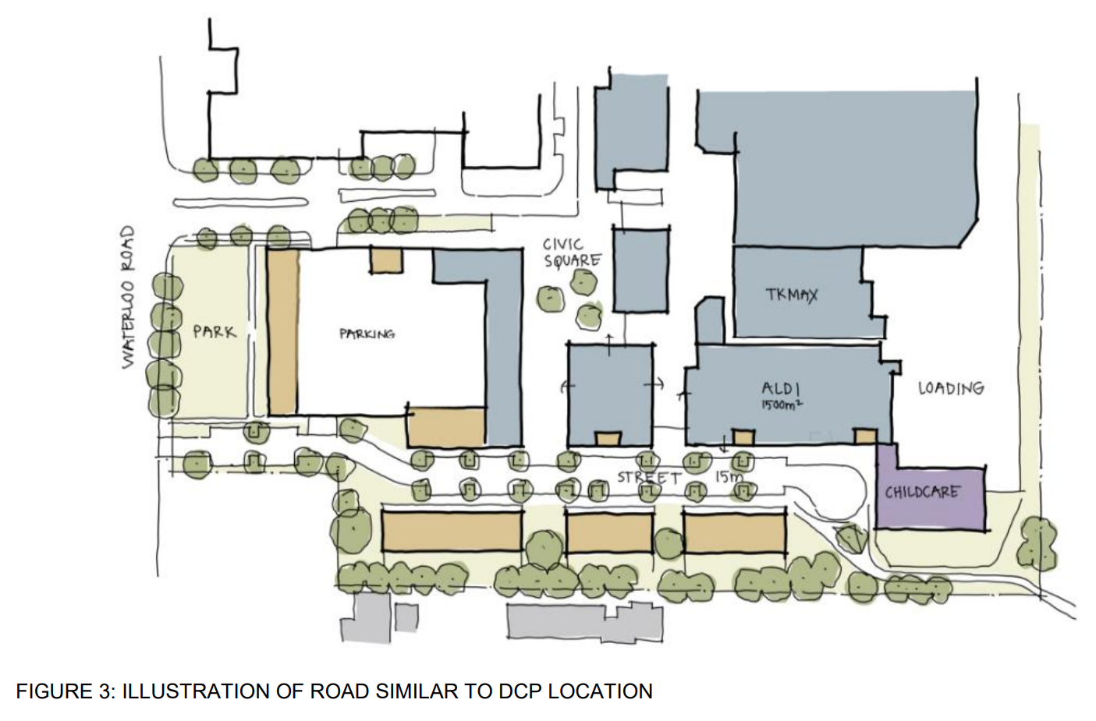
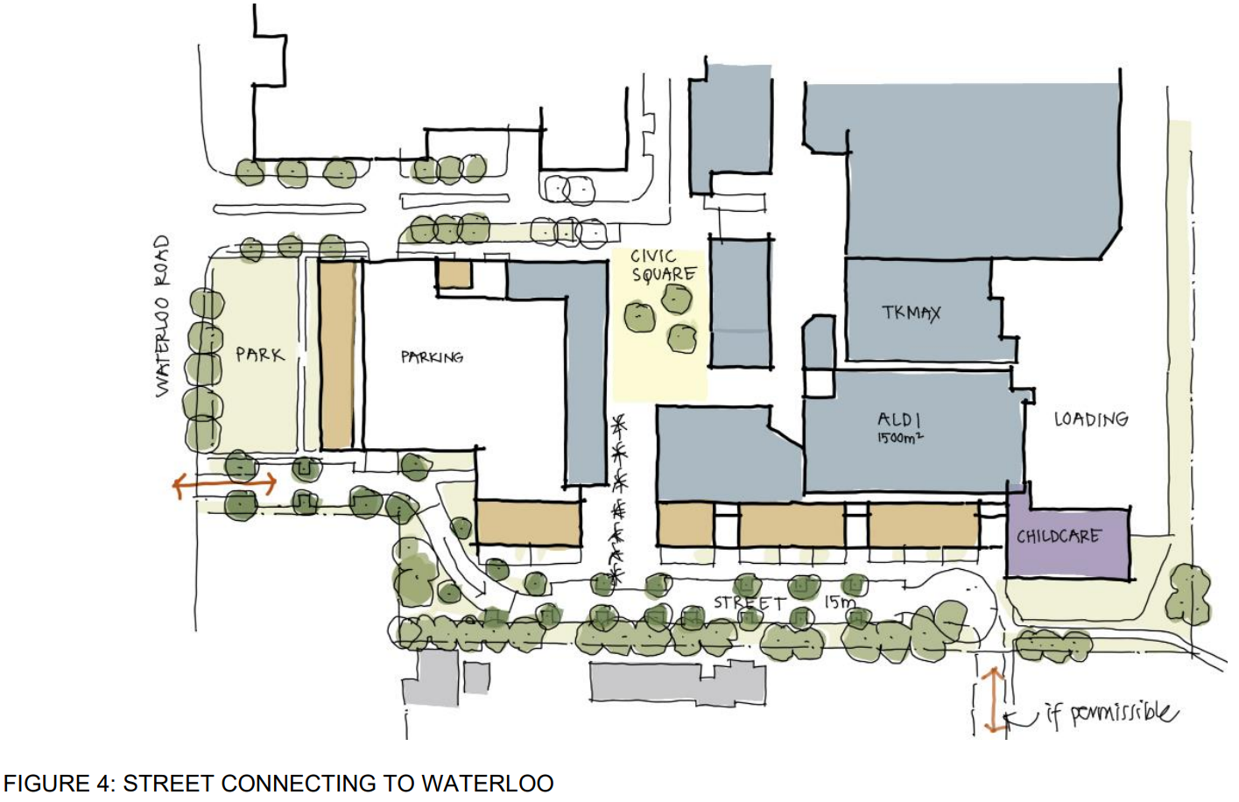
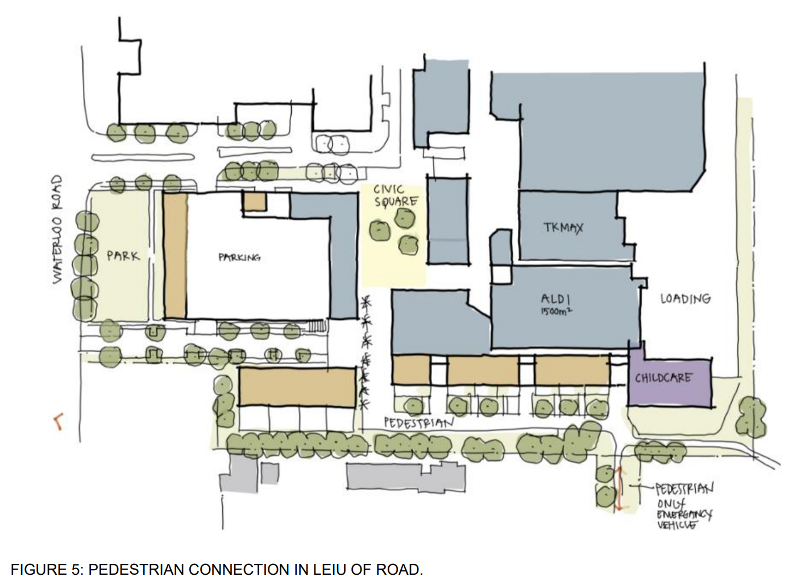
- Therefore, when considering the concept of permeability in the DCP it is not only motor vehicle permeability but pedestrian that is identified: Key design principle (c) in the ISP.
- The proposed design is said to have a permeable pattern of new streets, which are publicly accessible and appropriately respond to key connections within the site and the adjacent neighbourhoods. Henroth emphasises that all internal streets consist of shared paths to prioritise pedestrians and cyclists not vehicles. Through the ground floor plan pedestrians can permeate to and from the Civic Plaza which also feeds pedestrian access into the southern portion of the site and out to and into Norfolk Reserve. As such, that is entirely consistent with the DCP key design principle requiring permeability.
- Henroth submits that the fact that the public do not have access to the basement car park from Norfolk Lane and will need to do a U-turn to leave, does not mean the development is not legible. Nor does that feature mean that pedestrians and cyclists are not prioritised.
- It is submitted that the residential parking from Norfolk Road under the building is exactly what the ISP suggests. Albeit, it refers to the dotted line in/ off Waterloo Road over an area in the southwestern portion – going under a grey area that is an indicative building. As such, the separation of the proposed residential users from the other users is, as Mr Ryan identifies in the Amended SEE (Ex D), an improved amenity for those residents consistent with the DCP and exactly what s 4.15 (3A) of the EPA Act commands, improved outcomes in relation to what is contemplated in the ISP, and in terms of separation and the like. Ultimately, Henroth submits that all the elements said to be missing from the proposal - as identified in the Council’s submissions at par 141, are in fact satisfied by the amended application. Henroth’s Addendum SEE considers the amended DA against each of the provisions of the DCP and finds it consistent with key design principles and priorities and the ISP (Ex D Tab 6).
- Henroth contends that Section 3.3 of the DCP is an example of a “non-prescriptive indicator in the DCP”. The section states that “New streets and connections should generally be in accordance with key design principles and indicative structure plan outlined in section 1 and the typical street sections outlined in Figure 3”. In that regard, it submits that the development will:
- minimise overshadowing and visual impacts to adjoining properties (Key design principle (g)).
- provides passive surveillance over Norfolk Park and along Waterloo Road;
- insofar as the southern precinct is concerned Henroth contends that the land use has been designed and located in accordance with the ISP which has the shaded zone of lower density development without any specification of where it is to go;
- ground level non-residential use is located on ground level around the Central Civic Plaza; and
- a childcare centre and community facilities are located in areas where they will assist in activating the public domain entirely consistent with Section 4.3 of the DCP;
- taller buildings up to six storeys have been located in the centre of the site in accord with the DCP with a transition to four storeys along Waterloo Road and the Norfolk Reserve boundary; and
- two-storey townhouses are to be located adjacent to the southern boundary at more than the 10m setback in the ISP, with front gardens terraces aimed at maximising street activity.
- While Henroth declined to make the suggested change to “close the gap”, the mall entry from Norfolk Lane, as supported by the urban design experts (Mr Carter and Mr Smith) at this Stage it submits that the opportunity to reconsider this will be available at the Stage 2 DA stage. Henroth has proposed a condition of consent to address this and I will deal with this later when considering conditions.
- In respect of Stage 2, the urban design experts have agreed to the changes shown in Fig 7 of the Urban Design JER and it is appropriate that they be implemented.
- Henroth contends that a key driver of the proposed design response, and justification for any alternative solutions to strict compliance with the DCP has been the need for staged development that ensures the ongoing viable operation of the shopping centre, which is a key design principle of the site-specific DCP. It contends that the amended DA incorporates the key components of the relevant controls and policies and has been designed to change the current centre into a vibrant multi-use, people focused, town centre.
- Henroth emphasises that the development includes the concept for a high-quality shop top housing development “sleeving” the existing Chullora Marketplace building (which will remain operational throughout) and offers an improved public domain within the site to encourage community activities, active transport, and ongoing passive surveillance within the proposed public domain. These features, and other public benefits, are also encapsulated in the VPA prepared in conjunction with the PP, executed by both parties on 26 March 2022 - in accordance with s 7.4 of the EPA Act (Ex 14 (Council bundle) Vol 4 Item 17).

Findings – Consistency with the DCP
- The Council’s DCP states that the ISP and the key design principles and priorities are to guide any future development application for the site. Furthermore, as the urban design experts agree, the DCP ISP includes the notation that “the details of internal traffic movements are to be confirmed at that detailed design stage with consultation with Transport for NSW and Council”. I am not aware of any objection by Transport after referral of the DA to the proposed access of Norfolk Road or any other aspect of the proposal.
- The urban design experts also agree that the DCP states expressly that “Council may consider amendments to the ISP (applying to the whole site) at each stage where required consistent with the desired character and key design principles for the centre”. Consequently, the experts agree that strict compliance with the DCP is not and cannot be required under the Act where “Alternative solutions that achieve the objects of those standards for dealing with that aspect of the development are demonstrated”.
- The purpose and status of a DCP is prescribed in the EPA Act, and s 4.15(3A) states that where a development does not comply with the standards in the DCP the consent authority “is to be flexible in applying those provisions and allow reasonable alternative solutions that achieve the objects of the standards for dealing with that aspect of the development”. Section 3.42 also states that DCPs are not statutory instruments and that they should facilitate permissible development.
- The urban design experts agree that the architect of the proposal (Turner Studio) has a proven record of being capable of achieving design excellence (Ex 11 par 6). To that end, they also agree that the proposed strategy is a sensible way of providing meaningful quality housing co-located with the amenity of a shopping centre – like a local town centre. It is also agreed that “the over-arching strategy is a good and sensible approach to sites like these and should be encouraged and supported to help solve the housing crisis and poor urban design”.
- Furthermore, they accept that the commercial viability needs to be maintained, as it is integral to the vitality of the project.
- The experts state in the joint report that “Critical to that commercial vitality of the project are:
- That the shopping centre continues to trade with minimum disruption, which means the major retail outlets like Coles and Woolworths largely remain unaffected in their trade for as long as possible as they are highly used and valued, have long-term leases and critical carparking requirements as part of their leasing conditions.
- That carparking be optimised only for the duration of the construction, but for the proposal in general. Chullora Marketplace is not close to train station and is predominantly serviced by car. The shopping centre is therefore car dependant, making car parking and car parking spots critical.
- Mr Carter and Mr Smith have assessed that the proposal as satisfying the key SEPP 65/ADG criteria, and specifically the key (but not limited too) amenity criteria of solar access, cross ventilation, separation distances, privacy, and communal open spaces, except where changes are noted in their joint report (Ex 9, par 53) in respect to improvements to the ADG response. These changes are identified in more detail in their reports but in general terms include the removal of the midpoint access to the shopping centre; the reorganisation of the Mini Major and retail tenancy spaces so that the retail engages with the pedestrian walk and plaza – thereby providing active commercial frontage either side of the north-south pedestrian walk at the junction of Stages 1 and 2; (Ex 9 Fig 7 point C); the retail plaza be made a regular orthogonal shape and active commercial as much as practical as possible on the southern side (Stage 1 and western side Stage 2); reconfiguration of the retail outlet on the eastern interact of the plaza (Fig 7) to increase permeability.
- Despite substantial agreement about many of the design elements of the proposal, Mr Smith does not approve of the Norfolk Road connection. As such, he gave evidence that the proposal fails to achieve the objectives of the DCP because the driveway provided from Norfolk Road does not create a clear and legible movement network with though site connectivity as required by the DCP. He is concerned that while there is no access to the childcare car park from this driveway, shoppers and carers will use this entry point for opportunity parking and as a childcare drop-off point. The result will be lots of turning movements and pedestrian and car conflict. Mr Smith is concerned that the Stage 1 does not connect to any street in Stage 2 – it remains disconnected. Thereby the benefit of Norfolk Road is lost in Stage 2.
- That said, Mr Smith agreed with Mr Carter regarding the identity of the residential apartments, and the improvements in safety by providing vehicle access close to the front door of the apartments. Mr Smith also suggested that if the Norfolk Road is permissible the isolation issue could be solved if in Stage 2 Norfolk Lane could be connected through the site into the new street network (Figs 1, 3 and 4 Ex 9). Mr Smith is content with the Civic Square amendments as agreed to be made to the proposal as they enable better connection between the existing retail frontage and the new retail frontage in Stage 1.
- Mr Smith approved of the increased setback to the buildings but said that the benefits were diluted by the lack of landscaping provided to the boundary, retention of the existing ramp, and the retention of the levels of the existing loading dock which he believes creates significant privacy impacts to the adjacent R2 zoned land. He is critical of the transition to the R2 land and believes the ramp should be replaced with deep soil planting to a width of at least 6 preferably 10m. This would obviously necessitate the cutting back of the basement to enable this planting and once that is done the ground level of the landscaping could then transition from the proposed level of the internal street and the ground level at the boundary.
- That said, as Mr Carter stated in his evidence it is inevitable that some refinement of the abstract indicative plan will occur at the more detailed concept application and Stage 1 DA. The DCP though site specific and without question a central focus offers both generic controls as well as the site specific. I am satisfied that the application complies with the relevant provision of LEP 2015, the draft LEP 2023 and the DCP after consideration of all the evidence including Mr Ryan’s Table 2 of the Addendum SEE. Where there is divergence from the DCP as Mr Carter and Mr Ryan told the Court improvements to the design have been achieved.
- Accepting that a DCP is certainly a focal point: Zhang, it is also acknowledged in s 4.15 of the EPA Act that a DCP is designed to be flexible to deal with the complexities of development proposals as the design develops. They are not fixed controls. Consequently, strict compliance with the DCP is not and cannot be required under the Act, especially where alternative solutions that achieve the objects of those standards for dealing with that aspect of the development are demonstrated as is the case at hand for the reasons articulated by the applicant’s experts as summarised in this judgment.
- As Mr Carter stated in his evidence this DA is a good example of how a DCP applied as a guide with an “indicative plan” can flexibly deal with a large complex multifaceted and multi staged proposal and better achieve the stated objectives. For the reasons given by Mr Carter I accept that the proposed changes to the ISP in this application is minor (Ex 11 Fig 6 cf with Fig 1). Also, noting that the plan is “indicative”. That said, it is clear that the ISP always anticipated a road with a turning head required, as it only ever had one entry point and exit. This is exactly what is now proposed, not from Waterloo but Norfolk Road. While it is not clear from the ISP whether the plan envisaged a separation of shopping centre traffic from the residential and childcare addresses, as the dotted arrow simply runs along the edge of the R2 zone land and the 20m height zoned land the proposal solves this. The result is as Mr Carter states “a better urban design outcome” (Ex 11).
- I accept that the western extension of Norfolk Lane along the face of the apartments culminating in a roundabout provides the apartments with a logical and easy to understand residential address. It provides useful short-term parking for visitors to these homes. It is a share way that allows pedestrians, bicycles etc as well being designed to accommodate car movements at slow speeds. The laneway adds to passive surveillance and safety by increasing activity and interaction. This design supports emergency vehicles – offering easy function and access to all residential, there is a significant setback 30m between the rear fences of the adjoining properties and the Terraces in the R2 zone land of the proposal. The design complies with the height controls - as the terraces are within the blue shaded area of the ISP – and I accept for reason outlined by Mr Carter and Mr Ryan in their joint report it is an appropriate transition (Ex 11 and planning report).
- As the Addendum SEE identifies, the development achieves a high level of consistency with the site-specific section of the DCP having regard to:
“• The purpose and status of a DCP as prescribed in the Environmental Planning and Assessment Act 1979. Particularly Section 4.15(3A), where a DA does not ‘comply’ with standards in the DCP, the DCP ‘is to be flexible in applying those provisions and allow reasonable alternative solutions that achieve the objects of those standards for dealing with that aspect of the development’. Also, Section 3.42 that states that DCPs are not statutory requires and that they should facilitate permissible development;
• The DCP’s Indicative Structure Plan notes that the details of internal traffic movements are to be confirmed at the detailed design stage with consultation with Transport for NSW and Council;
• The new streets proposed are generally consistent with the minimum road widths, as identified in the Council’s DCP for the site and generally;
• A key objective of the DCP is to ensure the ongoing viability of the shopping centre; and
• Turner Studio have developed a Concept Plan that complies with the ISP for the purposes of assessing the DCP outcome against the DA response. This ‘compliant scheme’ highlights a number of issues in redeveloping the site, including the loss of commercial floorspace, insufficient retail parking spaces to support the shopping centre, the poor amenity for low density residential properties in the south of the site and ongoing viability concerns for the existing shopping centre (Appendix A).”
- Ultimately, the variations result from an urban design response and detailed Stage 1 building design that prioritises commercial feasibility of the existing shopping centre, ensures accessibility into and through the site from both retail and residential parking and seeks to protect and improve the amenity of adjoining low density residential properties. After careful consideration of all of the evidence, I am satisfied that the proposal is consistent with the key design principles and priorities in the DCP and the ISP.

Conditions
- The parties' urban design experts agree that in the Stage 1 DA the gap between the proposed new Aldi and Mini Major (Drawing DA-030-004 Rev ZH) should be removed due to amenity impacts on the adjoining residence(s). They also agreed that access to the mall (retail component) should be obtained via an extension to the footpath on Norfolk Lane that would continue a pathway around the buildings to connect with the existing footpath that proceeds to the existing main entry.
- The Council has proposed a condition 1(h) (draft conditions forwarded to the Court on 28 June 2024) addressing this evidence in Stage 1.
- Despite the agreed urban design evidence, Henroth maintains that the entry to the mall as currently proposed from Norfolk Lane should remain. However, if the Court required the “gap to be closed” in accord with the urban design evidence, then Henroth proposes deletion of the Council’s condition 1(h) and its replacement with its draft condition. In short, it offers either two alternatives - one closing the gap in Stage 1 or in Stage 2. I prefer the Council’s proposed condition 2 for the reasons identified by the urban design experts. There should be no gap created during the Stage 1 development.
- Another matter at issue is the timing of the certification for remediation. There is a Remediation Action Plan, as agreed by the contamination experts, and the Council’s condition requires remediation and certification before the issue of the construction certificate (CC). Henroth submits that this raises a complication that would require all remediation completed before Stage 1 was started. The Urban Design JER in Annexure A (Ex 9) shows an internal staging sequence for Stage 1. Henroth would like the remediation certification to be at the later Occupation Certificate (OC) stage to allow some work to be done. I am satisfied for the reasons submitted by Henroth’s contamination expert that the remediation certification should be submitted before OC rather than CC to allow the sequential Stage 1 works to be undertaken in a timelier manner avoiding demolition which undermines the logical staging of the works. The building site will be secured from the public during Stage 1 works, and it must be assumed that Henroth will comply with relevant OHS and other legislation to ensure a safe work site during the build. The remediation certification should be issued before the OC.
- In all other respects, I accept the Council’s draft conditions and they are to be imposed on the development consent granted in this appeal.
- For completeness, I recall that with respect to Stage 2, the urban design experts agreed to the changes shown in Fig 7 of the Urban Design JER (Ex 9). Those changes were not incorporated into the amended architectural plans before the Court. Although it may be possible to condition these changes, Mr Smith said it would be preferable to have amended plans for certainty because further development applications will need to be consistent with any approved concept plan. An amended plan needs to be prepared and included in the final plans reflecting these changes.
- To the extent that the childcare centre contention is related to the Court’s ability to grant approval because of the Child Care Planning Guideline (Guidelines), and s 3.23 of the T&I SEPP (Ex 14 Vol 2 at p 461), Henroth relies on Mr Ryan’s Table 6 that considered the Guidelines (Ex E, Tab 4 p 46 Table 6) and the Table 1 compliance table in Ex M for the proposed centre-based childcare facility.
- The application involves a concept application, or one which seeks the conceptual approval subject to final fit out. It is submitted that the appropriate approach is that those of the matters that are required to be considered, that can be taken into account at this stage, should be taken into account, rather than ignoring them and either deferring them until later or ignoring them and refusing them: The Uniting Church in Australia Property Trust (NSW) v Parramatta City Council [2018] NSWLEC 158.
- As I understand the final position on this issue the Council now accepts the concept approval of the proposed childcare centre subject to a condition dealing with its final fit out, operation and numbers. I am satisfied on the evidence that such a condition can be imposed and ought to be.

Conclusion and directions
- For the reasons stated, I have decided to grant development consent to the DA on a conditional basis. Before those orders can be made, the draft conditions forwarded to the Court on 28 June 2024 need to be amended to reflect my reasons for judgment. To that end, I make the following directions:
- The parties are to confer and settle the conditions in accordance with my reasons for judgment and to provide a copy to the Court by 7 November 2024.
- Upon receipt of the agreed conditions after review if they are acceptable, I will make final orders.
…………………
S Dixon
Senior Commissioner of the Court

Amendments
30 October 2024 - Correction to typographical error at [4].
31 October 2024 - Correction to typographical error at [167].

DISCLAIMER - Every effort has been made to comply with suppression orders or statutory provisions prohibiting publication that may apply to this judgment or decision. The onus remains on any person using material in the judgment or decision to ensure that the intended use of that material does not breach any such order or provision. Further enquiries may be directed to the Registry of the Court or Tribunal in which it was generated.

