 | Land and Environment Court  New South Wales

Case Name: | Amplitel Pty Limited v The Hills Shire Council
Medium Neutral Citation: | [2024] NSWLEC 1787
Hearing Date(s): | 17-18 October and 6 November 2024
Date of Orders: | 06 December 2024
Decision Date: | 6 December 2024
Jurisdiction: | Class 1
Before: | Young AC
Decision: | The Court orders that:  (1) The appeal is dismissed.  (2) Development Application No. 1227/2023/HA for installation of a telecommunications facility comprising a 25.4m monopole, six (6) antennas, nine (9) remote radio units and ancillary equipment at Lot 1 DP 785598 47A Blue Gum Road Kenthurst NSW is determined by refusal of consent.  (3) All the exhibits are returned.
Catchwords: | APPEAL – development application – telecommunications facility – monopole with headframe - visual impact – building height - compatibility with character of the area – suitability of the site – public interest
Legislation Cited: | Environmental Planning and Assessment Act 1979, ss 3.28, 4.15, 4.16, 8.2, 8.7  State Environmental Planning Policy (Transport and Infrastructure) 2022, ss 2.1, 2.7, 2.143  The Hills Local Environmental Plan 2019, cll 1.2, 2.3, 4.3, 4.6
Category: | Principal judgment
Parties: | Amplitel Pty Limited (Applicant)  The Hills Shire Council (Respondent)
Representation: | Counsel:  H Irish (Applicant)  H Grace (Respondent)  Solicitors:  King and Wood Mallesons (Applicant)  Hall & Wilcox (Respondent)
File Number(s): | 2024/21118
Publication Restriction: | Nil

Judgment
- COMMISSIONER: Amplitel Pty Limited (Amplitel) is seeking development consent for the construction of a telecommunications facility comprising a 25.4m monopole and a triangular headframe containing six (6) panel antennas, nine (9) remote radio units and ancillary equipment to provide 4G/5G mobile phone network coverage to the Kenthurst area. It lodged a development application (DA) on 9 February 2023, which was refused by the Local Planning Panel on behalf of The Hills Shire Council on 19 July 2023.
- On 1 December 2024, Amplitel applied for a review of the refusal under s 8.2 of the Environmental Planning and Assessment Act 1979 (EPA Act). As part of the review application, Amplitel amended the original DA by, among other amendments, reducing the height of the monopole from 30.4m to 25.4m and associated reduction in the height of the attached antennas. On 27 March 2024, the Local Planning Panel refused the review application. On 18 January 2024, Amplitel appealed this decision, pursuant to s 8.7(1) of the EPA Act.
- The proposed development is for the installation of a 25.4m concrete monopole (including triangular headframe and panel antennas) with a diameter at the base of 990mm and at the top of 540mm, six (6) panel antennas and nine (9) remote radio units mounted on a triangular headframe with a maximum size of approximately 1.8m in diameter on top of the monopole. The proposed development would also include the installation of an equipment shelter approximately 2.8m in height adjacent to the base of the monopole, planting of six (6) new trees on the north and western sides of the site, replacement of the fences on the north and western boundary of the site with a 1.8m colorbond fence, acoustic barriers to minimise any potential noise from the existing and proposed telecommunications infrastructure on the site and ancillary equipment associated with the safe operation of the facility including cabling, lightning protection system and signage.
- The Hills Shire Council remains opposed to the grant of development consent contending that the site is not suitable for the proposed development due to incompatibility with the rural-residential character of the immediate locality and surrounding area, unacceptable impacts visual and amenity impacts on adjacent properties, that the height of the proposed telecommunications facility significantly exceeds the maximum height limit of 10m prescribed in The Hills Local Environmental Plan 2019 (LEP), and that the proposed development is not in the public interest having regard to the matters above and the number and nature of public objections received in relation to the proposed development.
- For the reasons given below, I find that the proposed development would have an unacceptable visual impact on adjacent properties and that the site is not suitable for a development of this scale given the immediate context of the site.
- However, I do not accept Council’s contentions that the proposed development is incompatible with the rural-residential character of the locality. I also do not accept that the proposed development is not in the public interest as a result of public objections, particularly where there were a similar number of submissions made in support of the proposed facility. Given the above, I have determined that development consent should be refused.

The site and the locality
- The site is known as Lot 1 DP785598 at 47A Blue Gum Road, Kenthurst (see Figures 1 and 2). It has been owned by the Telstra Corporation Limited since 1988 and has an area of 1,007m2 or 0.1ha (25m frontage and 40m deep). The site contains an existing small-scale Telstra Telephone Exchange which measures approximately 3m x 7.5m and has a height of approximately 3m with several existing trees and shrubs between 3m and 14m. The site gently slopes towards the west with a height differential of approximately 1m across the land.
- Overall, the surrounding area has a rural-residential character with large residential lots typically 2ha in size with extensive gardens and mature trees ranging up to 23m in height, including in nearby road reserves.
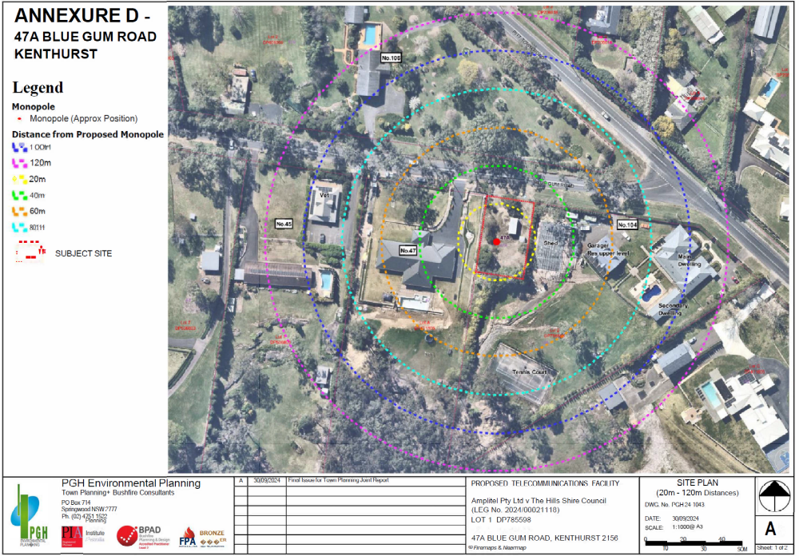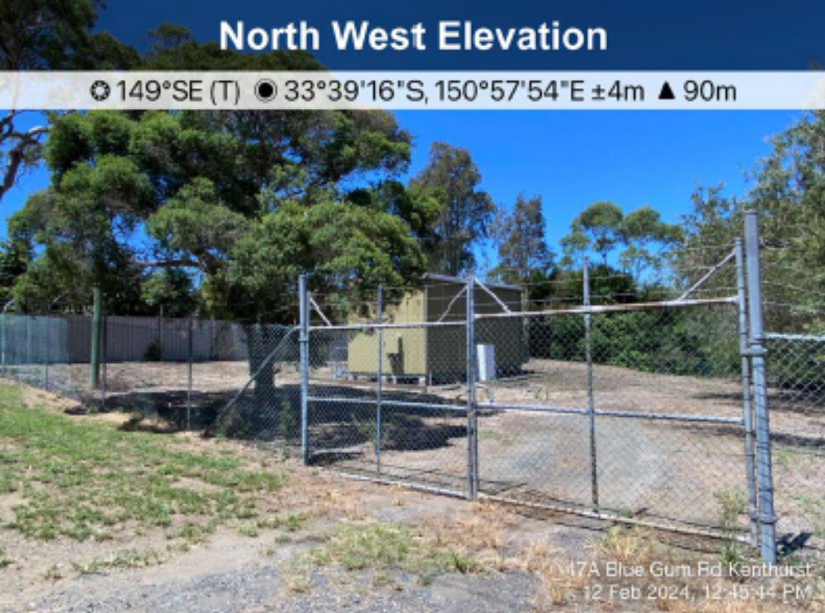Figure 1: View of the site at No. 47A Blue Gum Road looking south (Source: Ex 3)
Figure 2: Aerial photography showing distances from the proposed development to dwellings at No. 47 Blue Gum Road, 104 Pitt Town Road and 10 Pitt Town Road (Source: Ex 3)
- Adjoining to the west and further downslope from the site is a rectangular shaped rural-residential lot (No.47 Blue Gum Road) which is approximately 2.03ha in size and contains a large single story dwelling house with extensive landscaped gardens and outdoor grassed areas towards the front of the property and bushland to the south (see Figure 3). The distance between the proposed monopole and the dwelling is approximately 28m. The distance to the boundary of this property and the proposed monopole is approximately 8m.
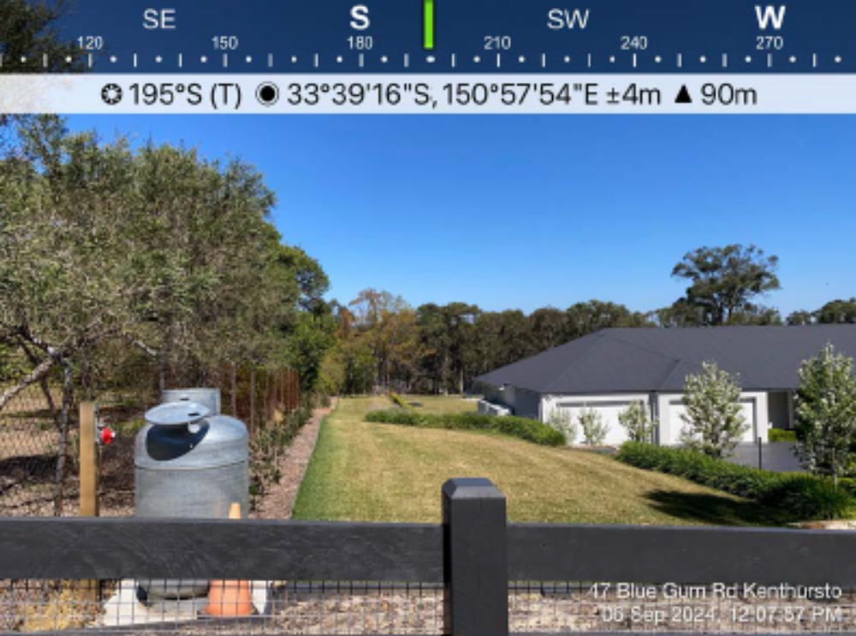Figure 3: View of the common boundary of the site and No. 47 Blue Gum Road looking south (Source: Ex 3)
- Adjoining to the east and south of the site (and slightly upslope), is an irregular shaped lot (No.104 Pitt Town Road) which is approximately 1.125ha in size and contains a double storey dwelling house, secondary dwelling, large shed, swimming pool and tennis court (see Figure 4). The distance between the monopole and the secondary dwelling is approximately 45m and the main residence is 80m. The distance to the boundary of this property and the proposed monopole is approximately 17m.
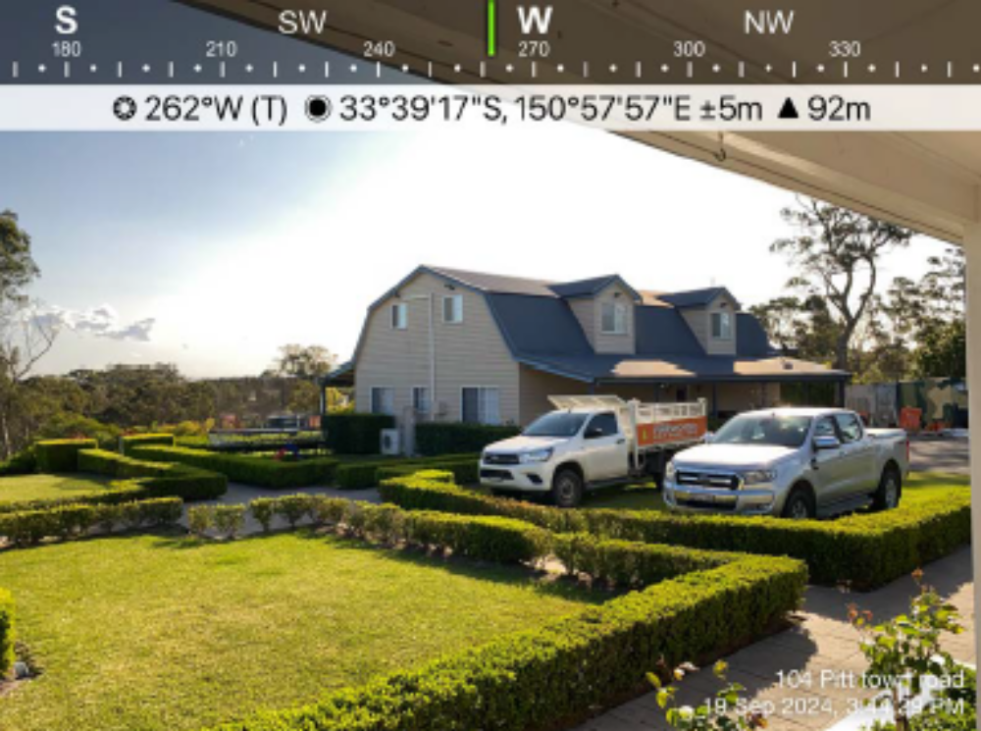Figure 4: View from the rear verandah of the main dwelling looking west towards the secondary dwelling at No. 104 Pitt Town Road and the site for the proposed development (Source: Ex 3)
- To the north of the site on the opposite side of Blue Gum Road is 10 Pitt Town Road which is an irregular shaped lot approximately 2ha in size with a dwelling house, swimming pool, shed and with extensive landscaped gardens and numerous mature trees ranging up to 19m in height.

The statutory framework

Permissibility
- The site is zoned ‘RU6 Transition’ under the LEP. The objectives of the zone are as follows:
To protect and maintain land that provides a transition between rural and other land uses of varying intensities or environmental sensitivities.
To minimise conflict between land uses within this zone and land uses within adjoining zones.
To encourage innovative and sustainable tourist development, sustainable agriculture and the provision of farm produce directly to the public.
To ensure that development does not have a detrimental impact on the rural and scenic character of the land.
- Development for the purposes of telecommunications facilities is not included in the land use table for the RU6 Transition zone that can be carried out with or without development consent and is therefore prohibited in the zone.
- However, the proposed development is permissible with development consent pursuant to s 2.143(1) of the State Environmental Planning Policy (Transport and Infrastructure) 2021 (T&I SEPP).
- Section 2.143 of the T&I SEPP provides:
2.143 Development permitted with consent
(1) Development for the purposes of telecommunications facilities, other than development in section 2.141 or development that is exempt development under section 2.20 or 2.144, may be carried out by any person with consent on any land.
(2) Before determining a development application for development to which this section applies, the consent authority must take into consideration any guidelines concerning site selection, design, construction or operating principles for telecommunications facilities that are issued by the Planning Secretary for the purposes of this section and published in the Gazette.
- The guidelines published in the Gazette are the NSW Telecommunications Facilities Guideline, Including Broadband, dated July 2010 (2010 Guidelines). Later guidelines, dated October 2022 (2022 Guidelines), have not been published in the Gazette.
- The 2010 Guidelines contain four principles for the site selection, design, construction and operation of telecommunications facilities, which are as follows:
“Principle 1: A telecommunications facility is to be designed and sited to minimise visual impact
Principle 2: Telecommunications facilities should be co-located wherever practical
Principle 3: Health standards for exposure to radio emissions will be met
Principle 4: Minimise disturbance and risk, and maximise compliance.”
- The Council contends that the 2022 Guidelines should also be considered in determining the development application. The 2022 Guidelines contain five principles, with the first four similar to the four above. The fifth principle is to “Undertake an alternative site assessment for new mobile phone base stations”.

Building Height Limit
- To ensure that the height of buildings is compatible with that of adjoining development and the overall streetscape, and to minimise the impact of overshadowing, visual impacts and loss of privacy on adjoining properties and open space areas, cl 4.3(2) of the LEP mandates that the height of a building on land is not to exceed the maximum height shown for the land on the Height of Building Map. In this case, the maximum height of a building is 10m.
- However, cl 4.6(2) of the LEP provides that develop consent may be granted for development even though the development would contravene a development standard provided the requirements in cl 4.6(3) and (4) are satisfied.
- Amplitel contends that the building height limit does not apply to the proposed development and is therefore not required to submit a written request under cl 4.6 of the LEP for two reasons.
- Amplitel’s primary contention in this regard, is that the 10m building height limit under the LEP has the effect of prohibiting an otherwise permissible telecommunications facility under the T&I SEPP. It therefore argues that the LEP is inconsistent with s 2.143 of the T&I SEPP, and that the T&I SEPP should prevail to the extent of any inconsistency and overrides the planning control in cl 4.3(2) of the LEP, in accordance with s 2.7 of the T&I SEPP and s 3.28(4) of the EPA Act.
- Secondly, Amplitel contends that the proposed development does not exceed the maximum building height of 10m because the monopole is excluded from the definition of “building height (or height of building)” under the LEP, as it should be properly construed to be one or more of the following: “communication devices, antennae…,masts…, and the like.”
- Notwithstanding the above, Amplitel has filed a written request with the Court to allow the exceedance of this development standard under cl 4.6 of the LEP, including consideration of the matters in cll 4.6(3) and (4) of the LEP.

The Hills Development Control Plan 2012
- The Hills Development Control Plan 2012 (DCP) also applies to the site, and at Part C Section 5 Telecommunications Facilities sets out a range of objectives for the siting, design and installation of telecommunications facilities.
- Section 1.3 of the DCP relevant states:
“Social
(iv) To ensure that the general public and local communities have access to telecommunications technology.
…..
Environmental
(iii) To provide infrastructure that is visually compatible with the surrounding character and locality/visual context with particular regard to heritage buildings/areas and cultural icons.
(iv) To minimise adverse impacts on the natural environment.
(v) To assess whether the proposed infrastructure is visually compatible with the amenity of the area.”
- Section 3.1 Visual Amenity of the DCP provides that:
“a) Carriers are to design antennae and supporting infrastructure in such a way as to minimise or reduce the visual and cumulative visual impact from the public domain and adjacent areas.
b) Within the local context, the infrastructure design must take account of:
Colour;
Texture;
Form;
Bulk and scale.
c) Infrastructure must:
Be well-designed;
Be integrated with the existing building structure unless otherwise justified in writing to council;
Have concealed cables where practical and appropriate;
Be unobtrusive where possible; and
Be consistent with the character of the surrounding area.”
- Amplitel contends that the DCP has no work to do in this case, principally due to the fact that the proposed development is prohibited in the RU6 Transition zone, and the DCP can only provide guidance to a consent authority in regard to “development that is permissible” under the LEP. It makes a similar argument about the application of the aims of the LEP and the objectives of the RU6 Transition zone under the LEP in determining the development application which is discussed further at [60] – [70] below.

Public Submissions
- The original development application (30.4m monopole) was notified between 13 February to 6 March 2023 and received 30 submissions, with 28 against and 2 in support of the proposed development.
- The amended development application (25.4m monopole) was notified between 1 December 2023 to 16 January 2024 and received 94 submissions, with 47 against and 48 in support.
- At the hearing, 10 submitters gave evidence during the site inspection with 6 against and 4 in support of the proposed development. The Court also received two written submissions, both objecting to the proposed development.
- The key issues raised by objectors focused on the impacts of the proposed development on the visual amenity and rural-residential character of the local area, the exceedance of the building height limit in the RU6 Transition zone, the need to consider alternative locations and technologies to address mobile phone coverage, and concerns about potential health and safety impacts associated with electromagnetic energy (EME) from the proposed telecommunications facility.
- The key issues raised by those in support focused on the limited mobile coverage in the local area and the urgent need to improve these services to address safety concerns in the case of an emergency (including bushfires) and to support local businesses, education, and other activities that require reliable mobile phone services. Amplitel also tendered letters from Mr Julian Lesser MP, Federal Member for Berowra advising that Kenthurst is the location from which he has received the largest number of complaints about poor mobile phone reception in his electorate.

Expert evidence

Radio Frequency Engineering
- Expert evidence on the need for additional mobile phone coverage in the local area and the required height of the telecommunications facility was given in a joint report and oral evidence by Mr Irwan Bardan, a Senior Wireless Network Engineer engaged by Amplitel, and Mr Yifan Wang, a Senior Principal Antenna Engineer engaged by the Council. Amplitel also submitted a detailed individual expert report from Mr Bardan.
- The experts generally agree that there is a need for additional mobile phone coverage for Telstra customers in the local area. However, they do not fully agree that the monopole needs to be 25m in height to provide sufficient coverage for Telstra customers in the target area.
- Mr Bardan considers that due to tall trees and the terrain, further reductions to the height of antennas on the monopole would significantly reduce the coverage of the proposed telecommunications facility in the target area. The Court benefited from drone footage from the site to illustrate the presence of large trees which have the potential to interfere with mobile phone coverage and the justify the proposed 25m height of the monopole and associated antennas.
- Mr Wang agreed that tall tress and the terrain in the local area needed to be taken into account when designing the facility, but did not accept that the monopole necessarily needed to be 25m in height to achieve sufficient coverage of the target area. However, Mr Wang was not in a position to provide any evidence about the optimal height of the monopole as he had not undertaken his own analysis to inform his view of the optimal design of the facility.

Planning and visual impacts
- Evidence on the town planning and visual impacts of the proposed development and its compatibility with the local character was given in a report and in oral evidence by Mr Nick Juradowitch, a town planner engaged by Amplitel, and Mr Patrick Hurley, a town planner engaged by the Council.
- The planning experts generally agree that the proposed development will not have unacceptable impacts on the broader amenity of the area, and that the primary matter in dispute between the parties is whether the visual impacts on adjoining properties at 47 Blue Gum Road and 104 Pitt Town Road are acceptable.
- Mr Juradowitch considers that these impacts have been minimised to the maximum extent possible in accordance with Principle 1 of the 2010 Guidelines. He considers that the only way to avoid any material visual impact of the proposed development on adjoining properties would be to lower the monopole to a height of 15m which would effectively amount to a refusal of the proposed development. Rather, when the broader public demand for improved mobile phone coverage in the local area is taken into account, Mr Juradowitch considers that the residual visual impacts on adjoining properties are not so significant that the proposed development should be refused.
- Mr Hurley considers that the relatively small size of the site and the proximity of the proposed facility to adjoining properties means that the visual impacts cannot be sufficiently minimised to achieve an acceptable outcome that is consistent with the rural-residential character of the immediate locality, particularly in regard to residual visual impacts on 47 Blue Gum Road and 104 Pitt Town Road. While Mr Hurley acknowledges the broader public interest associated with provision of adequate mobile phone coverage, he notes that some submitters residing in the local area consider that the existing phone coverage is adequate, and that the visual impacts on adjoining properties and the suitability of the site for a 25m telecommunications facility must be fully considered in the evaluation of the proposed development.

The role of the Court on the appeal
- In considering the appeal, the Court exercises the functions of the consent authority, which is to determine the development application pursuant to ss 4.15 and 4.16 of the EPA Act. In doing so, the Court is required to consider the matters in s 4.15(1), which includes the provisions of environmental planning instruments, the likely impacts of the development, the suitability of the site for the development, submissions on the proposed development, and the public interest.
- Importantly, the Court’s consideration in accordance with s 4.15 does not extend to the question of whether the proposed development would be better located elsewhere, or whether an alternative proposal on the site should be pursued instead of the current design.
- The role of the Court has been clearly articulated by Commissioner Gray in TPG Telecom Limited v Inner West Council [2023] NSWLEC 1778 at [36] where the Commissioner states, “the Court’s consideration in accordance with s 4.15 does not extend to the question of whether the proposed development would be better located elsewhere, or whether an alternative proposal should be pursued in lieu of the current design. Whilst the consideration in accordance with s 4.15 includes the 2010 Guidelines, pursuant to the SEPP TI, which requires regard to matters of site selection and design, this does not mean that the proposed development and its impacts ought to be assessed against a hypothetical alternative for it to be located elsewhere, or that there is any obligation on the proponent to establish that the proposed location and design is the best outcome. Instead, the role of the Court is to consider the acceptability of the proposed development in its proposed location, in accordance with s 4.15 of the EPA Act and based on the evidence in the proceedings.”
- In this case, the matters under s 4.15 of the EPA Act and the evidence in the proceedings focus principally on visual and amenity impacts, and the related questions of whether the site is suitable for the proposed development and whether the public disadvantages associated with the impacts of the proposed development outweigh the public advantages associated with improved mobile phone reception in the local area. The Court’s findings on these key considerations are set out below.

Consideration
- The contentions in these proceedings can be summarised as follows:
- Contention 1 – the proposed development is inconsistent with the rural-residential character of the site and surrounds, and will have unacceptable visual and amenity impacts on adjoining properties;
- Contention 2 – the site is not suitable for the proposed development;
- Contention 3 – Amplitel’s written request under Cl 4.6 of the LEP is inadequate; and
- Contention 4 – the proposed development is not in the public interest.
- Overall, I agree with the parties and the planning experts that the primary issue in dispute in the proceedings is the acceptability of the visual and amenity impacts of the proposed development on two adjoining properties, namely 47 Blue Gum Road and 104 Pitt Town Road, and whether these impacts warrant refusal of the development application.
- The other contentions and considerations under s 4.15 of the EPA Act regarding environmental planning instruments, suitability of the site, the public interest and the exceedance of the building height limit all relate, as least to some extent, to this central consideration in the proceedings about the acceptability of the visual impacts.

Visual Impacts

Council’s position
- The Council relies on the evidence of Mr Hurley to support its contention. Mr Hurley considers that the proposed development conflicts with the rural-residential character of the immediate locality and surrounding area, particularly the interface with the adjoining properties.
- In regard to 47 Blue Gum Road, Mr Hurley notes that while the facility will not be directly visible from the internal living areas of the dwelling, there will be prominent views from the front and rear yards of the property. The front yard consists of an undercover alfresco dining area and a large grassed area that is actively used by the residents. This area has direct views of the monopole and antenna panel arrays. Similarly, the undercover alfresco area, swimming pool (under construction), and surrounding grassed areas at the rear of the property will have direct views of the monopole and associated antenna arrays.
- In regard to 104 Pitt Town Road, Mr Hurley notes that the monopole and antenna arrays will be visible from the internal living areas of both the main dwelling, secondary dwelling and the upper habitable level of the outbuilding as well as from the pool and the main outdoor entertaining area.
- In summary, Mr Hurley considers that the telecommunications facility will be a prominent built form on the skyline when viewed from the primary outdoor living/entertaining spaces of the adjoining properties resulting in an unsympathetic and adverse visual impact on the amenity of these properties.
- The Council submits that, based on this evidence, that the proposed development is not consistent with Principles (1)(b) and (1)(e) of the 2010 Guidelines.
- Principles (1)(b) and (e), as contained in the 2010 Guidelines, are:
“(b) The visual impact of telecommunications facilities should be minimised, visual clutter is to be reduced particularly on tops of buildings, and their physical dimensions (including support mounts) should be sympathetic to the scale and height of the building to which it is to be attached, and sympathetic to adjacent buildings.
…
(e) A telecommunications facility should be located and designed to respond appropriately to its rural landscape setting.”
- For similar reasons, the Council also submits that the proposed development is inconsistent with the aim of the LEP in cl 1.2(2)(a) “to guide the orderly and sustainable development of The Hills, balancing its economic, environmental and social needs” and the objectives of the RU6 Transition zone “to ensure that development does not have a detrimental impact on the rural and scenic character of the land.”
- The Council also submits that the proposed development is inconsistent with the objectives of Part C Section 5 Telecommunications Facilities of the Hills DCP, which are reproduced at [26] and [27] above.

Amplitel’s position
- Amplitel relies on the evidence of Mr Juradowitch who considers that the visual impacts of the proposed development are acceptable. In addition to his own observations, Mr Juradowitch’s evidence relies on the detailed visual impact assessment in the Amended Statement of Environmental Effects which he considers provides a valid and objective assessment of the visual impacts of the proposed development and concurs with its findings.
- In regard to 47 Blue Gum Road, Mr Juradowitch notes that the dwelling is 27m from the proposed development and that the primary views from the property are towards the nearby bushland to the south and there are no windows on the walls of the house facing towards the proposed development.
- In regard to 104 Pitt Town Road, Mr Juradowitch notes that the separation distance to the primary and secondary dwellings is at least 80m and that the primary views from the property are towards the bushland to the southwest and to the northeast towards Pitt Town Road.
- Mr Juradowitch also considers that the only view that is affected from locations around the site is a view from the skyline, which he submits should be given minimal weight in the assessment of visual impact.
- Mr Juradowitch points to the measures proposed to minimise the visual impact of the proposed development, in accordance with Principle 1(b) of the 2010 Guidelines, including:
Minimising the height of the facility
Utilising a light grey colour to assist with blending into the skyline
Using a slimline antenna panel mounting to avoid a bulky headframe
Installing a 1.8m high solid screen fence around the site
Planting additional vegetation on the site to screen the lower portion of the facility.
- Amplitel submits that the key test in regard to the acceptability of the visual impacts of the proposed development is demonstrating that Principles 1(b) and 1(e) of the 2010 Guidelines have been adequately addressed.
- In this regard, it submits that these principles properly interpreted can be summarised as follows:
“a) The design and siting of telecommunications facilities is to “minimise” visual impact; and
b) A telecommunications facility is to be located and designed in a way that responds (if the description of setting is applicable) “to its rural landscape setting”.”
- Amplitel submits that it has adequately minimised the visual impacts of the proposed development through the mitigation measures proposed, and that there are no further opportunities to mitigate the impacts further without lowering the height of the facility, which based on the evidence of its radio frequency expert, would not achieve the necessary mobile phone coverage in the target area.
- It also submits that the 2010 Guidelines do not require that there be ‘no’ visual impacts or to ‘avoid’ visual impacts altogether, nor is there a qualitive visual impact standard that must be met. Similarly, there is no prescription that requires telecommunications facilities to avoid impacts on or to be excluded from rural landscape settings.
- On this basis, Amplitel submits that the Court should find that the proposal has been designed and sited to minimise visual impacts, and located and designed in a way that responds to its setting. In this regard, is also submits that the surrounding area has been characterised as ‘rural-residential’ by the planning experts rather than ‘rural’.
- In regard to the application of the LEP, Amplitel considers that there is no obligation under either 4.15(1)(a)(i) of the EPA Act or the provisions of the LEP to have regard to the aims of the local environmental instrument in the determination of a development application.
- As outlined in [28] above, Amplitel also considers that the objectives of the RU6 Transition zone and Part C Section 5 Telecommunications Facilities of the DCP are not engaged in the determination of the development application for two key reasons.
- Firstly, because ‘telecommunications facilities’ are an innominate prohibited development in the RU6 Transition zoning, and that the obligation in 2.3(2) of the LEP to “have regard to the objectives for development in a zone when determining a development application in respect of the land within the zone” is not engaged by a development application to carry out development that is prohibited in that zone.
- Secondly, it argues that there is relevant inconsistency between the applicable environmental planning instruments, namely the LEP which prohibits the proposed development on the land and the T&I SEPP which contains an aim to effectively deliver infrastructure across the State and permits that development, albeit subject to consideration of the principles in the 2010 Guidelines in regard to telecommunications facilities. It further argues that this inconsistency extends to other provisions of the LEP (or the DCP for that matter) including the objectives of the RU6 Transition zone where the provisions have the effect of prohibiting the proposed development.
- The implication of Amplitel’s argument is that the provisions of the LEP (and the DCP) do not apply where there is any inconsistency, and the relevant matters for consideration under the applicable environmental planning instruments in determining the development application are confined to the provisions of the T&I SEPP and the 2010 Guidelines, which must also be considered by a consent authority before determining the application in accordance with s 2.143(2) of the T&I SEPP.

The visual impacts are unacceptable
- As set out above, in considering whether the proposed development and its impacts are acceptable, it is not relevant to consider whether the proposed development would be better located elsewhere. I have also not undertaken a comparison of the relative impacts of the proposed developments with other mobile phone facilities that may have been approved in the local area. Instead, each development application must be considered on its merits, and I only need to consider the acceptability of the proposed development in the location currently proposed.
- As mentioned above [46], I agree with the planning experts that the proposed development would not result in any significant visual impacts on the broader amenity of the area, and that the real issue in dispute in the proceedings is the acceptability of the visual impact of the proposed development on two adjoining properties, namely 47 Blue Gum Road and 104 Pitt Town Road.
- I also accept that Amplitel has done everything that is reasonable and feasible to minimise the visual impact of the facility while still maintaining adequate mobile phone coverage in the target area, noting the evidence of the radio frequency engineers. In this regard, I note the comment from Mr Juradowitch that the only way to avoid any material impact of the proposed development would be to lower the proposed monopole to a height of 15m which would effectively amount to refusal of the proposed development.
- I also accept that there are no specific criteria in the applicable environmental planning instruments to determine the acceptability of the visual impacts, and that there is an inherent degree of subjectivity in assessing visual impacts.
- I also accept that the applicable standard is not “no” visual impacts and that there is no requirement to avoid all visual impacts on residential properties, and that some level of visual impact is often necessary and appropriate to facilitate the delivery of infrastructure in accordance with the aims of the T&I SEPP which make telecommunications facilities permissible with consent on any land across the State.
- However, in accordance with s 4.15(1)(b), I am still required to consider “the likely impacts of the development, including environmental impacts on both the natural and built environments, and social and economic impacts in the locality.”
- In this case, despite the mitigation measures proposed to minimise visual impacts, I consider that the residual impacts on the visual amenity of the adjoining properties are significant and unacceptable.
- While there are no photomontages in evidence for either of the adjoining properties, the Court benefited from an inspection of both properties during the hearing. During the site inspection of the adjacent properties and nearby public domain, a drone was flown at the height of the proposed monopole to assist the Court in considering the nature and extent of the visual impacts. Figure 5 provides a photomontage of the proposed development from the road reserve adjacent to 104 Pitt Town Road.
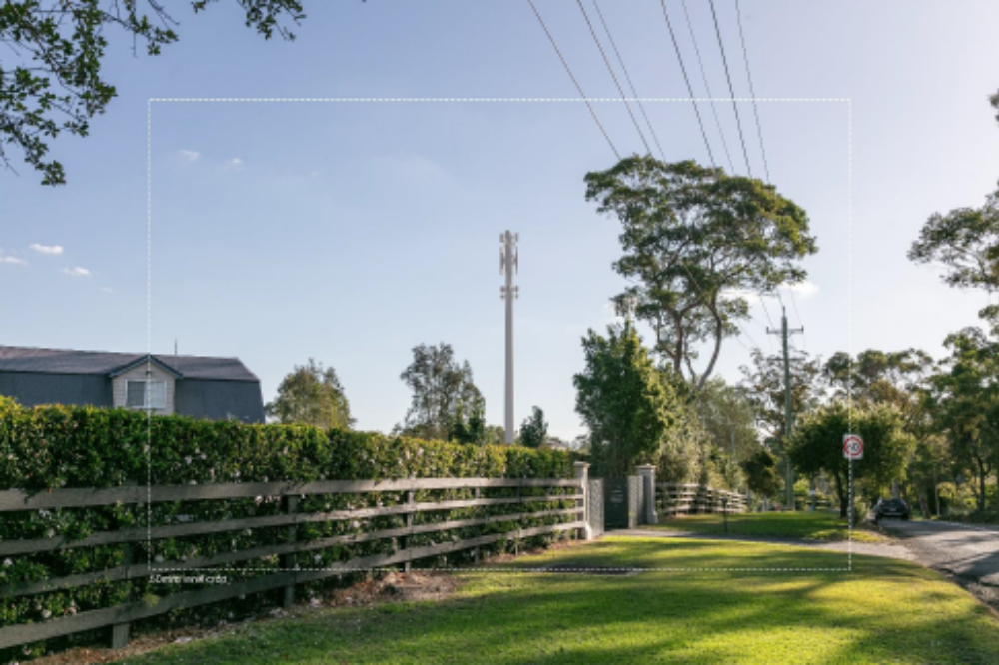Figure 5: Photomontage from road reserve adjacent to No. 104 Pitt Town Road looking west (Source: Ex 3)
- Overall, I agree with the evidence of Mr Hurley that the proposed structure would impose itself unacceptably on the views from both 47 Blue Gum Road and 104 Pitt Town Road.
- This is particularly the case for 47 Blue Gum Road where the boundary of the property is located only 8m from the proposed development; is downslope from the proposed development; and which has outdoor entertaining, extensive gardens and grassed areas at the front of the property which would have proximate and unobstructed views of the upper sections of the proposed development. Figure 6 shows the front yard of 47 Blue Gum Road and the view towards the site (noting that there are no photomontages from 47 Blue Gum Road).
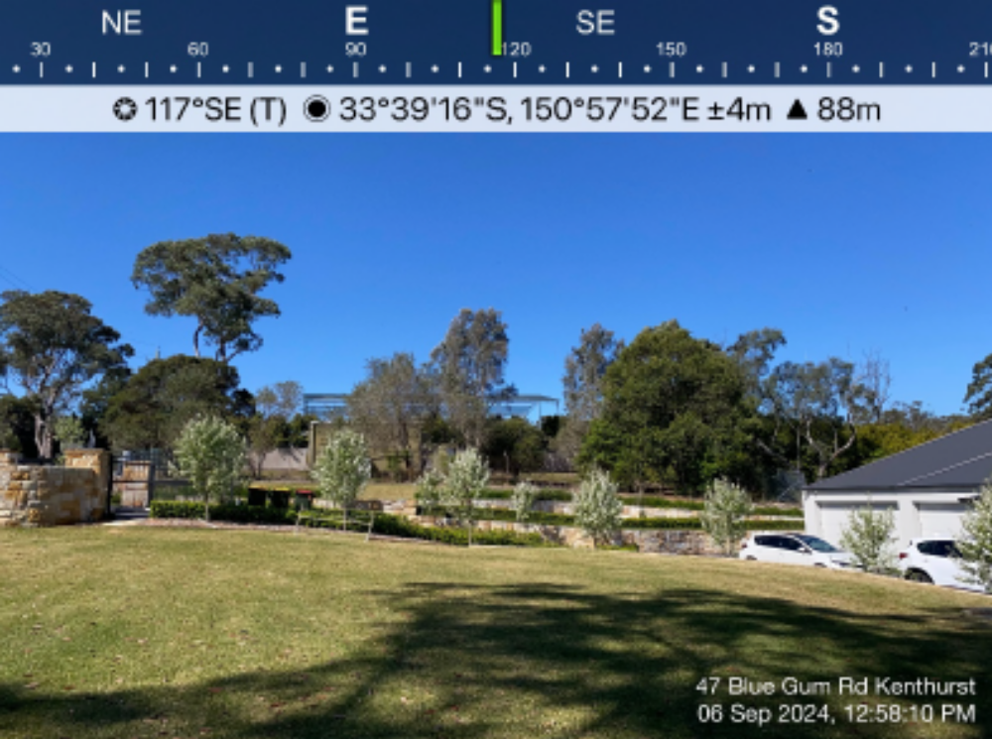Figure 6: View from the front yard of 47 Blue Gum Road looking east towards the site (Source: Ex 3)
- As a result of these specific factors, I consider that the proximity and relative height of the proposed development would be highly intrusive and visually dominate from a significant portion of the outdoor portions of the property that are actively used and enjoyed by the residents.
- The impacts on 104 Pitt Town Road would be somewhat less than at 47 Blue Gum Road due to a greater separation distance, the recently constructed shed which shields some parts of the property, the presence of a number of existing mature trees and the fact that the property is marginally upslope from the site.
- 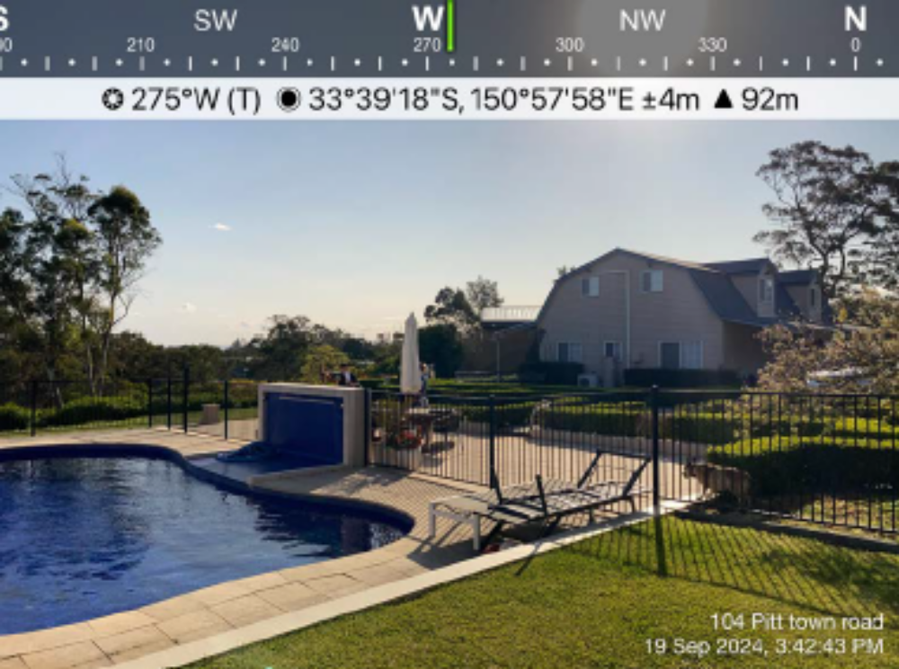Nonetheless, I consider that the proximity and scale of the proposed development would result in the facility remaining visually dominant from the dwellings and the main outdoor entertainment areas on the property. Figure 7 shows the view from the rear yard of 104 Pitt Town Road looking west towards the site.
Figure 7: View from the rear yard of 104 Pitt Town Road looking west towards the site (Source: Ex 3)
- In regard to the 2010 Guidelines, Principle 1 requires “A telecommunications facility to be designed and sited to minimise visual impact (emphasis added).” In particular, under Principle 1(b) it requires that “The visual impact of telecommunications facilities should be minimised, visual clutter is to be reduced particularly on tops of buildings, and their physical dimensions (including support mounts) should be sympathetic to the scale and height of the building to which it is to be attached, and sympathetic to adjacent buildings (emphasis added).”
- After consideration of all of the evidence, I am not satisfied that the visual impacts of the proposed development are acceptable. Rather, I consider that the proposed development is not sympathetic to the visual amenity of the adjacent buildings having regard to the limited setback of those dwellings and the surrounding outdoor areas from the proposed development which are actively used by the residents.
- I therefore consider that the proposed development has not been designed and sited to minimise its visual impact, nor is it sympathetic to adjacent buildings as required by Principle 1 of the 2010 Guidelines. This conclusion is further supported by the reasons given below in regard to the suitability of the site for the proposed development.

Suitability of the Site
- In this case, the suitability of the site is inextricably related to the visual impacts of the proposed development. Consequently, much of the evidence outlined above was used by the planning experts to inform their opinions about whether they considered the site to be suitable for the proposed development.
- However, in addition to the evidence regarding visual impacts, the Council also contends that the relative size of the site (0.1ha) is too small to host the proposed telecommunications facility given the proximity of the adjoining properties and associated dwellings.
- In this regard, I agree with Council’s submission that Amplitel’s case relies on the inherent limitations of the site as the basis that it has sufficiently minimised the visual impacts of the proposed development. The fact that Amplitel cannot minimise the visual impacts further due to the limitations of the site does not mean that its has minimised visual impact. Rather, I agree with Council that this means that the site itself is not suitable for the scale of the development proposed.
- That being said, I recognise that given the number of mature trees and the undulating terrain it is likely that any mobile phone base station in the target area would require a relatively tall monopole, unless there is an opportunity to collocate with other telecommunications facilities. I also recognise that there are no building setback controls to site boundaries prescribed under any environmental planning instruments or the DCP that would apply to the proposed development.
- I note Mr Juradowitch’s comment that refusal of this development may constitute a refusal of any similar proposals located less than 100m from dwellings in rural landscape settings. I also note his comment that he considers that the visual impact is satisfactory when balanced against the need for the facility and the absence of any alternative more suitable sites.
- However, each development application has to be considered on its own merits, so that a refusal based on the circumstances of the present development application does not mean that future development applications within close proximity to residential dwellings would lead to the same outcome, as it would depend on the merits of the particular application.
- Furthermore, as outlined above at [43], the Court is required to assess this application based on the evidence before it and has no power to consider a better or alternative site for this infrastructure.
- After consideration of all of the evidence, and for the reasons given above, I consider that the design, setbacks and siting of the development does not (and cannot) sympathetically respond to the local context, and does not provide adequate separation and visual relief to the adjoining dwellings and associated outdoor areas. Accordingly, I am not satisfied that the site is suitable for the proposed development in accordance with s 4.15(1)(c) of the EPA Act.

Public Interest
- The key question in regard to public interest is whether the broader public interest of approving the proposed telecommunications facility outweighs the impacts of the facility on the adjoining properties (as described in detail above).
- When the proposed development was renotified for the review of the application, the Council received 94 submissions with 46 opposed and 48 in support of the proposed development.
- Not unsurprisingly, the majority of submissions in opposition were from adjoining property owners and nearby residents, some of whom may be disproportionately affected by the proposed development (although as set out above, I consider these impacts to be primarily limited to the adjoining properties).
- In contrast, the majority of submission in support were from persons who do not reside in close proximity to the site and would not be adversely affected by the proposed development and would potentially benefit from improved mobile coverage.
- The Court also notes a number of letters from Mr Julian Lessor MP, Member for Berowra which attach correspondence from local residents raising concerns about the mobile phone coverage in Kenthurst. This includes a list of 27 complaints about poor telecommunications services in the Kenthurst area received by the Local MP in response to a survey.
- Based on this and the evidence from Amplitel’s radio frequency expert, Mr Bardan, I accept that there is an urgent and increasing need for improved mobile phone services in the target area and that the proposed development would address that need at least for existing and future customers of Telstra.
- I also agree with Mr Juradowitch that telecommunications facilities (and other utilities such as electricity poles/towers) can and must form part of a rural-residential land use matrix to ensure adequate essential services are provided to those who reside in those areas.
- The broader public interest of facilitating effective delivery of public infrastructure such as telecommunications services across the State is also clearly articulated in the aims of the T&I SEPP (s 2.1).
- However, there is no evidence in the proceedings about the mobile coverage offered by other carriers in the target area and several submitters residing within the target area indicated to the Court that they had adequate mobile phone reception. It is recognised that this is lay evidence, but the Court has no evidence to either substantiate or refute these claims, nor any evidence about the relative performance of the services offered by other carriers or the relative merits of other telecommunication technologies.
- I also note that the issue of poor mobile phone reception is not uncommon outside the more densely populated urban areas, and that the questions regarding the impacts of the proposed development and the suitability of the site must also be taken into consideration in evaluating the merits of the proposed development under s 4.15 of the EPA Act.
- On balance, I consider that the benefits of the proposed development do not outweigh the direct and material impacts on the visual amenity of adjoining properties and the associated finding regarding the suitability of the site.
- Other Contentions
- Given the above findings, I do no need to consider Council’s contention in regard to the application of the building height limit under cl 4.3(2) of the LEP or the adequacy of Amplitel’s written request to exceed this limit under cl 4.6 of the LEP, including whether Amplitel’s argument that the building height limit does not apply due to inconsistency with the provisions of the T&I SEPP (s 2.7).
- Similarly, I do not need to consider whether the objectives of the RU6 Transition zone and Part C Section 5 Telecommunications Facilities of the DCP apply and/or whether the proposed development is consistent with these provisions.
- In determining the development application, I am also not required to consider the 2022 Guidelines as this document has not been published in the Government Gazette as required under s 2.143(2) of the T&I SEPP. This includes consideration of the fifth principle which relates to the consideration of an alternative site assessment for new mobile phone base stations.
- Conclusion
- In considering whether, in the exercise of discretion, development consent ought to be granted, the Court (as the consent authority) must take into consideration the 2010 Guidelines, as specified by s 2.143(2) of the T&I SEPP, and the matters in s 4.15(1) of the EPA Act.
- The 2010 Guidelines provides principles for design and siting and operating telecommunications facilities and to encourage provision of those facilities provided they are “designed and sited to minimise visual impact” and “sympathetic to adjacent buildings”.
- For the reasons outlined above, I am not satisfied that the proposed development been designed and sited to minimise its visual impact and to be sympathetic to adjacent buildings, contrary to Principle 1(b) of the 2010 Guidelines.
- Having regard to the likely impacts of the proposed development and the suitability of the site in its context under s 4.15(1) of the EPA Act, I am not satisfied that the proposed development should be approved.
- Orders
- The Court orders:
- The Appeal is dismissed.
- Development Application No. 1227/2023/HA for installation of a telecommunications facility comprising a 25.4m monopole, six (6) antennas, nine (9) remote radio units and ancillary equipment at Lot 1 DP 785598 47A Blue Gum Road Kenthurst NSW is determined by refusing consent.
- All the exhibits are returned.

M Young

Acting Commissioner of the Court

**********

DISCLAIMER - Every effort has been made to comply with suppression orders or statutory provisions prohibiting publication that may apply to this judgment or decision. The onus remains on any person using material in the judgment or decision to ensure that the intended use of that material does not breach any such order or provision. Further enquiries may be directed to the Registry of the Court or Tribunal in which it was generated.

