 | Court of Appeal  Supreme Court  New South Wales

Case Name: | Cameron v Woollahra Municipal Council
Medium Neutral Citation: | [2024] NSWCA 216
Hearing Date(s): | 3 July 2024
Date of Orders: | 3 September 2024
Decision Date: | 3 September 2024
Before: | Payne JA at [1];  White JA at [183];  Price AJA at [184].
Decision: | (1) Appeal dismissed.  (2) Appellants to pay the first respondent’s costs of the appeal.
Catchwords: | CIVIL PROCEDURE — Time — Extension of time to commence judicial review proceedings  ADMINISTRATIVE LAW — Whether reviewable decision — Jurisdictional error — where decision to issue a construction certificate legally unreasonable  ENVIRONMENT AND PLANNING — Consent — Conditions — Construction certificate — plans and specifications or standards of building work or subdivision work specified in the certificate are not consistent with the development consent – effect of decision in Burwood Council v Ralan Burwood Pty Ltd (No 3) [2014] NSWCA 404 in circumstances where jurisdictional error has been established
Legislation Cited: | Building and Construction Industry Security of Payment Act 1999 (NSW) s 32A  Environmental Planning and Assessment Act 1979 (NSW) ss 6.1, 6.2, 6.3, 6.4, 6.5, 6.7, 6.8, 4.16, 4.17, 4.28, 4.31, 4.55, 4.59, 6.32, 6.33, 9.44, 9.45, 9.46  Environmental Planning and Assessment (Development Certification and Fire Safety) Regulation 2021 (NSW) cll 7, 8, 12, 13, 16, 17, 19  Environmental Planning and Assessment Regulation 2000 (NSW) cl 145  Land and Environment Court Act 1979 (NSW) ss 20, 58  Supreme Court Act 1970 (NSW) ss 69, 71  Uniform Civil Procedure Rules 2005 (NSW) r 59.10
Cases Cited: | Al Maha Pty Ltd v Huajun Investments Pty Ltd [2018] NSWCA 245  Attorney-General for the States of New South Wales v Quin (1990) 170 CLR 1; [1990] HCA 21  Avon Downs Pty Ltd v Federal Commissioner of Taxation (1949) 78 CLR 353  Bankstown City Council v Ramahi [2015] NSWLEC 74  Bankstown City Council v Ramahi (No 2) [2016] NSWLEC 34  Baxter v New South Wales Clickers’ Association (1909) 10 CLR 114  Bunderra Holdings Pty Ltd v Pasminco Cockle Creek Smelter Pty Ltd (subject to Deed of Company Arrangement) (2017) 96 NSWLR 434; [2017] NSWCA 263  Burwood Council v Ralan Burwood Pty Ltd (No 3) [2014] NSWCA 404  Ceerose Pty Ltd v A-Civil Aust Pty Ltd (2023) 112 NSWLR 225; [2023] NSWCA 215  Central Coast Council v 40 Gindurra Road Somersby Pty Ltd (No 2) [2019] NSWLEC 171  Clancy v Director of Public Prosecutions [2018] NSWCA 102  Commissioner of Taxation v Futuris Corporation Limited (2008) 237 CLR 146; [2008] HCA 32  Community Housing Limited v Clarence Valley Council (2015) 90 NSWLR 292; [2015] NSWCA 327  Corowa v Geographe Point Pty Ltd & Anor [2007] NSWLEC 121  Corporation of the City of Enfield v Development Assessment Commission (2000) 199 CLR 135; [2000] HCA 5  Hossain v Minister for Immigration and Border Protection (2018) 264 CLR 123; [2018] HCA 34  House v The King (1936) 55 CLR 499  Jadwan Pty Ltd v Secretary, Department of Health and Aged Care (2003) 145 FCR 1; [2003] FCAFC 288  Kirk v Industrial Court of New South Wales (2010) 239 CLR 531; [2010] HCA 1  Kruger v The Commonwealth (1997) 190 CLR 1; [1997] HCA 27  Lesnewski v Mosman Municipal Council [2005] NSWCA 99  Masi-Haini v Minister for Home Affairs (2023) 298 FCR 277; [2023] FCAFC 126  Minister for Immigration and Citizenship v Li (2013) 249 CLR 332; [2013] HCA 18  Minister for Immigration and Citizenship v SZIAI (2009) 83 ALJR 1123; [2009] HCA 39  Minister for Immigration and Citizenship v SZMDS (2010) 240 CLR 611; [2010] HCA 16  Minister for Immigration and Multicultural Affairs v Bhardwaj (2002) 209 CLR 597; [2002] HCA 11  Minister for Immigration and Multicultural Affairs v Eshetu (1999) 197 CLR 611; [1999] HCA 21  Minister for Immigration, Citizenship, Migrant Services and Multicultural Affairs v Moorcroft (2021) 273 CLR 21; [2021] HCA 19  Moorebank Recyclers Pty Ltd v Tanlane Pty Ltd [2018] NSWCA 304  MZAPC v Minister for Immigration and Border Protection (2021) 273 CLR 506; [2021] HCA 17  New South Wales v Kable (2013) 252 CLR 118; [2013] HCA 26  Oakey Coal Action Alliance Inc v New Acland Coal Pty Ltd (2021) 272 CLR 33; [2021] HCA 2  Probuild Constructions (Aust) Pty Ltd v Shade Systems Pty Ltd (2018) 264 CLR 1; [2018] HCA 4  Project Blue Sky Inc v Australian Broadcasting Authority (1998) 194 CLR 355; [1998] HCA 28  Sader v Elgammal [2022] NSWLEC 107  Settlers Estate Pty Ltd v Penrith City Council [2021] NSWCA 13  Smith v Wyong Shire Council [2003] NSWCA 322  The Hills Shire Council v Drenovac [2022] NSWLEC 139  Tomko v Palasty (No 2) (2007) 71 NSWLR 61; [2007] NSWCA 369  Toth v Director of Public Prosecutions (NSW) [2014] NSWCA 133  Trives v Hornsby Shire Council (2015) 89 NSWLR 268; [2015] NSWCA 158
Texts Cited: | J Kirk SC, ‘The Concept of Jurisdictional Error’ in Key Issues in Judicial Review (Neil Williams SC ed, Federation Press, 2014)  M Aronson, M Groves and G Weeks, Judicial Review of Administrative Action and Government Liability (Thomson Reuters, 6th ed, 2017)
Category: | Principal judgment
Parties: | Andrew Cameron (first appellant)  Vanessa Green (second appellant)  Woollahra Municipal Council (first respondent)  Paul Aramini (second respondent)
Representation: | Counsel:  I Hemmings SC / J Farrell (appellants)  J Lazarus SC / M Harker (first respondent)  Solicitors:  Mills Oakley (appellants)  Rosemary Bullmore (first respondent)  HBA Legal (second respondent)
File Number(s): | 2024/151110
Publication Restriction: | Nil
Decision under appeal:
Court or Tribunal: | Land and Environment Court
Jurisdiction: | Class 4
Citation: | [2024] NSWLEC 27
Date of Decision: | 28 March 2024
Before: | Pritchard J
File Number(s): | 2023/68853

[Note: The Uniform Civil Procedure Rules 2005 provide (Rule 36.11) that unless the Court otherwise orders, a judgment or order is taken to be entered when it is recorded in the Court's computerised court record system. Setting aside and variation of judgments or orders is dealt with by Rules 36.15, 36.16, 36.17 and 36.18. Parties should in particular note the time limit of fourteen days in Rule 36.16.]

HEADNOTE
[This headnote is not to be read as part of the judgment]
On 13 April 2021, Woollahra Municipal Council (“the Council”) granted development consent for a proposed development in Bellevue Hill, which involved demolishing a pre-existing dwelling and replacing it with a three-storey house. Mr Cameron and Ms Green (“the appellants”) are the registered proprietors of the property. On 11 April 2022, the appellants lodged a modification application under s 4.55 of the Environmental Planning and Assessment Act 1979 (“the EPA Act”), which sought to modify the development consent in various ways, including by adding a cellar level to the proposed development, with access to the cellar and associated storage area to be provided by a lift and access stairs.
On 16 June 2022, the Council issued an assessment report responding to the appellants’ modification application. The report recommended “the deletion of the new cellar level and associated excavation” and that the proposed modifications otherwise be accepted. The Local Planning Panel modified the development consent and added condition C.1(d), which deleted the cellar level and provided that the area must remain unexcavated. The modified development consent approved three construction plans in each case with the notation “Cellar Level Deleted”.
On 31 August 2022, the second respondent, an accredited certifier, issued a construction certificate for the site, listing the development consent, the second development consent and the modified development consent as the relevant consents. Structural plans showed works in the area of the former cellar including an apparent lower floor level for a construction void with a concrete slab and precast concrete walls, stairs leading into the construction void, a lift, and a crane base. Thus, an issue arose from the inconsistency between condition C.1(d) of the development consent, which deleted the cellar level from the proposed consent, and the construction certificate, which permitted excavation of the area where the cellar level had been proposed for the purposes of building a crane base and installing a crane.
The primary judge held that the Court should extend time under r 59.10 of the Uniform Civil Procedure Rules 2005 (NSW) (“UCPR”) for the Council to commence proceedings for judicial review of the certifier’s decision to issue the construction certificate. The modified development consent, properly construed, prohibited excavation within the area previously identified as the cellar level for all purposes. The plans, specifications and standards of building work specified in the construction certificate were not consistent with the modified development consent. The primary judge found it was legally unreasonable for the certifier to determine that the construction certificate was consistent with the modified development consent. The primary judge made a declaration of invalidity in respect of part of the construction certificate.
There were three issues on appeal:
(i) Was there error in the exercise of the primary judge’s discretion to extend time to commence judicial review proceedings pursuant to UCPR r 59.10?
(ii) Was the decision of the private certifier to issue a construction certificate in the form it took legally unreasonable?
(iii) Was the consequence of a finding of legal unreasonableness the invalidity of part of the construction certificate?
The Court (Payne JA, White JA and Price AJA agreeing at [183] and [184] respectively) held, dismissing the appeal:
On issue (i):
(1) The primary judge did not err in extending time pursuant to UCPR r 59.10: at [75]. In general, a tight rein should be kept on applications to extend time in the statutory context of residential building pursuant to a construction certificate issued after an extensive development application process. The absence of any evidence of prejudice to the appellants by the extension of time in the present case was striking: at [74].
Bankstown City Council v Ramahi [2015] NSWLEC 74 considered. Clancy v Director of Public Prosecutions [2018] NSWCA 102; Toth v Director of Public Prosecutions (NSW) [2014] NSWCA 133; Tomko v Palasty (No 2) (2007) 71 NSWLR 61; [2007] NSWCA 369 applied.
On issue (ii):
(2) The construction certificate was inconsistent with the development consent. The task in determining “inconsistency” is to make findings about the nature and extent of the variations to the approval plans and specifications. It is necessary to make an evaluative judgment as to whether the variations were or were not inconsistent, in the relevant sense, with the plans and specifications approved in the development consent: at [105]-[108].
Burwood Council v Ralan Burwood Pty Ltd (No 3) [2014] NSWCA 404 applied.
(3) Inconsistency between a development consent and a construction certificate does not, in itself, establish that the decision of the certifier to issue a construction certificate was legally unreasonable. The issues are to be resolved by proper construction of the development consent, read as a whole, and the construction certificate, and the application of well-known principles to establish unreasonableness. It is necessary to analyse the reasons of the certifier and the nature and extent of the inconsistency. The question is whether a certifier acting rationally, and having regard to the development consent as a whole, could have taken the view that the construction certificate plans were consistent with that development consent: at [109]-[125].
Minister for Immigration and Citizenship v Li (2013) 249 CLR 332; [2013] HCA 18; Burwood Council v Ralan Burwood Pty Ltd (No 3) [2014] NSWCA 404; Al Maha Pty Ltd v Huajun Investments Pty Ltd [2018] NSWCA 245; Corowa v Geographe Point Pty Ltd & Anor [2007] NSWLEC 121 applied.
(4) There was no evidence of a recommendation of the Geotechnical/Hydrogeological Monitoring Program or direction of the supervising professional engineer to excavate the former cellar level. There is no indication in the voluminous materials that the construction of the crane in the former cellar area, the precast panels, or the construction void were necessary to permit the ongoing construction of structural elements of the new house: at [126]-[136]. In the face of such a clear condition, the certifier’s decision to issue a construction certificate which set condition C.1(d) at naught was legally unreasonable: at [138].
On issue (iii):
(5) A decision involving jurisdictional error, although it remains a decision in fact, is properly to be regarded as no decision at all: at [153]-[161]. The consequence of a finding of jurisdictional error is a question of statutory construction: at [159]. The appellants accepted that the decision to issue the construction certificate was amenable to judicial review for jurisdictional error. Jurisdictional error having been found, the impugned decision was void, at least in part. Nothing in Burwood Council v Ralan Burwood Pty Ltd (No 3) [2014] NSWCA 404 mandates a different conclusion: at [160]-[180].
Hossain v Minister for Immigration and Border Protection (2018) 264 CLR 123; [2018] HCA 34; Minister for Immigration and Multicultural Affairs v Bhardwaj (2002) 209 CLR 597; [2002] HCA 11; New South Wales v Kable (2013) 252 CLR 118; [2013] HCA 26 applied. Ralan Burwood Pty Ltd (No 3) [2014] NSWCA 404 considered.

Judgment
- PAYNE JA: Mr Cameron and Ms Green (“the appellants”) are the registered proprietors of a property in Bellevue Hill. The first respondent, Woollahra Municipal Council (“the Council”) is the consent authority for residential building development in Bellevue Hill. The second respondent, Mr Paul Aramini, (“the certifier”), is a private certifier who issued a construction certificate for the appellants’ property. Mr Aramini entered submitting appearances in this Court and in the Land and Environment Court.
- On 13 April 2021, the Council granted development consent DA 457/2020 for a proposed development in Bellevue Hill, which involves demolishing a pre-existing dwelling and replacing it with a three-storey house. A second development consent was later granted, which is irrelevant to the present appeal.
- On 11 April 2022, the appellants lodged modification application DA 457/2020/3 under s 4.55 of the Environmental Planning and Assessment Act 1979 (NSW) (“the EPA Act”), which sought to modify the development consent in various ways, including by adding a cellar level to the proposed development, with access to the cellar and associated storage area to be provided by a lift and access stairs.
- On 16 June 2022, the Council issued an assessment report responding to the appellants’ modification application. The report recommended that the Woollahra Local Planning Panel accept the proposed modifications except for the proposed new cellar level. Instead, the report recommended “the deletion of the new cellar level and associated excavation”. The report gave the following reason:
... given the amount of excavation is in excess of the volumetric control, the short-term amenity effects are not reasonable as they are likely to be greater due to the extended period of time required to excavate more material than when compared to a compliant development.
Conclusion
The approved development already exceeded the maximum excavation volume. The extent of variation sought under this modification is not justified.
- Also on 16 June 2022, the Local Planning Panel modified the development consent “for the reasons set out in the assessment report”. Relevantly, the Panel included the following new sub-paragraph (d) to condition C.1:
C.1 Modification of Details of the Development (section 4.17(1)(g) of the Act)
The approved plans and the Construction Certificate plans and specification, required to be submitted to the Certifying Authority pursuant to clause 139 of the Regulation, must detail the following amendments:
…
(d) Deletion of the ‘cellar’ level and the associated excavation (imposed under DA 475/2020/3)
To minimise excavation, the ‘cellar’ level including the mechanical ventilation, wine cellar, store, lift and access stairs must be deleted; and the area must remain unexcavated. (emphasis added).
- The modified development consent approved three construction plans, DA07, DA08 and DA10, each showing the proposed “cellar level” and in each case with the notation “Cellar Level Deleted”.
- The notations “stair” and “cellar” and “Cellar Level Deleted. Refer to Condition C.1(d)” on approved plan DA07 (Section A) are shown below:
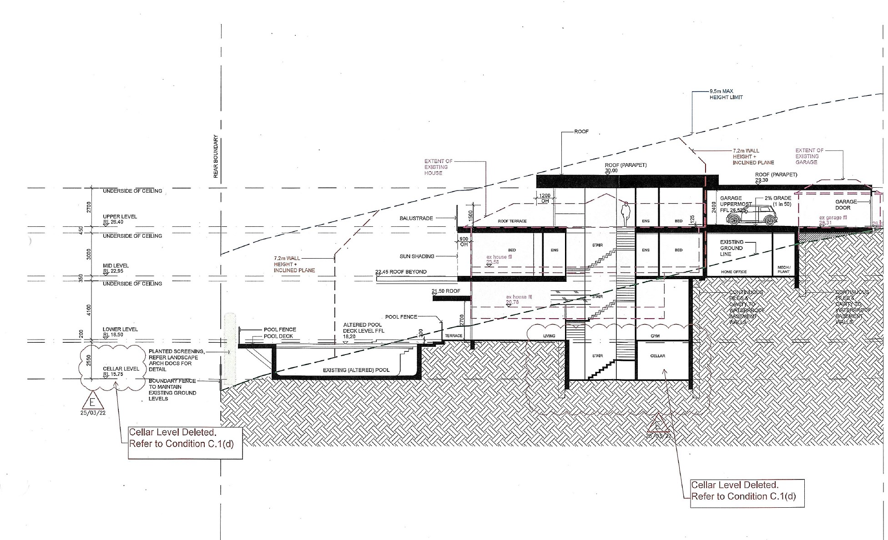
- The notations “store” and “cellar” and “Cellar Level Deleted. Refer to Condition C.1(d)” on approved plan DA08 (Section B) are shown below:
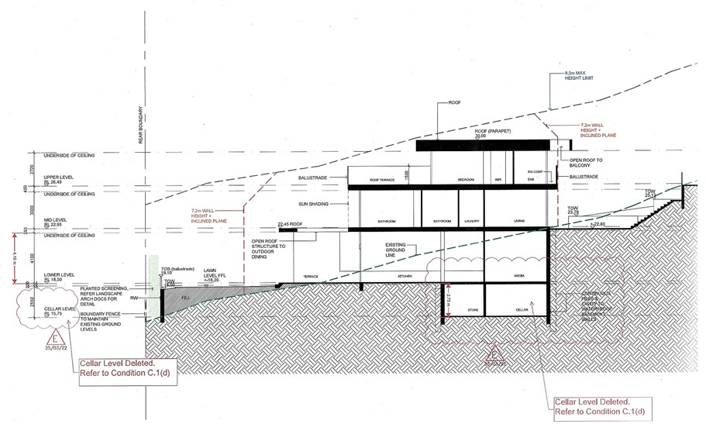
- The notations “cellar” and “store” and “Cellar Level Deleted. Refer to Condition C.1(d)” on approved plan DA10 (Section E) are shown below:
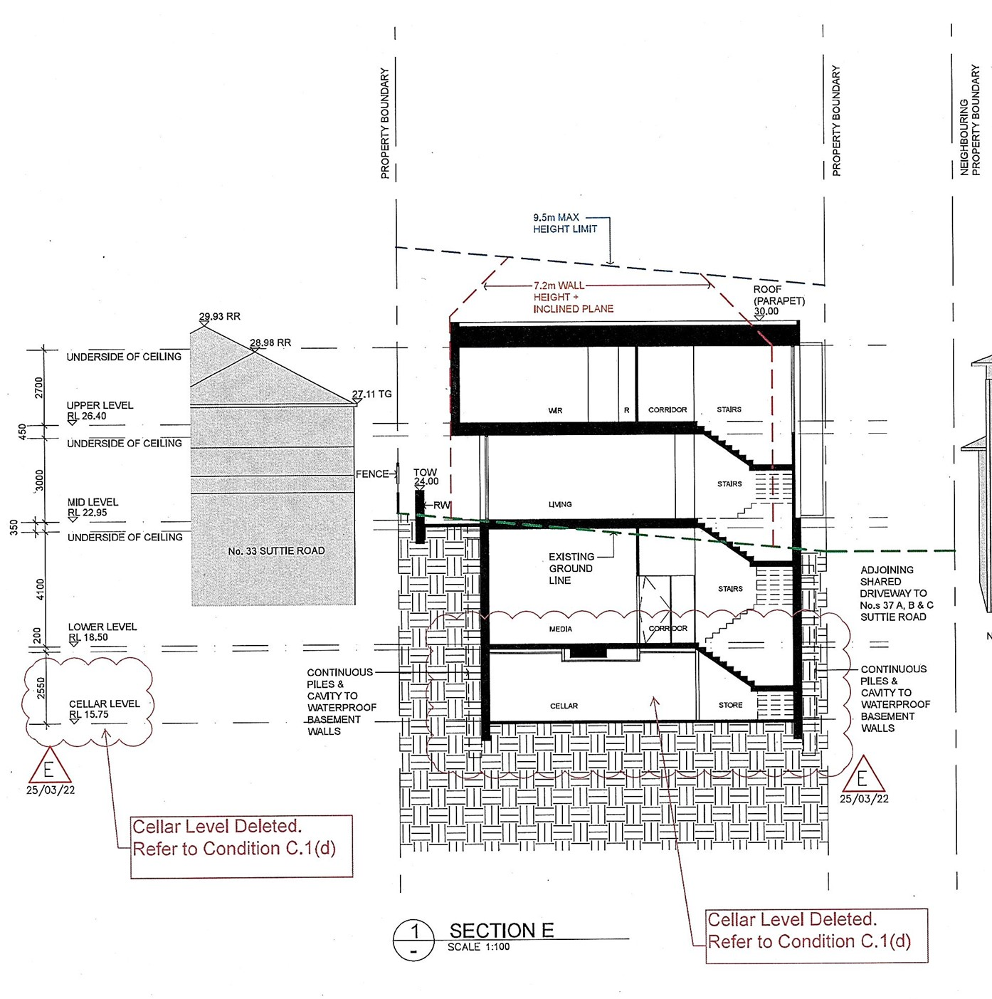
- On 31 August 2022, the second respondent, an accredited certifier, issued construction certificate number 21/345 for the site, listing the development consent, the second development consent and the modified development consent as the relevant consents. The relevant building plans were a set of architectural plans and a set of structural plans (both stamped and approved by the second respondent).
- The structural plans “stamped” by the second respondent and dated 14 July 2022 included:
- Dwg 1051 Rev D, Shoring Elevations Sheet 1 (Shoring Elevations Sheet 1) which shows in the area of the former cellar:
- an apparent lower floor level for a construction void;
- stairs leading into the construction void; and
- a crane base with a notation “CRANE BASE BY OTHERS. MAXIMUM 5mx5mx1.35m DEEP”;
- Dwg 1100 Rev C, Construction Void Marking Plan (the Construction Void Marking Plan) which shows in the area of the former cellar:
- a concrete slab at the level of the construction void; and
- precast concrete walls.
Part of the Construction Void Marking Plan is reproduced below:
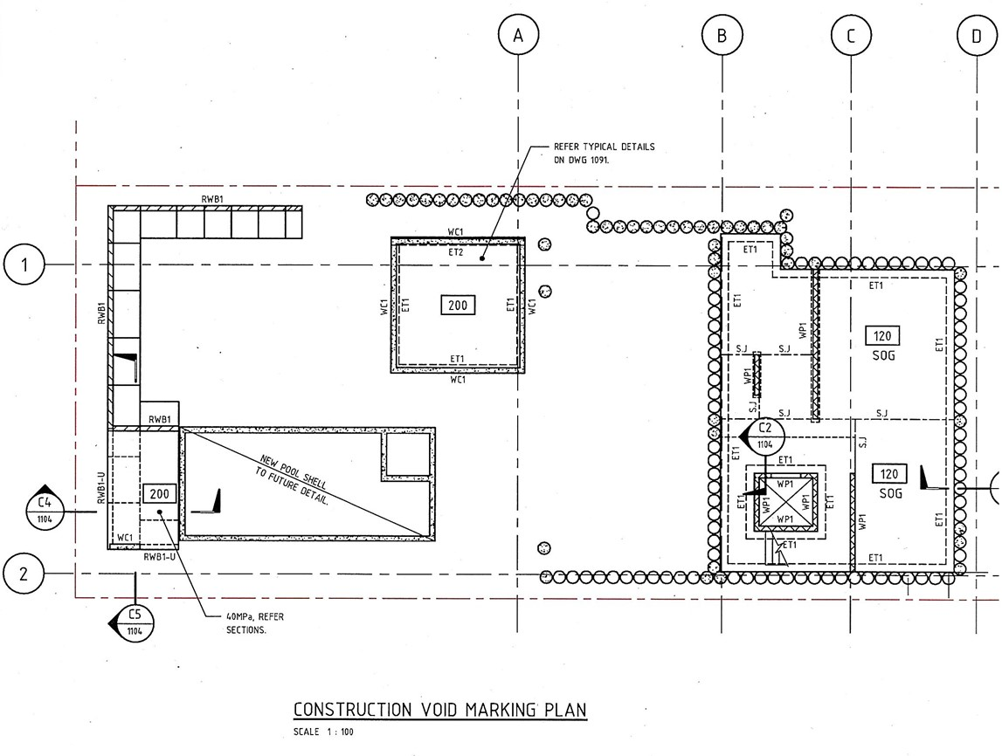
- Dwg 1104 Rev C, Construction Void Sections Sheet 1 (the Construction Void Sections Sheet 1) which shows:
- a crane base; and
- a construction void.
Part of the Construction Void Sections Sheet 1 is reproduced below:
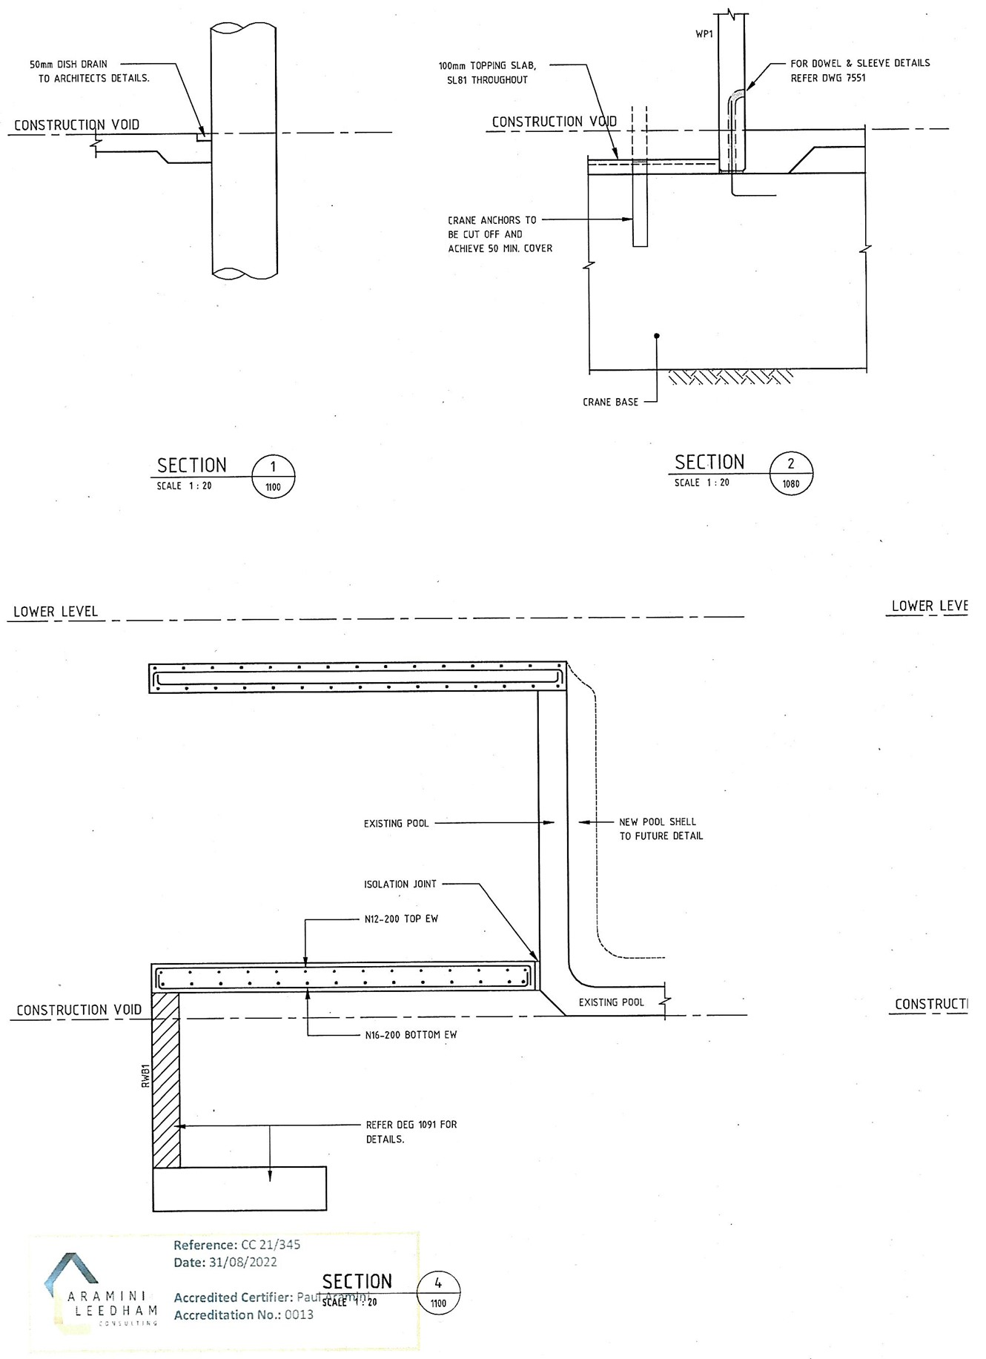
- Dwg 1200 Rev C, Lower Level Marking Plan which shows in the area of the former cellar:
- stairs; and
- a concrete slab with 200mm thickness;
- Dwg 1204 Rev C, Lower Level Sections Sheet 1 which includes a marking for a construction void; and
- Dwg 7502 Rev C, Wall Elevations – Precast Sheet 2, which shows:
- a lift;
- stairs; and
access to the construction void.
- The primary judge concluded that an approximate level for the construction void of between RL 15.6 and RL 15.8 could be extrapolated from the architectural plans and structural plans:
- the architectural plans depicting the lower level of the dwelling (being the level above the cellar or construction void level) with a finished floor level of RL 18.50;
- the same architectural plans showing a crane base, but not depicting the level of the crane base; and
- the structural plans showing a 2900mm socket extending:
- from the finished floor level of the lower level of the dwelling (shown on the architectural plans as at RL 18.50); and
- to below the finished floor level of the construction void, but within the width of the floor slab above the crane base.
An extract from the Shoring Elevations Sheet 1 structural plan is as follows:
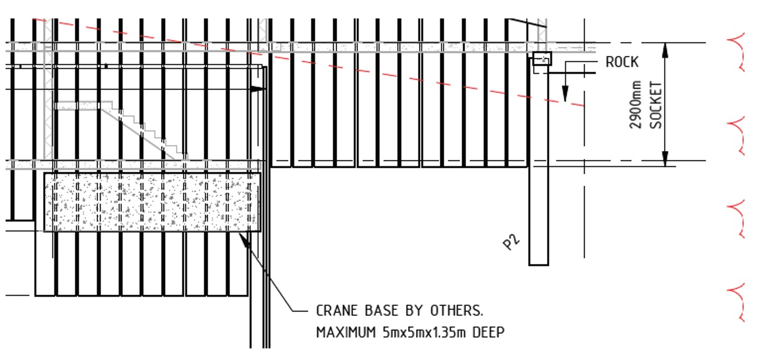
- the slab above the crane base being shown to continue beyond the crane base to the adjoining area and being variously:
- 100mm thick; and
- 200mm thick,
depending on its location within the floor plan of the construction void.
- Pausing there, as will become apparent, the central issue in this case springs from the inconsistency between condition C.1(d) of the development consent, which deleted the “cellar” and “store” and “Cellar Level” from the proposed consent and the construction certificate which permitted excavation of the area where the “Cellar Level” had been proposed, for the purposes of building a crane base and installing a crane.

The primary judgment
- There were five issues identified by the primary judge. Only issues 1, 4 and 5 remain controversial on appeal. Those issues and the answers given by the primary judge were:
- Whether the Court should extend time by approximately three months under r 59.10 of the Uniform Civil Procedure Rules 2005 (NSW) (“UCPR”) for the Council to commence proceedings for judicial review of the certifier’s decision of 31 August 2022 to issue the construction certificate. The three month period under r 59.10 for commencing the proceedings expired on 30 November 2022. The proceedings were commenced on 1 March 2023. Answer: Yes.
- Whether the modified development consent, properly construed, prohibits excavation within the area previously identified as the cellar level for all purposes. Answer: Yes.
- Whether the plans, specifications and standards of building work specified in the construction certificate are consistent with the modified development consent. Answer: No.
- If the answer to question (3) is no, whether it was legally unreasonable for the second respondent to determine that the plans, specifications and standards of building work specified in the construction certificate were consistent with the modified development consent. Answer: Yes.
- If the answer to question (4) is yes, whether the Court should make a declaration of invalidity in respect of all or part of the modified development consent having regard to any relevant discretionary consideration. Answer: Declaration of invalidity in respect of part of the modified development consent, being part of the construction certificate.
- On 26 April 2024, the primary judge made the following orders:
1 The Court declares that construction certificate 21/345, issued by Paul Aramini, on 31 August 2022 (CC) for the demolition of the existing dwelling and the construction of a new dwelling at [XX] Suttie Road, Bellevue Hill, is invalid and of no effect in so far as it purports to approve below RL 18.28 in the area hatched in red on the attached plan:
a. excavation;
b. structures including lift, lift shafts, stairs, walls, floor, and crane base; and
c. other works in that area.
2 Order that the First and Second Respondents, by themselves, their servants and agents, are restrained from carrying out any development in reliance on that part of the CC referred to in Order 1 above.
- The attached plan referred to in the primary judge’s orders provided: 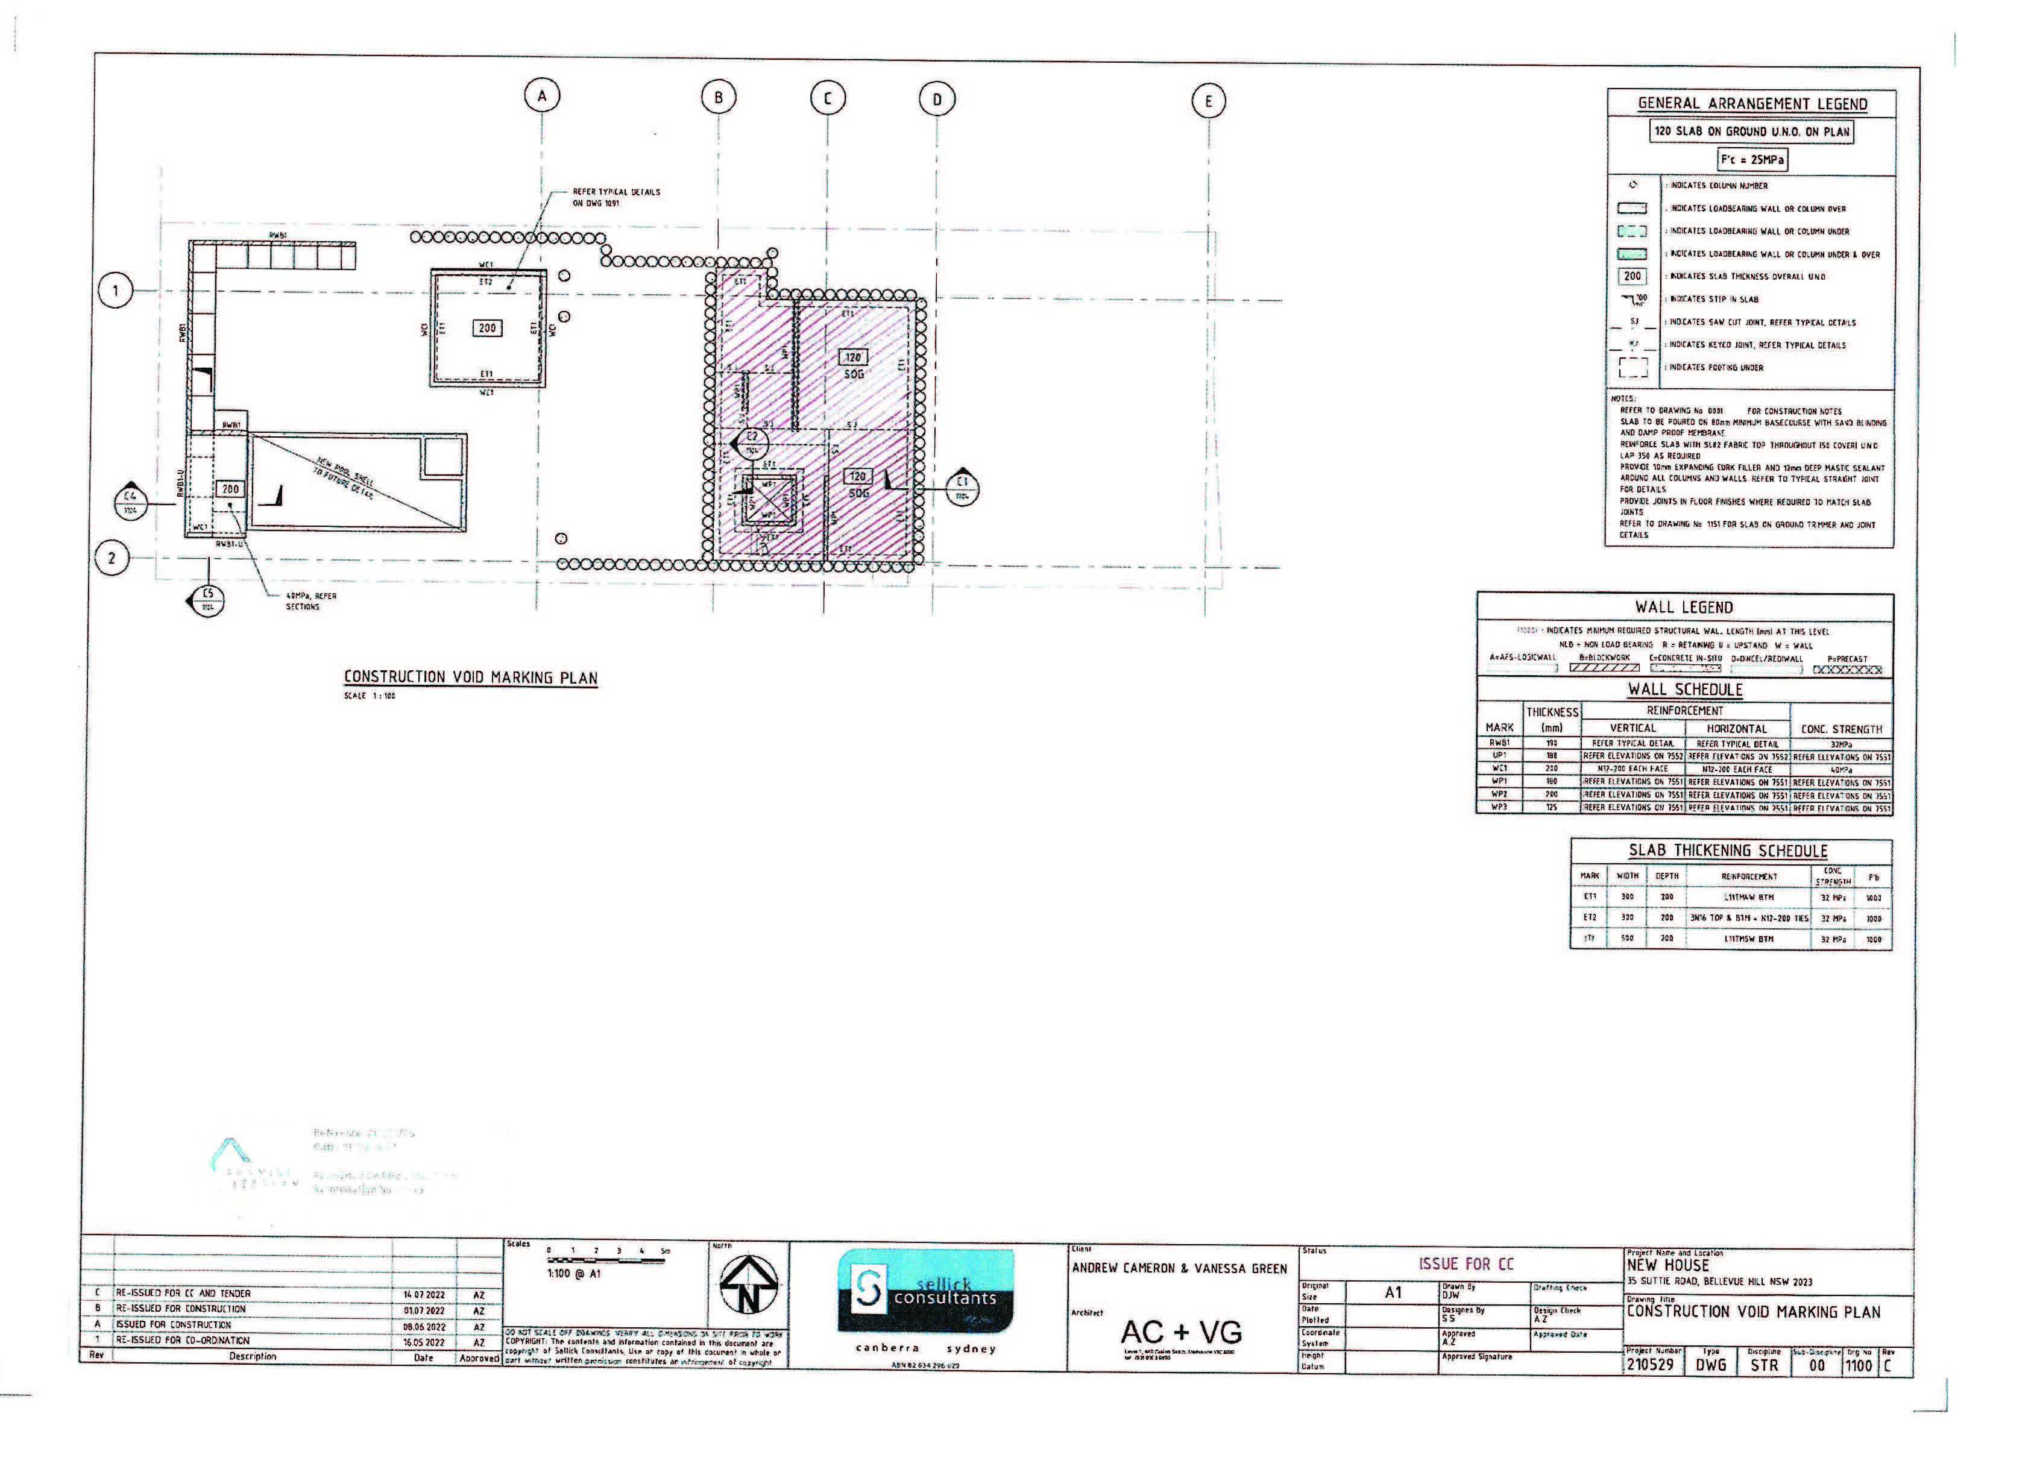
- Two matters should immediately be noticed about these orders. The first is that the construction certificate is set aside in part only, being the area hatched in red at the identified level. The second is that excavation below RL 18.28 is the level at which the order applies, rather than lower than the level of RL 18.50, which is the approved “lower level” in the development consent (see the diagram at [9] above). I will return to both of these matters below.

Reasoning of the primary judge

(1) Extension of time under UCPR r 59.10
- The primary judge was satisfied that the Land and Environment Court had jurisdiction to extend time to commence the proceedings under UCPR r 59.10: Bankstown City Council v Ramahi [2015] NSWLEC 74 (“Ramahi”).
- Her Honour was persuaded by the Council’s responsibility to enforce the EPA Act and the lack of significant prejudice to the appellants from the delay. Her Honour accepted the Council’s submission that any relevant prejudice, being expenses on building work incurred up to the expiry of the three month period for commencing the proceedings, is not connected to any delay on the part of the Council in commencing the proceedings. The primary judge accepted that there was no evidence as to what other works (if any) were carried out during that period, nor the potential costs of any such works, to enable a quantification of prejudice.
- The primary judge accepted the Council’s submission that any prejudice to the appellants needed to be considered in the context that the appellants knew that the Local Planning Panel “had essentially refused consent to a cellar level” and nonetheless submitted plans to the principal certifying authority that showed a cellar level.
- The primary judge was satisfied that the Council’s delay was not undue. The Council, having reviewed the construction certificate, attended the site the following day and on 6 February 2023 issued a development control order requiring the cessation of all excavation works below RL 18.30.
- The primary judge held that neither The Hills Shire Council v Drenovac [2022] NSWLEC 139 nor Central Coast Council v 40 Gindurra Road Somersby Pty Ltd (No 2) [2019] NSWLEC 171 is authority for the proposition that the Council’s role is to proactively monitor certificates issued by private certifiers. The rejection of that submission in Drenovac turned on the inadequacies of the Council’s evidence at [180], and in Gindurra Road at [234], Pain J emphasised that the Council had delayed for over one year.
- The primary judge accepted that the Council was entitled to presume that the construction certificate had been issued in compliance with the EPA Act, the Certification Regulation and the applicable environmental planning instrument and development standards.

(2) Construing the development consent
- Secondly, the primary judge held that the modified development consent, properly construed, prohibited excavation and works within the area previously identified in condition C.1(d) as the ‘cellar’ level for all purposes, including critically, to build a crane base. The primary judge concluded that there was nothing ambiguous in the language of condition C.1(d). As I have said this is no longer an issue on appeal.

(3) Inconsistency
- Thirdly, the primary judge held that the plans, specifications, and standards of building work specified in the construction certificate were not consistent with the development consent for several reasons:
- The development consent did not permit excavation for a crane base in the “cellar” level area. The development consent explicitly prohibited excavation in the spatial area previously occupied by the “cellar” level. The construction certificate permitted excavation in that area.
- The structural plans approved by the certifier indicated far more extensive excavation than what was allowed for a crane base. The “Cellar Level Plan”, deleted by the modified consent, still appeared in the construction plans, showing lifts and stairs inconsistent with the consent.
- The structural plans suggested the creation of a broader accessible space, not just the crane base and shoring. The inclusion of permanent structures like a lift and stairs indicated that the excavation was intended to be permanent, contradicting the requirement for the area to remain unexcavated.

(4) Legal unreasonableness
- The primary judge concluded that the certifier’s decision to issue the construction certificate was legally unreasonable. Her Honour found that there was no evident or intelligible basis for the certifier to determine that the building design and construction shown in the construction certificate was consistent with the development consent.
- The primary judge held that a certifier must act according to the law and must be rational and not unreasonable. In Trives v Hornsby Shire Council (2015) 89 NSWLR 268; [2015] NSWCA 158 at [14], Basten JA noted that even if a certificate’s validity depends on the certifier’s state of satisfaction, the certifier must act within legal and rational bounds. This means that unreasonableness must be inferred objectively from the matters before the certifier and the actual decision reached.
- The primary judge explained that while the threshold for proving a certifier’s decision is legally unreasonable is high, it has been met in other cases, such as Bankstown City Council v Ramahi (No 2) [2016] NSWLEC 34 (“Ramahi (No 2)”). The certifier, in the present case, had to ensure that the building design and construction plans incorporated in the construction certificate were consistent with the modified development consent per cl 19(1)(b) of the Environmental Planning and Assessment (Development Certification and Fire Safety) Regulation 2021 (NSW) (“Certification Regulation”).
- The primary judge also relied on Sader v Elgammal [2022] NSWLEC 107, where there was a successful legal unreasonableness challenge to a construction certificate because the development consent did not authorise the demolition of a wall. Duggan J at [51] observed that to the extent that the construction certificate permitted demolition of a wall, it was inconsistent with the development consent as the relevant provisions in the development consent and the construction certificate “could not be undertaken harmoniously”.
- Applying these principles, the primary judge held that only one conclusion was open to the certifier given the architectural and structural plans provided. These plans indicated the installation of a concrete crane base, which presupposed excavation, and described the area above it as a “void”. Her Honour held that a comparison of the modified development consent plans and the stamped construction plans clearly shows that the construction void overlaps with the “cellar” level.
- Thus, her Honour held that it was unreasonable to conclude that the construction certificate plans, which required excavation, were consistent with the modified development consent that prohibited such excavation.

(5) Invalidity
- The fifth issue was whether the Court should make a declaration of invalidity in respect of all or part of the modified development consent having regard to any relevant discretionary considerations.
- The primary judge concluded that the modified development consent does not permit excavation in the “cellar” level area and that the construction plans are inconsistent with the consent. The primary judge found that a declaration of invalidity was warranted due to jurisdictional error, but it would only apply to the excavation in the “cellar” level to minimise disruption and costs for the appellants. Her Honour found:
- Jurisdictional error generally leads to a declaration of invalidity, as such decisions lack a legal foundation. The declaration of invalidity was limited to the “cellar” level excavation to avoid broader impacts on the construction of the new dwelling.
- The appellants failed to show that the crane base could not be relocated to a higher level. The proposed excavation was not justified and was contrary to the development control plan’s objectives.
- Burwood Council v Ralan Burwood Pty Ltd (No 3) [2014] NSWCA 404, which was relied upon by the appellants, dealt with different legal issues and did not preclude the current declaration of invalidity.

Grounds of Appeal
- The notice of appeal provided:
1 In deciding to extend the time under rule 59.10 of the Uniform Civil Procedure Rules 2005 for the First Respondent to commence proceedings for judicial review of the Second Respondent’s decision of 31 August 2022 to issue construction certificate 21 /345 (Construction Certificate), the learned primary judge erred in the exercise of her discretion at J[107] in that her Honour:
a. treated as irrelevant and failed to take into account (or alternatively gave insufficient weight) to material considerations, namely:
i. that the First Respondent was in a position to commence the proceedings within time, having in its possession a copy of the Construction Certificate and having attended the development site on 27 October 2022 for enforcement purposes on that date; and/or
ii. the public interest in the certainty and finality of decisions made by certifiers in relation to construction certificates;
b. gave material weight to (or alternatively gave undue weight) to irrelevant considerations, namely:
i. the resources of the First Respondent and ‘the number of construction certificates and complying development certificates issued in the Woollahra Local Government Area each year’ at J[107](7); and/or
ii. that the First Respondent ‘knew’ that the Local Planning Panel “had essentially refused consent to a cellar level, submitted plans to the principal certifying authority that showed a cellar level” at J[107](5).
2 The learned primary judge erred in finding that it was ‘legally unreasonable’ for the Second Respondent to determine that the plans, specifications and standards of building work specified in the Construction Certificate were consistent with the modified development consent, in that, on the evidence before the Court, there was an evident and intelligible justification for the inconsistency between the relevant architectural plans and the structural plans contrary to J[179](1) and J[179](5)-(6) and J[179](10).
3 The learned primary judge erred in finding that the consequence of a finding of legal unreasonableness was the invalidity of the Construction Certificate at J[195] – [197].
- This appeal is brought under s 58 of the Land and Environment Court Act 1979 (NSW) and is an appeal by way of rehearing.

Relevant legal framework
- Before descending into the detail of the issues on the appeal it is necessary first to set out the relevant statutory background.
- Section 4.16(12) of the EPA Act (then numbered differently) is a provision at the heart of the decision in Ralan, a case which I will analyse in detail below. Section 4.16 (12) provides:
4.16 Determination (cf previous s 80)
…
(12) Effect of issuing construction certificate If a consent authority or a registered certifier issues a construction certificate, the construction certificate and any approved plans and specifications issued with respect to that construction certificate, together with any variations to the construction certificate or plans and specifications that are effected in accordance with this Act or the regulations, are taken to form part of the relevant development consent (other than for the purposes of section 4.55).
- Section 6.1 of the EPA Act contains definitions, relevantly
building work means any physical activity involved in the erection of a building.
Certifier means a council or a registered certifier.
…
Note—
Section 1.4 (Definitions) includes a complying development certificate in the definition of development consent for the purposes of this Act.
- Division 6.2 of the EPA Act deals with certificates required under the certification part of the Act, and s 6.3 provides, relevantly:
6.3 Work or activity that requires certificate under this Part (cf previous s 109C)
(1) A person must not carry out any of the following work or activity without a certificate under this Part that is required by this Part for that work or activity—
(a) building work,
…
(2) A person must not, in carrying out any such work or activity, contravene a certificate under this Part that applies to the carrying out of the work or activity.
…
Maximum penalty—Tier 1 monetary penalty.
…
- Section 6.4 identifies the kinds of certificates to which the Part applies, being relevantly:
6.4 Kinds of certificates under this Part (cf previous s 109C)
There are the following kinds of certificates under this Part—
(a) construction certificate—a certificate to the effect that building work completed in accordance with specified plans and specifications or standards will comply with the requirements of the regulations.
…
- Section 6.5 of the EPA Act sets out the functions of certifiers and provides, relevantly:
6.5 Functions of certifiers (including principal certifiers) (cf previous s 109E)
(1) A certifier has the following functions in relation to building work—
(a) issuing construction certificates for building work,
….
(4) A certifier also has any other functions conferred or imposed on the certifier under this or any other Act.
….
(5) A certifier must not issue a certificate under this Part—
(a) in any case in which this part or Part 7 provides that the certificate is not to be issued, or
(b) in any case in which the function of issuing the certificate is not conferred on the certifier by this Part.
Maximum penalty—Tier 3 monetary penalty.
…
- Section 6.7 of the EPA Act requires the issue of a construction certificate prior to the erection of a building in accordance with a development consent:
6.7 Requirement for construction certificate (cf previous s 81A)
(1) A construction certificate is required for the erection of a building in accordance with a development consent.
…
- Section 6.8(1) of the EPA Act contains preconditions to the issue of a construction certificate. That section provides, relevantly:
6.8 Restriction on issue of construction certificate (cf previous s 109F)
(1) A construction certificate must not be issued with respect to the plans and specifications for any building work unless—
(a) the requirements of the regulations have been complied with, and
…
(2) A construction certificate has no effect if it is issued after the building work to which it relates is physically commenced on the land to which the relevant development consent applies.
- The Certification Regulation provides for the detailed requirements of a construction certificate, including those referred to in s 6.8 of the EPA Act. Clauses 7 and 8 of the Certification Regulation set out the formal requirements of a construction certificate, including the use of the electronic planning portal (cl 7) and identify the contents of a construction certificate (cl 8). It is not suggested that these clauses throw particular light on the question in this case.
- Clause 12 of the Certification Regulation allows a certifier to request additional information. Clause 13 of the Certification Regulation provides further requirements for the contents of a construction certificate and provides for notification, via the NSW planning portal, to the consent authority of, relevantly, the construction certificate issued as a result of the determination and the relevant building work plans and specifications. It is common ground here that the certifier complied with the requirements of cl 13 of the Certification Regulation and within two days notified the Council of all relevant information including the construction certificate issued as a result of the determination and the relevant building work, plans and specifications.
- Clauses 16 and 17 of the Certification Regulation provide a requirement for inspections and a creation of a record of site inspections.
- Clause 19(1) of the Certification Regulation is a critical provision in the present case. Clause 19, relevantly, provides:
19 Compliance with development consent and Building Code of Australia
(1) A certifier must not issue a construction certificate for building work unless—
…
(b) the design and construction of the building, as described in the relevant building work plans and specifications and in other information given to the certifier under section 12, is consistent with the development consent, and
…
Maximum penalty (subsection (1))—
(a) for a corporation—300 penalty units, or
(b) for an individual—150 penalty units.
- In respect of an asserted breach of cl 19(1)(b), an important change was inserted into the EPA Act in March 2018 in s 6.32. Section 6.32 provides:
6.32 Validity of certificates under this Part
Without limiting the powers of the Court under section 9.46(1), the Court may by order under that section declare that a certificate under this Part (other than an occupation certificate) is invalid if—
(a) proceedings for the order are brought within 3 months after the issue of the certificate, and
(b) the plans and specifications or standards of building work or subdivision work specified in the certificate are not consistent with the development consent for the building work or subdivision work.
- The section is no doubt a statutory reaction to the decision of this Court in Ralan. A number of things should be noticed about the section. It addresses the validity of a construction certificate and provides an express power to order that a certificate issued under this Part (other than an occupation certificate) is invalid. The power to make an order declaring a construction certificate invalid has a strict time limit to commence proceedings in which such an order can be sought; 3 months after the issue of the certificate.
- There is an equivalent provision in relation to a complying development certificate in s 4.31 of the EPA Act:
4.31 Validity of complying development certificate
Without limiting the powers of the Court under section 9.46(1), the Court may by order under that section declare that a complying development certificate is invalid if—
(a) proceedings for the order are brought within 3 months after the issue of the certificate, and
(b) the certificate authorises the carrying out of development for which the Court determines that a complying development certificate is not authorised to be issued.
- Section 6.33 provides:
6.33 Regulations: Part 6
(cf previous s 109Q)
(1) The regulations may make provision for or with respect to the carrying out of building work or subdivision work and, in particular, for or with respect to the following—
(a) requirements to comply with provisions of the Building Code of Australia or other specified standards in relation to building work or subdivision work,
(b) applications for and the issue of certificates under this Part,
(c) the form and contents of certificates under this Part,
(d) conditions of certificates under this Part,
(e) modification of certificates under this Part,
(f) exempting classes of manufactured homes or temporary structures from requirements relating to construction certificates or occupation certificates,
(g) inspection of building work and subdivision work,
(h) the functions of certifiers under this Part,
(i) the replacement of certifiers,
(j) exemptions in relation to the requirement to obtain a certificate under this Part,
(k) the keeping of records in relation to building work or subdivision work,
(l) notices and information to be given in relation to the carrying out of building work and subdivision work,
(m) the procedure for dealing with complaints about building work or subdivision work.
(2) The regulations may apply the provisions of this Part to State significant infrastructure.
- Division 9.5, which is headed “Civil Enforcement Proceedings”, is important. Section 9.44, which illustrates the scope of the other provisions of Division 9, should be referred to. That section provides:
9.44 Definitions (cf previous s 122)
In this Division—
(a) a reference to a breach of this Act is a reference to—
(i) a contravention of or failure to comply with this Act, and
(ii) a threatened or an apprehended contravention of or a threatened or apprehended failure to comply with this Act, and
(b) a reference to this Act includes a reference to the following—
(i) the regulations,
(ii) an environmental planning instrument,
(iii) a consent granted under this Act, including a condition subject to which a consent is granted,
(iv) a complying development certificate, including a condition subject to which a complying development certificate is granted,
(v) a development control order,
(vi) a planning agreement referred to in section 7.4.
- Key provisions are ss 9.45 and 9.46 of the EPA Act which provide:
9.45 Restraint etc of breaches of this Act (cf previous s 123)
(1) Any person may bring proceedings in the Court for an order to remedy or restrain a breach of this Act, whether or not any right of that person has been or may be infringed by or as a consequence of that breach.
(2) Proceedings under this section may be brought by a person on his or her own behalf or on behalf of himself or herself and on behalf of other persons (with their consent), or a body corporate or unincorporated (with the consent of its committee or other controlling or governing body), having like or common interests in those proceedings.
(3) Any person on whose behalf proceedings are brought is entitled to contribute to or provide for the payment of the legal costs and expenses incurred by the person bringing the proceedings.
(4) (Repealed)
9.46 Orders of the Court (cf previous s 124)
(1) Where the Court is satisfied that a breach of this Act has been committed or that a breach of this Act will, unless restrained by order of the Court, be committed, it may make such order as it thinks fit to remedy or restrain the breach.
(2) Without limiting the powers of the Court under subsection (1), an order made under that subsection may—
(a) where the breach of this Act comprises a use of any building, work or land—restrain that use,
(b) where the breach of this Act comprises the erection of a building or the carrying out of a work—require the demolition or removal of that building or work, or
(c) where the breach of this Act has the effect of altering the condition or state of any building, work or land—require the reinstatement, so far as is practicable, of that building, work or land to the condition or state the building, work or land was in immediately before the breach was committed.
(3) Where a breach of this Act would not have been committed but for the failure to obtain a consent under Part 4, the Court, upon application being made by the defendant, may—
(a) adjourn the proceedings to enable a development application to be made under Part 4 to obtain that consent, and
(b) in its discretion, by interlocutory order, restrain the continuance of the commission of the breach while the proceedings are adjourned.
(4) The functions of the Court under this Division are in addition to and not in derogation from any other functions of the Court.
(5) Nothing in this section affects the provisions of Division 3 of Part 3 of the Land and Environment Court Act 1979.
- As Basten JA explained in Moorebank Recyclers Pty Ltd v Tanlane Pty Ltd [2018] NSWCA 304, s 9.45 (which was s 123 before it was renumbered) has two purposes: first, it is an open standing provision which permits “[a]ny person” to bring proceedings to remedy or restrain a breach of the EPA Act, whether or not that person has a right which has been infringed. Secondly, it confers jurisdiction on the Land and Environment Court to hear and determine such proceedings. Section 9.46 (which was s 124 before it was renumbered) confers power on the Land and Environment Court to provide relief no more particularly identified than simply by reference to “an order to remedy or restrain a breach”, which had been the submission made in that case. His Honour was not, contrary to a submission made by the Council in the present case, stating that orders under s 9.46 could be made to address the jurisdiction conferred by s 20(2) of the Land and Environment Court Act.
- Section 20(2) of the Land and Environment Court Act provides:
The Court has the same civil jurisdiction as the Supreme Court would, but for section 71, have to hear and dispose of the following proceedings—
(a) to enforce any right, obligation or duty conferred or imposed by a planning or environmental law, a development contract or a strata renewal plan,
(b) to review, or command, the exercise of a function conferred or imposed by a planning or environmental law, a development contract or a strata renewal plan,
(c) to make declarations of right in relation to any such right, obligation or duty or the exercise of any such function,
(d) whether or not as provided by section 68 of the Supreme Court Act 1970—to award damages for a breach of a development contract.
- Section 20(2) of the Land and Environment Court Act provides a judicial review jurisdiction in relation to rights and functions “conferred or imposed by a planning or environmental law, a development contract or a strata renewal plan”. This jurisdiction engages an equivalent jurisdiction to that conferred by s 69 of the Supreme Court Act 1970 (NSW) to those rights and functions to which it applies.

Ground 1

Submissions on ground 1
- Although the appellants’ written submissions stated that because the appeal is brought pursuant to s 58 of the Land and Environment Court Act 1979 (NSW), it is not necessary to demonstrate a House v The King (1936) 55 CLR 499 error to establish ground 1, it was conceded by Mr Hemmings SC, Senior Counsel for the appellants at the hearing, that House v The King error needed to be shown.
- The appellants submitted that the House v The King error arose from the primary judge’s failure properly to recognise the statutory scheme which provides for a three month limitation to commence cases seeking orders of invalidity of a construction certificate under s 6.32 of the EPA Act.
- The appellants submitted that there were two main reasons tending against the extension of time to commence judicial review proceedings here. First, it was submitted that the Council was in a position to commence proceedings within time. Secondly, it was submitted that there was public interest in the certainty and finality of decisions made by certifiers in relation to construction certificates.
- The appellants submitted that the primary judge failed properly to take into account a material consideration being the time at which the Council became aware or, by exercising reasonable diligence, should have become aware that the construction certificate was issued. The appellants highlighted the mandatory notification provisions in the Certification Regulation which are triggered by the decision-making process. Clause 13(2) of the Certification Regulation requires that within 2 days after determining the application, the certifier use the NSW planning portal to give a copy of the determination and the construction certificate to the Council as well as other materials necessary to scrutinise the construction certificate to determine whether there is a departure from the development consent or a risk to public safety that might warrant intervention: Ralan at [184]. Such scrutiny may occur within a three month window: s 6.32 of the EPA Act. While the Council was not actually aware of the inconsistency between the construction certificate and the development consent until it received a complaint on 31 January 2023, the appellants submitted that this was because the Council had elected to take a reactive approach.
- The appellants submitted that the argument that the Council has limited resources is unpersuasive given specific legislation limiting challenges to relevant time periods citing Drenovac [2022] at [180] and Gindurra at [233] and [234]. It was argued that a contrary finding would mean that the statutory time limit in s 6.32 of the EPA Act serves no purpose.
- The Council submitted that it was not part of the Council’s statutory functions or duties to be a supervising body over certifiers. The Council, it said, received the documentation as a record keeper. The primary judge noted the number of construction certificates and complying development certificates issued in the Woollahra Local Government Area each year. The Council has a responsibility to ensure compliance with planning law and thus had an interest in these proceedings. The Council submitted that the Council was entitled to presume that certifiers will comply with their statutory obligations: Ramahi at [95].

Consideration of ground 1
- UCPR r 59.10 provides:
59.10 Time for commencing proceedings
(1) Proceedings for judicial review of a decision must be commenced within 3 months of the date of the decision.
(2) The court may, at any time, extend the time for commencing proceedings fixed by subrule (1).
(3) In considering whether to extend time under subrule (2), the court should take account of such factors as are relevant in the circumstances of the particular case, including the following—
(a) any particular interest of the plaintiff in challenging the decision,
(b) possible prejudice to other persons caused by the passage of time, if the relief were to be granted, including but not limited to prejudice to parties to the proceedings,
(c) the time at which the plaintiff became or, by exercising reasonable diligence, should have become aware of the decision,
(d) any relevant public interest.
(4) This rule does not apply to proceedings in which there is a statutory limitation period for commencing the proceedings.
(5) This rule does not apply to any proceedings in which the setting aside of a decision is not required.
- In Ramahi, Preston CJ of LEC dealt with a case involving a complying development certificate issued by a private certifier. Despite the apparent similarity of the issues involved here, Ramahi is quite different to the present case. Ramahi was a case where there was no right of appeal against the determination of, or a failure or refusal to determine, an application for a complying development certificate by a council or accredited certifier (then s 85A(10) of the EPA Act, now repealed, see s 4.28 EPA Act). However, as Preston CJ of LEC recognised, there was still available the right conferred by s 20(2) of the Land and Environment Court Act to bring proceedings for judicial review of a determination of, or a failure or refusal to determine, an application for a complying development certificate.
- There was a privative provision, then numbered s 101 of the EPA Act, now s 4.59 of the EPA Act, which forbade judicial review of a determination of an application for a complying development certificate save where proceedings were commenced within three months after the occurrence of identified procedural steps. Section 101 provided:
If public notice of the granting of a consent or a complying development certificate is given in accordance with the regulations by a consent authority or an accredited certifier, the validity of the consent or certificate cannot be questioned in any legal proceedings except those commenced in the Court by any person at any time before the expiration of 3 months from the date on which public notice was so given.
- Preston CJ of LEC explained that the public notification of a complying development certificate operated to commence the three month time limitation period for commencing proceedings questioning the validity of the complying development certificate for the purposes of s 101. The ratio of Ramahi is:
“[73] In this case, because no public notice has been given for the purposes of s 101 of the EPA Act of the decisions to issue the complying development certificates, s 101 of the EPA Act does not operate to establish a three month limitation period for commencing proceedings for judicial review of those decisions. This means, for the purposes of r 59.10(4), there will only be a statutory limitation period for commencing proceedings for judicial review of decisions to grant development consent or a complying development certificate if and when public notice of the decisions is given for the purposes of s 101 of the EPA Act.”
- In the present case the provision engaged, s 6.32 of the EPA Act, is different to s 101 (which is now s 4.59). The section does not on its face forbid judicial review of a determination of an application for a construction certificate if the identified procedural steps in s 6.32 are not complied with. Rather, s 6.32 is a merits review provision which must be exercised, if at all, by commencing proceedings within a strict three month time limit.
- No case was advanced, by any party, that in context s 6.32 of the EPA Act should be understood as a privative provision of the kind addressed by the former s 101. As I will explain, in addressing ground 3, there is a potentially large question, expressly disavowed by the appellants here, about the availability of judicial review for jurisdictional error of a decision to grant a construction certificate. Any suggestion that the availability of judicial review for jurisdictional error of a decision to grant a construction certificate was in any way limited was also expressly disavowed by the appellants: as an example of possible limits to the availability of judicial review for jurisdictional error see Commissioner of Taxation v Futuris Corporation Limited (2008) 237 CLR 146; [2008] HCA 32.
- There was also an issue in Ramahi about the potential application of UCPR r 59.10(4), which it will be recalled provided “[t]his rule does not apply to proceedings in which there is a statutory limitation period for commencing the proceedings”. The appellants, however, made no submission that the time limit in s 6.32 of the EPA Act was relevant to UCPR r 59.10(4).
- The appellants accepted that the Land and Environment Court had jurisdiction to judicially review the grant of the construction certificate for jurisdictional error. That is because, in 20(2) of the Land and Environment Court Act, that Court is granted the same civil jurisdiction as the Supreme Court would have (but for s 71) to hear and dispose of proceedings including the present proceedings and, relevantly, to make declarations of right or to review or command the exercise of a function.
- Section 20(2) has been set out above at [55]. It is common ground that all relevant Acts and Regulations engaged in this case are “a planning or environmental law” within the meaning of s 20(2). As Leeming JA explained in Community Housing Limited v Clarence Valley Council (2015) 90 NSWLR 292; [2015] NSWCA 327, a case where it was submitted that there was a conflict between limited statutory right of appeal and the general right to invoke the supervisory jurisdiction of the Land and Environment Court conferred by s 20(2) of the Land and Environment Court Act:
“[32] The direct answer to this issue is that there is, in truth, no conflict between the limited statutory right of appeal and the general right to invoke the supervisory jurisdiction of the Land and Environment Court by way of judicial review. A recurring feature of litigation within the Australian legal system is the overlap between judicial review and statutory rights of appeal. Typically, the existence of a right of appeal will give rise to discretionary considerations attending judicial review. See for example Brennan v New South Wales Land and Housing Corporation [2011] NSWCA 298; 83 NSWLR 23 at [101]; recent examples may be seen in Navazi v New South Wales Land and Housing Corporation [2015] NSWCA 308 and Day v Sanders [2015] NSWCA 324.”
- In exercising the discretion to extend time pursuant to UCPR r 59.10, the Court takes into account the factors in the rule where they are relevant. Time will not be extended unless there is both a sufficient explanation for the delay and it is in the interest of justice to grant an extension: Clancy v Director of Public Prosecutions [2018] NSWCA 102 at [7] (Basten JA, Macfarlan and Meagher JJA agreeing). The four considerations in UCPR r 59.10(3) are inclusive rather than exhaustive: Toth v Director of Public Prosecutions (NSW) [2014] NSWCA 133. From Toth, (at [9]) and Tomko v Palasty (No 2) (2007) 71 NSWLR 61; [2007] NSWCA 369 the following matters as being important to the exercise of the discretion to extend time may be derived:
- the delay in bringing the application for an extension of time;
- the practical consequence of a successful judicial review of the relevant decision;
- the explanation of the delay in bringing the proceedings;
- the apparent merit of the proceedings (which requires at least the demonstration of a fairly arguable case); and
- the extent of any prejudice suffered by the respondent to the application.
- It was common ground that in order to disturb the decision of the primary judge granting an extension of time House v The King error needs be shown.
- The statutory context, residential building pursuant to a construction certificate issued after an extensive development application process, suggests that a tight rein should be kept on applications to extend time for judicial review lodged after expiry of the three month limit. I am not, however, satisfied that the primary judge erred in extending time to commence proceedings in the present case. This is for the following reasons:
- The appellants’ submission that the primary judge failed to afford sufficient weight to the public interest in the certainty and finality of decisions made by certifiers in relation to construction certificates must be seen in that light; that is, the appellants did not submit that in this statutory scheme a decision by a certifier to grant a construction certificate was certain or final after three months.
- The delay in bring proceedings in this case, of (approximately 6 months from the issue of the construction certificate and 3 months from the expiry of the time limit for merits review) is a fairly neutral factor in the decision to extend time to commence judicial review proceedings. It is certainly not the kind of gross delay which is itself disentitling.
- The potential practical consequences of a successful judicial review application in the present case are significant.
- The primary judge accepted the Council’s explanation of the delay in bringing the proceedings as being, essentially, that there are hundreds of construction certificates issued each year and the Council’s resources were insufficient properly to monitor those construction certificates for consistency with development approvals. I do not think her Honour erred in so concluding. I do not accept, however, the Council’s submission that it has no statutory role in monitoring compliance of construction certificates with the statutory scheme. The requirement (here complied with) imposed on a certifier to file a construction certificate with the Council within two days of its making is inconsistent with any such conclusion. A Council who acts as this Council did runs the risk that the respondent to the judicial review application can successfully resist an application for extension of time by demonstrating prejudice. For example, in the present case if excavation of the construction void had been completed or substantially completed, that would likely have been fatal to the Council’s application to extend time to commence a judicial review application.
- The need to demonstrate the apparent merit of the proceedings, which requires at least the demonstration of a fairly arguable case, was satisfied here.
- The absence of any evidence of prejudice to the appellants by the extension of time in the present case was striking. There was no evidence as to what other works (if any) were carried out during the period, nor the potential costs of any such works, to enable a quantification of Council’s delay. No evidence was led of difficulties in the already commenced construction or even any additional costs likely to be incurred if the application for judicial review was permitted to be commenced out of time. Had there been any evidence of real prejudice to the appellants, an extension of time application may have faced real difficulties. But there was no relevant evidence led.
- The primary judge did not err in extending time pursuant to UCPR r 59.10 to commence judicial review proceedings for jurisdictional error of the decision to issue a construction certificate in the form it took. I would reject ground 1.

Ground 2

Appellants’ submissions
- By ground 2, the appellants argued that the primary judge erred in finding that it was legally unreasonable for the certifier to determine that the plans, specifications and standards of building work in the certificate were consistent with the development consent.
- The appellants argued that the text and context of the EPA Act support a high bar of legal unreasonableness which mere inconsistency between the development consent and construction certificate would not ordinarily suffice. They gave the following reasons:
- The starting point is section 4.16(12) of the EPA Act, extracted above at [37].
- Section 6.32 expands the scope of merits review but limits it to a three month period, recognising public interest in the finality of certificates. After this period, a challenge based solely on inconsistency is not enough.
- The prohibition in s 6.8 of the EPA Act targets the authority issuing a construction certificate, such as a council or an accredited certifier, rather than the person benefiting from the development consent. But the developer may suffer adverse consequences if they rely in good faith on a certificate that is later deemed invalid due to inconsistency with the development consent.
- The appellants observed that this high bar has “led the Courts to remark that judicial review on the basis of manifest unreasonableness is rare”.
- The appellants argued that the inquiry into whether a decision is legally unreasonable is “outcome-focused”, “asking whether the decision ultimately reached by the decision-maker can be supported by a hypothetical decision-maker undertaking logical analysis on the evidence available”: Minister for Immigration and Citizenship v SZMDS (2010) 240 CLR 611; [2010] HCA 16 (Crennan and Bell JJ at [130]) and Masi-Haini v Minister for Home Affairs (2023) 298 FCR 277; [2023] FCAFC 126 at [51]. The appellants argued that the “outcome-focused” approach is the appropriate approach in this case because the certifier did not give reasons for the issue of the certificate.
- As to the standard of unreasonableness, the appellants said that “[a] decision may be unreasonable if it lacks an evident and intelligible justification or is so devoid of plausible justification that no reasonable person could have taken that course”.
- In particular, the appellants argued that a certifier may issue a construction certificate that breaches a consent condition, making it inconsistent but not necessarily irrational or manifestly unreasonable, especially if there is a clear justification for the decision. Whether issuing the certificate was irrational or “manifestly unreasonable” depends on the specific facts in the consent conditions.
- Applying this standard to the facts, the appellants argued that while the matters identified by the primary judge may give rise to a finding of inconsistency, they do not yield a finding which is inconceivable, irrational or perverse when the conditions of the consent are read as a whole. The appellants’ reasoning was as follows.
- First, the appellants construed condition C.1(d) of the development consent which they said “must be read with other conditions. A development consent must be read as a whole and the ordinary rules of construction and principles of interpretation apply as with any other statutory instrument”.
- Secondly, the appellants argued that the excavation and shoring and piling works were required to be carried out by reference to the structural plans and details. The construction certificate documentation contains detailed written directions of a professional engineer and “[u]ltimately, it does not matter whether upon close review of the plans there was a staircase or liftwell at the base of the construction void to the crane base, because this was in accordance with the written directions of the engineer”.
- In relation to the issue of stairs and lifts being installed, the appellants submitted that the level was not to be used as a cellar but for construction purposes.
- Thirdly, the appellants argued that in installing the crane base, being a substantial slab of concrete, “it is logical that it would be located at the deepest part of the development so that the development could be constructed above it”. Again, they argued that “it was not the proper role of the certifier to critically analyse the structural engineer’s approach to the structural engineering and construction of the building”.
- Fourthly, the appellants argued that “assuming that the development was finally completed in accordance with the architectural plans, at the completion of the development it would be possible to say that the cellar ‘level’ would ‘remain unexcavated’ for the purposes of condition C.1(d) as the void is depicted as being filled”. As such, “the justification for the construction void was that it was for construction purposes, was temporary and in accordance with condition [E.8]”. Condition E.8 provided:
“Excavation must be undertaken in accordance with the recommendations of the Geotechnical/Hydrogeological Monitoring Program and any oral or written direction of the supervising professional engineer …”
- Fifthly, the appellants’ submitted that the development consent must be construed as a whole to determine whether there was an evident justification for a conclusion that the construction certificate was consistent with the development consent. As Mr Hemmings SC said, “We say that the evident justification that the certifier has is by looking at the materials that have been provided to him by the professional engineer”. These materials include the “written directions of the supervising professional engineer in respect of excavation for the purposes of condition E.8”.
- The appellants submitted that the primary judge erred in finding that the certifier’s decision was unreasonable because:
- The primary judge ought to have found that there was an evident or intelligible basis for the certifier to conclude that the design and the construction of the building in the construction certificate was consistent with the development consent. That included reliance on the conditions of consent as a whole, including the conditions contemplating the use of a crane and condition E.8 which required that excavation must be undertaken in accordance with written direction of the supervising professional engineer.
- Ramahi (No 2) related to a different statutory regime, being that pertaining to complying development certificates. The facts there involved a clear departure from the built form controls, including a proposed rear setback of the secondary dwelling of 0.9m, when the required rear setback was of 8m.
- Sader which was relied upon by the primary judge was not a manifest unreasonableness challenge. Rather, it was a challenge brought within time limited by s 6.32, and merely found inconsistency.

The Council’s submissions
- The Council submitted that any inference of unreasonableness is drawn from an objective consideration of the matters in issue before the certifier and the outcome. In other words, “[i]t is not incumbent upon an applicant for judicial review, nor the Court, to identify a particular error to ground a conclusion of unreasonableness. That would negate the results-focussed lens for assessing unreasonableness”.
- The Council submitted that the certifier had no jurisdiction to misconstrue the law. That is, the area of discretion given to the certifier was premised upon a single correct construction of the development consent. The question of how the development consent is construed is one for the Court. The Council said that the appellants approach attempted to speculate that the certifier may have made a different legal error, most likely a jurisdictional error, by misconstruing the consent. Thus, the relevant question is not whether another construction of the development consent was reasonably open to the certifier, but, given the Courts finding about the legal meaning of a legislative instrument such as a development consent—a question of law with only one correct answer—whether there was an evident and intelligible justification for the certifier’s conclusion that the plans and specifications shown in the plans were consistent with the consent (properly construed).
- The Council also argued that the appellants “mischaracterise[d] the primary judge’s approach” by saying that the primary judge erroneously equated her finding that the development consent had one meaning with a finding that anything different to that single meaning was manifestly unreasonable. The Council submitted that the primary judge was correct to find that the question of consistency with the consent (after it was properly and objectively construed and given its one legal meaning) was not one on which reasonable minds could differ.
- The Council argued that the primary judge’s approach was correct, that is, “any inference of unreasonableness is drawn from an objective consideration of the matters in issue before the certifier and the outcome”. Applying these considerations, the Council argued that that the certifier’s decision was unreasonable for several reasons.
- First, as the primary judge found, the language of condition C.1(d) is clear. It is not expressed in generic language, but gave a specific direction as to what must occur with the plans (deletion of the cellar level), and what must not occur on the site (the area must remain unexcavated). The Council submitted that there was no contestable evaluative element in this case. Condition C.1(d) is unambiguous. Secondly, the Council argued that none of the conditions pointed to by the appellants required excavation or the installation of a crane, let alone in the area of the cellar level. General conditions, such as that any excavation required a monitoring program (condition E.8) or that cranes may be erected (condition E.13), yield to the more specific condition that there be no excavation in the cellar level (condition C.1(d)).
- In oral submissions, Mr Lazarus SC for the Council explained that:
[The other provisions] may contemplate, to use Mr Hemmings’ language, the use of a crane, but they certainly don’t contemplate or they don’t mandate the use of a crane and nor do they contemplate the use of a crane in this location. The mere fact, as Mr Hemmings said, that the structural engineers have come up with what he described as a solution, it may be a very clear solution to a problem; doesn’t obviate the need and doesn’t excuse the certifier from forming a proper reasonable view about the consistency question, and that is important.
- Thirdly, the Council argued that documents created after the grant of a development consent, such as a construction management plan, cannot be relevant to construction of the consent. As such, they argued that the fact that an engineer may have prepared plans (or given a written direction) requiring a construction void and crane base after the grant of the consent and the imposition of condition C.1(d), cannot have any bearing on the construction of that consent. That approach, they argued, would provide “carte blanche to an engineer to recommend any extent of excavation, with the effect of altering the consent, irrespective of express conditions”.
- Fourthly, in response to the appellants’ argument that the cellar level would technically remain “unexcavated”, the Council submitted that the appellants should not be able to run this argument because “[t]he argument about the meaning of ‘remain’ was expressly abandoned by the Appellants in the proceedings below”. The appellants argued that the void would not be backfilled; instead, after removing the crane, a lift would be installed on top of the slab to function as a goods lift for the internal fit-out. Thus, “[i]t is inimical to the due administration of justice to permit the Appellant to run an argument that not only was not run below, but is in complete contradistinction to it”.
- In the alternative, the Council argued that “[i]t defies common sense, and the ordinary meaning of the word “remain”, for an area to remain unexcavated when part of it is occupied by a crane base, lift, stairs, and walls”. As held by the primary judge, “there was to be no excavation at all of the area of the ‘cellar’ level”. The words “associated excavation” in the heading are in context “plainly referable to the location, and not the purpose, of the excavation”.
- The Council argued that the primary judge did not err in finding that the certifier’s decision was unreasonable because “[t]here was no evident or intelligible justification” for the certifier to make the finding that the construction certificate was consistent with the development consent. Adopting the primary judge’s reasoning:
- Installation of a crane base substantially below the surface presupposes excavation, as does the description of the area immediately above it as a void.
- A simple comparison between the construction certificate plans (structural and architectural) and the plans approved by the modification application “clearly shows” that the construction void is in the same area as the cellar level.

Consideration of ground 2
- The unreasonableness ground of judicial review is no longer limited to what is in effect an irrational, if not bizarre, decision – which is to say one that is so unreasonable no reasonable person could have arrived at it: Minister for Immigration and Citizenship v Li (2013) 249 CLR 332; [2013] HCA 18 at [68] (Hayne, Kiefel and Bell JJ). In Judicial Review of Administrative Action and Government Liability by M Aronson, M Groves and G Weeks (Thomson Reuters, 6th ed, 2017) it is suggested at [6.450], that Li “invites a qualitative assessment of the impugned discretionary decision, but it does not allow an appeal to the judicial review judge’s subjective sense of reasonableness”.
- In Li French CJ said:
“[30] The requirement of reasonableness is not a vehicle for challenging a decision on the basis that the decision-maker has given insufficient or excessive consideration to some matters or has made an evaluative judgment with which a court disagrees even though that judgment is rationally open to the decision-maker. Gleeson CJ and McHugh J made the point in Eshetu that the characterisation of somebody’s reasoning as illogical or unreasonable, as an emphatic way of expressing disagreement with it, “may have no particular legal consequence”. As Professor Galligan wrote [DJ Galligan, Discretionary Powers: A Legal Study of Official Discretion (Oxford University Press, 1986) at 140]:
“The general point is that the canons of rational action constitute constraints on discretionary decisions, but they are in the nature of threshold constraints above which there remains room for official judgment and choice both as to substantive and procedural matters. In other words, within the bounds of such constraints, different modes of decision-making may be employed.”
A distinction may arguably be drawn between rationality and reasonableness on the basis that not every rational decision is reasonable. It is not necessary for present purposes to undertake a general consideration of that distinction which might be thought to invite a kind of proportionality analysis to bridge a propounded gap between the two concepts. Be that as it may, a disproportionate exercise of an administrative discretion, taking a sledgehammer to crack a nut, may be characterised as irrational and also as unreasonable simply on the basis that it exceeds what, on any view, is necessary for the purpose it serves. That approach is an application of the principles discussed above and within the limitations they would impose on curial review of administrative discretions.” (Footnotes omitted.)
- The plurality in Li, Hayne, Kiefel and Bell JJ, at [63] held that the legislature is taken to intend that a discretionary power, statutorily conferred, will be exercised reasonably: see also Attorney-General for the States of New South Wales v Quin (1990) 170 CLR 1 at 36; [1990] HCA 21; Kruger v The Commonwealth (1997) 190 CLR 1 at 36; [1997] HCA 27; Minister for Immigration and Multicultural Affairs v Eshetu (1999) 197 CLR 611; [1999] HCA 21 at [126]; Minister for Immigration and Citizenship v SZIAI (2009) 83 ALJR 1123; [2009] HCA 39 at [15]. Their Honours went on:
“[65] In Sharp v Wakefield [[1891] AC 173 at 179], it was said that when something is to be done within the discretion of an authority, it is to be done according to the rules of reason and justice. That is what is meant by “according to law”. It is to be legal and regular, not arbitrary, vague and fanciful. The discretion must be “exercised within the limit, to which an honest man competent to the discharge of his office ought to confine himself”. It is pointed out in Wade and Forsyth [Administrative Law (Oxford University Press, 10th ed, 2009) at 293-294] that the legal conception of discretion dates from at least the 16th century. In Sharp v Wakefield, Lord Halsbury LC had referred to Rooke’s Case [(1597) 5 Co Rep 99b at 100a; 77 ER 209 at 210], in which it was stated that the discretion of commissioners of sewers “ought to be limited and bound with the rule of reason and law”.
[66] This approach does not deny that there is an area within which a decision-maker has a genuinely free discretion. That area resides within the bounds of legal reasonableness. The courts are conscious of not exceeding their supervisory role by undertaking a review of the merits of an exercise of discretionary power. Properly applied, a standard of legal reasonableness does not involve substituting a court’s view as to how a discretion should be exercised for that of a decision-maker. Accepting that the standard of reasonableness is not applied in this way does not, however, explain how it is to be applied and how it is to be tested.
…
[68] Lord Greene MR’s oft-quoted formulation of unreasonableness in Wednesbury has been criticised for “circularity and vagueness”, as have subsequent attempts to clarify it. However, as has been noted, Wednesbury is not the starting point for the standard of reasonableness, nor should it be considered the end point. The legal standard of unreasonableness should not be considered as limited to what is in effect an irrational, if not bizarre, decision – which is to say one that is so unreasonable that no reasonable person could have arrived at it – nor should Lord Greene MR be taken to have limited unreasonableness in this way in his judgment in Wednesbury. This aspect of his Lordship’s judgment may more sensibly be taken to recognise that an inference of unreasonableness may in some cases be objectively drawn even where a particular error in reasoning cannot be identified. This is recognised by the principles governing the review of a judicial discretion, which, it may be observed, were settled in Australia by House v The King, before Wednesbury was decided. And the same principles evidently informed what was said by Dixon J about review of an administrative decision in Avon Downs Pty Ltd v Federal Commissioner of Taxation, which was decided less than two years after Wednesbury, at a time when it was the practice of the High Court to follow decisions of the Court of Appeal in England which appeared to have settled the law in a particular area.” (Footnotes omitted.)
- Gageler J said:
“[90] Implication of reasonableness as a condition of the exercise of a discretionary power conferred by statute is no different from implication of reasonableness as a condition of an opinion or state of satisfaction required by statute as a prerequisite to an exercise of a statutory power or performance of a statutory duty [R v Connell; Ex parte The Hetton Bellbird Collieries Ltd (1944) 69 CLR 407 at 432; [1944] HCA 42; Enfield City Corporation v Development Assessment Commission (2000) 199 CLR 135 at [34]; [2000] HCA 5]. Each is a manifestation of the general and deeply rooted common law principle of construction that such decision-making authority as is conferred by statute must be exercised according to law and to reason within limits set by the subject-matter, scope and purposes of the statute [Sharp v Wakefield [1891] AC 173 at 179, cited in R v Connell; Ex parte The Hetton Bellbird Collieries Ltd (1944) 69 CLR 407 at 431; [1944] HCA 42 and in Shrimpton v The Commonwealth (1945) 69 CLR 613 at 620; [1945] HCA 4. See generally R v Anderson; Ex parte Ipec-Air Pty Ltd (1965) 113 CLR 177 at 189; [1965] HCA 27; Murphyores Incorporated Pty Ltd v The Commonwealth (1976) 136 CLR 1 at 17-18; [1976] HCA 20; Minister for Immigration and Multicultural Affairs v Jia Legeng (2001) 205 CLR 507 at [62]; [2001] HCA 17].”
- In this case, it was common ground that there is an implication that a certifier will act reasonably in exercising the function set out in s 6.5(1)(a) of the EPA Act of issuing construction certificates.

The meaning of “consistent”
- Before addressing unreasonableness in the context of a decision to issue a construction certificate, it is first necessary to address the meaning of “consistent” in cl 19 of the Certification Regulation and s 6.32 of the EPA Act.
- In Ralan, Sackville AJA explained:
“[147] The ordinary meaning of “inconsistent” includes “lacking in harmony between different parts or elements” or “self-contradictory” (Macquarie Dictionary); “discrepancy” or “incongruity” (Shorter Oxford English Dictionary). There is no reason to think that the expression “not inconsistent” is used in anything other than its ordinary meaning: see Coffs Harbour Environment Centre Inc v Minister for Planning (1994) 84 LGERA 324 at 331 (Kirby P) (construing s 36 of the EPA Act which concerns “inconsistency” between environmental planning instruments). On this basis, his Honour should have directed attention to whether the two sets of specifications were inconsistent, in the sense of lacking harmony between different elements or lacking congruity.
[148] No doubt this is not a straightforward task. Not every difference between the DA and the plans and specifications furnished to the certifying authority and approved in the CCs amounts to an inconsistency in the relevant sense. As Lloyd J observed in El Cheikh v Hurstville City Council [2001] NSWLEC 175; 115 LGERA 425 at [74], albeit in another context, a difference does not necessarily constitute an inconsistency. Some adjustment to approved plans and specifications, as the primary Judge suggested, may be inevitable in a large and complex project. (See also the observations of Sperling J (Sully and Simpson JJ agreeing) in Moy v Warringah Council [2004] NSWCCA 77; 133 LGERA 49 at [59]-[82]).
[149] But the question of inconsistency was not to be resolved by asking whether Mr Bowers had, or thought he had, aesthetic or other reasons for changing the approved plans and specifications (see Primary Judgment at [326]). Nor was it a matter of whether the variations could reasonably be regarded as improving the external appearance of the building. It was also not to the point that, as his Honour found (at [325]), Mr Bowers had not “deliberately ignored the question of whether his changes might, in some cases, warrant the making of a modification application”. To address the Council’s contention, it was necessary to make findings as to the nature and extent of the variations to the approval plans and specifications. It was then necessary to make a judgment as to whether the variations were or were not inconsistent, in the relevant sense, with the plans and specifications approved in the DA. The primary Judge did not undertake these tasks.”
- A number of matters may be noticed arising from these important passages:
- In determining whether a construction certificate was inconsistent with a development consent the ultimate question is whether the two sets of “specifications” are inconsistent, in the sense of lacking harmony between different elements or lacking congruity. As Sackville AJA said: “No doubt this is not a straightforward task”.
- It bears emphasis that not every difference between a development consent and the plans and specifications furnished to the certifying authority and approved in the construction certificate amounts to an inconsistency in the relevant sense. A difference does not necessarily constitute an inconsistency. Some adjustment to approved plans and specifications are likely inevitable in a large and complex project.
- The task in determining “inconsistency” is to make findings about the nature and extent of the variations to the approval plans and specifications. It is then necessary to make an evaluative judgment as to whether the variations were or were not inconsistent, in the relevant sense, with the plans and specifications approved in the development consent.
- As I have earlier said, there is no challenge to the primary judge’s finding that the construction certificate was inconsistent with the development consent in the manner identified.

What does unreasonableness provide in the context of a decision to issue a construction certificate?
- Although Corowa v Geographe Point Pty Ltd & Anor [2007] NSWLEC 121 was decided when cl 145 of the Environmental Planning and Assessment Regulation 2000 (NSW) required the satisfaction of the certifier and before Ralan established that inconsistency with a development consent did not render a construction certificate invalid, Jagot J, when her Honour was a judge of the Land and Environment Court, usefully summarised the correct approach to a claim of manifest unreasonableness in relation to the issue of a construction certificate:
“[92] Construction certificates are regulated by Pt 4A of the EPA Act. The statutory provisions have not materially altered since the Council issued the construction certificate (8 March 2006). Section 109C(1)(b) provides that a construction certificate is a certificate to the effect that work completed in accordance with specified plans and specifications will comply with the requirements of the regulations referred to in s 81A(5). Section 81A(5) enables the regulations to make provision concerning the issue of certificates for the erection of buildings and the subdivision of land. Section 80(12) provides that a construction certificate and any approved plans and specifications issued with respect to it are taken to form part of the relevant development consent (other than for the purposes of s 96). Clause 145(2) provides that a certifying authority must not issue a construction certificate for subdivision work unless it is satisfied that the design and construction of the work (as depicted in the plans and specifications and as described in any other information furnished to the certifying authority under cl 140) are not inconsistent with the development consent. The question “whether or not there is a breach of a provision of the Act will depend in part on the proper construction of the provision in question” (Lesnewski v Mosman Municipal Council (2005) 138 LGERA 207 at [82]). The relevant pre-condition to the issue of the construction certificate was the state of satisfaction of the certifying authority (in this case, the Council) that the design and construction of the work depicted in the construction certificate documents was not inconsistent with the development consent. Accordingly, an allegation of inconsistency, of itself, cannot found breach (see Lesnewski at [82]). It follows that the only claim capable of founding breach in this case was that the Council’s state of satisfaction was manifestly unreasonable.
[93] The resolution of that claim requires comparison between the construction certificate and the development consent before the construction certificate was granted (given the effect of s 80(12)). Mr Corowa’s essential complaint is that the development consent required the development to be completed in accordance with the statement of environmental effects and figure 1.0 prepared by Blueland engineers dated August 2004, except where varied by the conditions of consent (see condition 1). The text of the statement of environmental effects apparently represented that most trees and vegetation on lot 121 would be retained. Yet many trees and vegetation on lot 121 have been removed. In these circumstances, it is not difficult to understand a sense of grievance about the development application process in this case. Nevertheless, the Court “has no jurisdiction to cure administrative injustice or error” (Quin at 36). The issues are to be resolved by proper construction of the development consent and construction certificate, and application of the well-known principles applying to claims of manifest unreasonableness…”(emphasis added)
- Jagot J emphasised that the well known principles applying to claims of manifest unreasonableness including the “stringent threshold required to make good a claim of manifest unreasonableness” at [97].

Inconsistency and unreasonableness
- It was common ground that the statutory powers exercised by the certifier under the EPA Act and the Certification Regulation to issue a construction certificate are subject to the implied statutory condition that they are to be exercised within the bounds of reasonableness: Li at 351-2 (French CJ), 370-1 (Gageler J). That is, it was common ground that the decision of the certifier was amenable to judicial review for legal unreasonableness.
- No decision of this Court has considered the scope of judicial review for legal unreasonableness of a certifier’s decision to issue a construction certificate under the current statutory regime. None of the prior authorities in the Land and Environment Court have addressed this issue under the current provisions. As I noted, Geographe Point was decided under legislation which required the satisfaction of the certifier of the relevant state of affairs.
- It is of course correct that cl 19(1) of the Certification Regulation imposes a positive requirement that the design and construction of the building, as described in the relevant building work plans and specifications and other information given to the certifier, is “consistent with” the modified development consent. That is the first step in the analysis.
- But inconsistency between a development consent and a construction certificate does not, in itself, establish that the decision of the certifier to issue a construction certificate was legally unreasonable. It is a mistake to move too readily from the conclusion that, correctly construed, a construction certificate is inconsistent with a development consent to the conclusion that the making of the construction certificate was legally unreasonable in the sense I have explained. To do so would replace the judicial review jurisdiction with merits review, which is strictly time limited by s 6.32 of the EPA Act.
- I accept the appellants’ submission that the text and context of the EPA Act establish a high bar for a finding of legal unreasonableness. Many of the Council’s submissions in this Court elided the distinction between establishing inconsistency and establishing legal unreasonableness. This is an error in approach. The fact that on its proper construction the construction certificate was inconsistent with the development consent is only the beginning of the analysis.
- For that reason, I respectfully disagree with the primary judge that the conclusion of Duggan J in Sader was relevant to establishing legal unreasonableness. That case addressed a challenge brought within 3 months under s 6.32 of the EPA Act. Although Duggan J’s analysis of the inconsistency between the construction certificate and the development consent addresses the first question, the correct construction of the construction certificate, the decision does not provide guidance about whether the decision in that case was legally unreasonable.

Threshold of unreasonableness
- In addressing the question of legal unreasonableness, Jagot J’s analysis in Geographe Point, although under a different regime, provides useful guidance: the “issues are to be resolved by proper construction of the development consent and construction certificate, and application of the well-known principles applying to claims of manifest unreasonableness”. The well known principles of applying to claims of manifest unreasonableness are those I have set out at [99]-[103] above.
- Shortly put, in judicial review for legal unreasonableness the Court is required to undertake a qualitative assessment of the impugned decision. The fact the construction certificate is inconsistent with the development consent does not necessarily mean that a certifier, acting reasonably, could not have come to another conclusion. The label “legal unreasonableness” will attach to the certifier’s decision if the nature and extent of the inconsistency and the reasons for which the certifier came to conclude that the construction certificate and the development consent were “consistent” lead to the conclusion that the decision was unreasonable in the sense explained in Li,.
- As Sackville AJA explained in Ralan, a case which proceeded on a common assumption that the construction certificate issued there was inconsistent with the development consent, despite the mandatory language used in the then s 109F(1) of the EPA Act (which is now s 6.8(1)) and cl 145(1) of the Environmental Planning and Assessment Regulation 2000 (which is now cl 19 of the Certification Regulation), the defaults in the issue of a construction certificate in a particular case may be “major or minor, deliberate or inadvertent, fundamental or marginal”: Ralan at [173] citing Smith v Wyong Shire Council [2003] NSWCA 322.
- To establish legal unreasonableness in the present context, it must be shown that the certifier’s decision that the construction certificate was consistent with the development consent was unreasonable in the sense explained in Li. Useful guidance about this question is provided by Al Maha Pty Ltd v Huajun Investments Pty Ltd [2018] NSWCA 245, albeit the case involved a Land and Environment Court Commissioner’s decision to grant consent to development application for residential flat building which was inconsistent and unclear. The issue was whether the decision to grant development consent was legally unreasonable. This Court held that it was not. Preston CJ of LEC said:
“[213] Although I agree that the further amended plans describing the internal access and circulation within the basement carpark are inconsistent and unclear, I do not consider that these deficiencies in the plans caused the development application not to be a development application for the purposes of the EPA Act and the [Certification Regulation] or cause the development consent granted to that application not to be valid, by lacking certainty or being legally unreasonable. The issue is one of construction of the provisions of the EPA Act and the [Certification Regulation] regulating the making of a development application and the grant of consent to a development application as well as the application of those provisions to the circumstances of the case: Winn v Director General of National Parks and Wildlife at [12].
[214] I do not consider that the deficiencies in the further amended plans for the basement carpark are of such magnitude as to cause the development application not to comply with the essential statutory prescriptions for a development application. The development application still describes the development to be carried out, being the erection of a building and the subsequent use of the building, which is development that may not be carried out except with development consent. The fact that, if development is carried out in accordance with the further amended plans, the internal access and circulation in the basement will be significantly constrained does not cause the development described in the plans not to be “development” for the purposes of the EPA Act or the development application seeking consent for that development not to be a development application for the purposes of the EPA Act. As I noted earlier, Spigelman CJ held in Currey v Sutherland Shire Council at [35] that people are entitled to apply to a consent authority for whatever development they like, provided that it answers the description of being development that may not be carried out except with consent, and that “there is no relevant prohibition, express or implied, which impinges upon the application making process”.
[215] Only if the deficiencies in the description of the development in the development application, such as in the plans accompanying the development application, cause the development application to fail to meet some essential statutory prescription for making a development application, will the deficiencies cause the development application not to be a development application for the purposes of the EPA Act and [Certification Regulation].”

Assessing reasonableness in this case
- As earlier explained, the appellants adduced no evidence from themselves, their builder, architect or structural engineer, nor from the certifier. As no reasons were given by the certifier for the making of the construction certificate, in addressing the question of legal unreasonableness it is necessary to engage in a process of inferential reasoning. Dixon J in Avon Downs Pty Ltd v Federal Commissioner of Taxation (1949) 78 CLR 353 explained a decision may be reviewable for jurisdictional error even though the decision-maker has not given reasons, Dixon J stated at 360:
“If the result appears to be unreasonable on the supposition that he addressed himself to the right question, correctly applied the rules of law and took into account all the relevant considerations and no irrelevant considerations, then it may be a proper inference that it is a false supposition.”
- The starting point remains that there is no challenge to the determination of the primary judge that the construction certificate was not consistent with the development consent. In determining whether the certifier, acting reasonably, could nevertheless have come to the conclusion that the construction certificate was consistent with the development consent, inferences must be drawn.
- I accept the appellants’ submission that in addressing the question of legal unreasonableness, the development consent must be read as a whole. In doing so, I note that the development consent permits the ongoing construction of structural elements of the new house that were approved prior to the removal of the cellar level. Condition C.1(d) was however emphatic that “the ‘cellar’ level including the mechanical ventilation, wine cellar, store, lift and access stairs must be deleted; and the area must remain unexcavated”. The primary judge found that:
“[137] … there is nothing ambiguous in the language of condition C.1(d) and that, properly construed, the modified development consent prohibits excavation in the area identified in condition C.1(d) by the descriptor ‘cellar’ level; that is, excavation below RL 18.28 in the area hatched red on the Construction Void Marking Plan (Dwg No. 1100 Rev C) attached to Council’s amended proposed orders. That includes excavation and works in that area for all purposes, including for structures such as a lift, lift shaft, stairs, walls, floors and a crane base.”
- The construction plans approved as part of the development consent have clearly and unequivocally deleted the “cellar” level, the store room, the staircase and the lift accessing the lower level.
- It is against that background that the appellants argued that acting reasonably the certifier could have concluded that the construction certificate was consistent with the development consent must be tested.
- The appellants’ case essentially rested on how condition C.1(d) of the development consent was to be reconciled with specific construction conditions, including condition E.8 extracted above at [87], if there was a relevant direction from a supervising professional engineer. Condition C.1(d) was not expressed as prevailing over the other conditions.
- Whilst the construction plans approved by the engineer as part of the construction certificate provided the excavation of the former cellar level to place a crane, there is no evidence that the excavation of the deleted cellar level to place a crane was a “recommendation of the Geotechnical/Hydrogeological Monitoring Program and any oral or written direction of the supervising professional engineer” or, perhaps more importantly, any basis that the construction plans could have been understood as such by a certifier acting reasonably. If there had been such a “direction” from the supervising professional engineer, within the meaning of condition E.8, this may have been a very different case.
- Secondly, it is also correct that the development consent approved some piling below the 18.5 level, despite deletion of the “cellar” level. The development consent did not, however, approve piling below the 18.5 level in the deleted cellar area. I do not accept that, acting reasonably, a certifier could have concluded that despite deletion of the “cellar” level, including the piling below the 18.5 level in the area in the deleted cellar level was nevertheless permissible under the development consent.
- In the plans approved by the Council as part of the development consent, although the store and cellar levels are marked as “to be deleted”, section B shows continuous piles and cavity to waterproof basement walls. To the extent that the installation of piles is excavation, there is no specific requirement in the conditions of the consent or marked on the plans that these piles be reduced in their depth. It is clear, in context, however that these piles and cavity to waterproof basement walls were an integral part of the deleted store and cellar level. They were within the red clouded area clearly marked as deleted. Acting reasonably the certifier could not have understood that the continuous piles and cavity to waterproof basement walls to have been approved by the development consent.
- Thirdly, the appellants relied on “approved specified architectural plans and documents including architectural plans and a Geotechnical and Hydrogeological Report prepared by AssetGeoEnviro dated 18 September 2020” which provided for works below ground level including continuous piles and cavity to waterproof basement walls. These piles were to extend below the floor level of the lower ground level. They were accompanied by a note that the conditions of consent prevailed over the approved plans stating: “plans and supporting documentation may be subject to conditions imposed under section 4.17(l)(g) of the Act modifying or amending the development (refer to conditions which must be satisfied prior to the issue of any construction certificate).”
- Reliance on these plans by the appellants is essentially circular. These plans are integral to the excavation for the purpose of crane installation in the deleted cellar level. The continuous piles and cavity to waterproof basement walls were, on all the evidence, matters necessary to build the crane platform but were not otherwise necessary to permit the ongoing construction of structural elements of the new house that was approved prior to the removal of the cellar level.
- Fourthly, while I accept the appellants’ submission that there is no doubt that the “development consent as a whole permits the installation of a crane”, this does not take the matter very far. The development consent envisaged that if cranes were to be accommodated on site, the plans must detail how the cranes will be erected and removed: “Site cranes and hoists may be erected with the boundary of the land being developed”. This shows the development consent anticipated building the new house by using cranes in order to erect it.
- What is conspicuously absent, however, is any indication in any of the material before the Court that construction of the crane at a level excavated in the former cellar area was necessary to permit the ongoing construction of structural elements of the new house that was approved prior to the removal of the cellar level, such that a reasonable certifier could have concluded that the construction certificate was consistent with the development consent.
- I accept that, acting reasonably, a certifier could have concluded that the plans accompanying the construction certificate demonstrated that the proposed cellar itself had been removed and that the walls within the construction void serve structural purposes, not for performing a function for a cellar. What I am unable to accept, however, is that the excavation to create the construction void was necessary to permit the ongoing construction of structural elements of the new house that was approved prior to the removal of the cellar level, such that a reasonable certifier could have concluded that the construction certificate was consistent with the development consent as a whole.
- Fifthly, in relation to the construction void marking plan and its “Wall Legend”, I am unable to accept the appellants submission that these precast panels in the construction void were necessary to support the load-bearing walls above. There is no indication in any of the material that this is the correct conclusion to draw. If additional load bearing walls were necessary for any purpose other than to create the construction void, there would have been some indication in the voluminous material that additional load bearing walls were necessary properly to construct the house.
- Finally, I accept that the stairs and the lift leading to the construction void in the construction certificate plans served construction purposes. That conclusion, however, rather begs the question. The evidence does not support an inference that the excavation to create the construction void was necessary to permit the ongoing construction of structural elements of the new house that was approved prior to the removal of the cellar level, such that a reasonable certifier could have concluded that the construction certificate was consistent with the development consent as a whole.

Conclusion on unreasonableness
- The starting point of the analysis is that the construction certificate was not consistent with the development consent. Condition C.1(d) had two clear elements. The question is whether a certifier acting rationally, and having regard to the development consent as a whole, could have taken the view that the construction certificate plans were consistent with that development consent.
- Although there is a high hurdle for an applicant who seeks to demonstrate legal unreasonableness in the making of a construction certificate, this was a case in which there was a very clear condition of development consent. On its proper construction the development consent does not permit excavation of the area formerly described as the cellar. Inferences I draw from the available material provide support for a conclusion that the engineer believed that an appropriate way of building the house was to excavate the area where the deleted cellar was to be located and put a crane in the void. That however is not enough. In the face of such a clear condition no reasonable certifier could have issued a construction certificate which set condition C.1(d) at naught unless there was some basis to think that the excavation of the former cellar level was necessary in order properly to build the house.
- In all the circumstances of this case, I have concluded that the primary judge did not err in concluding that the decision of the private certifier to issue a construction certificate in the form it took was legally unreasonable.
- Ground 2 should be dismissed.

Ground 3

Submissions on ground 3
- The appellants argued that the finding made by the primary judge of jurisdictional error for legal unreasonableness does not necessarily result in invalidity of the construction certificate. The appellants accepted that Ralan is not determinative of whether a finding of jurisdictional error was invalidity of the certificate as a whole.
- The appellants accepted that Ralan concerned an alleged breach of the EPA Act and not judicial review. The appellants argued, nevertheless, that the reasoning in Ralan should be extended to judicial review cases.
- First, the appellants argued that “there is no rule that jurisdictional error necessarily results in a finding of invalidity. Rather it is merely the usual outcome and ultimately the intention of the Parliament which is the guiding principle”. They submitted that “[i]t is rare for a Parliament to indicate in clear terms that if a decision maker errs on a particular topic, then the decision in question will be invalid”. In assessing Parliament’s intention, the appellants argued that “[i]t is not a matter of identifying whether there has been jurisdictional error and then asking if such error was intended to lead to invalidity … Rather, one asks if there has been an error or non compliance with the express or implied requirements of the statute”.
- Secondly, the appellants submitted that, based on the statutory scheme under the EPA Act and the intention of Parliament, this Court in Ralan concluded emphatically that a jurisdictional error did not result in invalidity. The appellants submitted:
- In both Ralan and in these proceedings, the core of the Council’s complaint is one of “inconsistency” for the purposes of the relevant regulation. The rationale in Project Blue Sky Inc v Australian Broadcasting Authority (1998) 194 CLR 355; [1998] HCA 28 applies where there is a failure to comply with a condition regulating the exercise of a power. Compliance with the provisions of the regulations, and a requirement to act reasonably, were both such requirements
- There is nothing about the scheme of the EPA Act that requires the ultimate conclusion in Ralan not to apply in a legal unreasonableness case. The appellants argued that Sackville AJA’s reasoning in Ralan (as follows) is “directly applicable”:
- Adverse consequences. The requirements in s 6.8 are not directed to the person who has the benefit of a consent. They are directed to the person who is empowered to issue a construction certificate namely a Council or a certifier. A developer may suffer adverse consequences by relying in good faith on a construction certificate that has apparently been lawfully issued if it is held invalid for inconsistency with the consent.
- Text of s 6.8(2). Section 6.8(2) of the EPA Act strongly suggests that a construction certificate issued in breach of s 6.8(1) is not invalid. Section 6.8(2) states that a construction certificate “has no effect” if it is issued after the building work to which it relates is physically commenced. This provision demonstrates that if Parliament intends that a construction certificate issued in breach of statutory requirements is to be held invalid, it says so explicitly.
- Administration of a power only. In Project Blue Sky, the High Court observed (at [95]) that if the relevant requirement does not have a “rule-like quality which can be easily identified and applied”, the better conclusion is that the requirement goes to the administration of a power, rather than to its validity. In the EPA statutory scheme, a requirement of consistency is an “inherently contestable” judgment.
- Other provisions. The EPA Act provides that construction certificates will be invalid in certain specific instances such as when the certificate is issued after the commencement of construction: s 6.8(2) EPA Act. The statutory scheme suggests that “if the Parliament intends that a construction certificate issued in breach of statutory requirements is to be held invalid, it says so explicitly” Another example of the issue with an invalid construction certificate is that a person cannot start using or occupying a new building until an occupation certificate is issued. This restriction in the statutory scheme, the appellants argued, suggests that “Parliament has chosen to guard against the risk of accredited certifiers failing to comply with their statutory obligations by an accreditation and disciplinary regime, rather than by the blunt mechanism of rendering a construction certificate void”.
- In oral address, senior counsel for the appellants submitted that the EPA Act provided specific mechanisms to address statutory breaches, which do not necessarily involve invalidating the decision:
The legislative scheme as a whole has identified a three month window in which you can have it set aside. After having set it aside, the construction of the statutory scheme says a certificate issued in breach is not declared invalid because the legislature took a deliberately different approach, which was to sanction the certifier, either professionally or criminally, and to provide for something like 4.16(12).
- The appellants also referred to the case of Bunderra Holdings Pty Ltd v Pasminco Cockle Creek Smelter Pty Ltd (subject to Deed of Company Arrangement) (2017) 96 NSWLR 434; [2017] NSWCA 263. They argued that Bunderra suggested that the construction certificate once issued is taken to be incorporated into the development consent, and therefore, carrying out development in accordance with the development consent in the certificate means it is not carrying out unlawful development.
- The appellants further submitted that the Land and Environment Court has, by s 20(2) of the Land and Environment Court Act, the same civil jurisdiction as the Supreme Court would have (but for s 71 of the same Act) to relevantly, make declarations of right or to review or command the exercise of a function. The appellants argued that “the judicial review jurisdiction is inherent in the Land and Environment Court itself because it doesn’t, of necessity, depend upon a breach”:
- The Council gave three reasons why the reasoning in Ralan should not extend to legal unreasonableness review for jurisdictional error.
- First, “the nature of unreasonableness” is “a ground for judicial review; it is inherent in the nature of the ground that its breach is a jurisdictional error”. The Council argued that “the requirement of legal reasonableness is implied” and “is not one which is derived from the words of the statute”. Therefore, “[g]iven the legislature is taken to have intended that power not be exercised outside the bounds of reasonableness, the result of a finding of unreasonableness is that the decision is outside of the authority of the statute, or ultra vires”.
- Secondly, “there are limits as to what reliance upon the legislative scheme can achieve in limiting review for what would otherwise be jurisdictional error”. The Council submitted that if jurisdictional error is inherent in a finding of legal unreasonableness, the effective exclusion of review in reliance upon the statutory scheme is contrary to the constitutional entrenchment of review for jurisdictional error mandated by Kirk v Industrial Court of New South Wales (2010) 239 CLR 531; [2010] HCA 1. It was submitted:
The EPA Act does not expressly exclude review for jurisdictional error. The two provisions identified by the Appellants, being s 6.32 and 6.8(2), expand that jurisdiction. Section 6.8 makes clear of one instance that results in the construction certificate having no effect. Section 6.32 confers power upon the Court to engage in a direct review for inconsistency. That was introduced in response to the decision in Ralan. The provision itself makes clear that it is an additional power, and not restrictive of other powers of the Court.
- Thirdly, it was submitted that an extension of Ralan’s reasoning was not warranted. The Council submitted that the appellants’ framing of the issue conflates a finding of jurisdictional error with its consequences. A finding of jurisdictional error has the effect that the decision is properly to be regarded as no decision at all which, usually, will result in a declaration of invalidity. Extending Ralan’s reasoning to jurisdictional error is problematic. If the decision-maker acted outside their legal authority, invalidity follows naturally from this finding.
- The Council also submitted that s 9.46 of the EPA Act was available as a source of power for the Land and Environment Court to set aside the construction certificate in part. The Council cited in support Tanlane.

Consideration of ground 3

Jurisdictional error
- As Kiefel CJ, Gageler and Keane JJ explained in Hossain v Minister for Immigration and Border Protection (2018) 264 CLR 123; [2018] HCA 34 at [23], “[j]urisdiction, in the most generic sense in which it has come to be used … refers to the scope of the authority that is conferred on a repository”. In its application to judicial review of administrative action the taking of which is authorised by statute, jurisdiction refers to the scope of the authority which a statute confers on a decision-maker to make a decision of a kind to which the statute then attaches legal consequences. It encompasses in that application all of the preconditions which the statute requires to exist in order for the decision-maker to embark on the decision-making process. It also encompasses all of the conditions which the statute expressly or impliedly requires to be observed in or in relation to the decision-making process in order for the decision-maker to make a decision of that kind. A decision made within jurisdiction is a decision which sufficiently complies with those statutory preconditions and conditions to have “such force and effect as is given to it by the law pursuant to which it was made”: Minister for Immigration and Multicultural Affairs v Bhardwaj (2002) 209 CLR 597; [2002] HCA 11 at [46].
- In the same case their Honours (at [24]) explained that jurisdictional error describes an error in a statutory decision-making process, being a failure to comply with one or more statutory preconditions or conditions to an extent which results in a decision lacking characteristics necessary for it to be given force and effect by the statute pursuant to which the decision-maker purported to make it. To describe a decision as “involving jurisdictional error” is to describe that decision as having been made outside jurisdiction: Bhardwaj at [17].
- Their Honours emphasised that a decision made outside jurisdiction is not necessarily to be regarded as a “nullity”, in that it remains a decision in fact which may yet have some status in law: Bhardwaj at [46]; Hossain at [24]; Oakey Coal Action Alliance Inc v New Acland Coal Pty Ltd (2021) 272 CLR 33; [2021] HCA 2 at [49]-[50]; Minister for Immigration, Citizenship, Migrant Services and Multicultural Affairs v Moorcroft (2021) 273 CLR 21; [2021] HCA 19; Jadwan Pty Ltd v Secretary, Department of Health and Aged Care (2003) 145 FCR 1; [2003] FCAFC 288 at [42]. But a decision made outside jurisdiction is a decision in fact which is properly to be regarded for the purposes of the law pursuant to which it was purported to be made as “no decision at all”: Bhardwaj at [51].
- As the High Court explained, to that extent, the decision is “invalid” or “void”: Baxter v New South Wales Clickers’ Association (1909) 10 CLR 114 at 157; Probuild Constructions (Aust) Pty Ltd v Shade Systems Pty Ltd (2018) 264 CLR 1; [2018] HCA 4 at [63]; MZAPC v Minister for Immigration and Border Protection (2021) 273 CLR 506; [2021] HCA 17 at [29].

Establishing jurisdictional error vs the consequences of jurisdictional error
- It is important at the outset to delineate two quite different things. The first is whether an administrative decision is amenable to being set aside for jurisdictional error. Not all errors are jurisdictional. Some errors of law are errors within jurisdiction. Jurisdictional error is an expression not simply of the existence of an error but of the gravity of that error. The unavoidable distinction between jurisdictional errors and non-jurisdictional errors is ultimately “a distinction between errors that are authorised and errors that are not; between acts that are unauthorised by law and acts that are authorised. Thus, whether an error is jurisdictional or not is a question of statutory construction: Hossain at [25].
- The second is that a decision affected by jurisdictional error is not necessarily to be regarded as a “nullity”, in that it remains a decision in fact which may yet have some status in law. In New South Wales v Kable (2013) 252 CLR 118; [2013] HCA 26 Gageler J speaking of an invalid law said:
“[52] Yet a purported but invalid law, like a thing done in the purported but invalid exercise of a power conferred by law, remains at all times a thing in fact. That is so whether or not it has been judicially determined to be invalid. The thing is, as is sometimes said, a “nullity” in the sense that it lacks the legal force it purports to have. But the thing is not a nullity in the sense that it has no existence at all or that it is incapable of having legal consequences. The factual existence of the thing might be the foundation of rights or duties that arise by force of another, valid, law. The factual existence of the thing might have led to the taking of some other action in fact. The action so taken might then have consequences for the creation or extinguishment or alteration of legal rights or legal obligations, which consequences do not depend on the legal force of the thing itself.”
- It will also be a question of statutory construction to determine the consequences of a finding of jurisdictional error. A fairly recent example is provided by s 32A of the Building and Construction Industry Security of Payment Act 1999 (NSW), which has the effect that only those parts of a payment determination found to be affected by jurisdictional error are set aside – that is, the determination is not a nullity: see Ceerose Pty Ltd v A-Civil Aust Pty Ltd (2023) 112 NSWLR 225; [2023] NSWCA 215.
- The difference between the first and second matters I have just described is important in the present case. This is because, in relation to the first issue, the case was conducted on the basis that the decision to make a construction certificate was amenable to review for jurisdictional error. The appellants accepted this premise that “[t]he ability to challenge on the basis of a jurisdictional error is available”. That is, a sufficiently important error in making and issuing a construction certificate would be jurisdictional and not an error within jurisdiction.
- There may have been a possible argument that as a matter of statutory construction, s 6.32 of the EPA Act was a time limited privative provision, which in context, excluded judicial review for jurisdictional error. Any suggestion that an argument of this kind was being pursued was disavowed by senior counsel for the appellants. I thus express no views about its likely merits.

The effect of the finding of jurisdictional error in this case
- As to the second issue, on the assumption that grounds 1-3 were otherwise dismissed, both parties were content with the orders made by the primary judge to set aside the construction certificate in part. The Council submitted that the power to set aside part of the construction certificate was contained in former s 124 (now 9.46) of the EPA Act. I have extracted s 9.46 at [53] above,
- The Council submitted that s 9.46(1) supported the making of the order by the primary judge, and cited Tanlane in support. In Tanlane, the Court was faced with a submission that “these proceedings have been and are, we contend … judicial review proceedings” and not “civil enforcement in which [the appellant] can contend there has been a breach and that breach should be remedied pursuant to s 124”. Importantly, for present purposes, this Court rejected that submission and decided that both judicial review and civil enforcement for breach had been pleaded and litigated (see my judgment at [78]-[82]).
- My judgment in Tanlane, which was cited by the Council in support, is diametrically opposed to the submission that s 9.46 orders may be made in judicial review proceedings. My conclusion in Tanlane at [78]-[82] was that the pleading by the appellant in that case of s 9.46 (then numbered s 124) made clear that the case was not limited to judicial review proceedings commenced under s 20(2) of the Land and Environment Court Act; that is, that the breach or apprehended breach of the EPA Act case advanced by the appellant in Tanlane had been pleaded. The fact that both types of case were engaged also explains the passage in Tanlane relied upon by the Council here where Basten JA explained that in proceedings referable to the EPA Act (relating to powers now found in 9.45 and 9.46 of the EPA Act) and the Land and Environment Court Act (which engaged an equivalent jurisdiction to that reflected in s 69 of the Supreme Court Act 1970 (NSW)), “the powers will be exercised by reference to both the statutory scheme and general law principles relevant to the validity of the exercise of statutory functions”. His Honour said:
“[35] It is not necessary for present purposes to determine whether the relief available pursuant to ss 123 and 124 is broader than the powers of the Supreme Court in exercising its judicial review jurisdiction to make quashing orders, direct the carrying out of a duty or grant injunctive relief. It is sufficient to note that, in general terms, similar forms of relief will be available in proceedings brought by way of judicial review under s 20(2)(b) of the Land and Environment Court Act. In proceedings referable to the jurisdiction conferred by the Planning Act and the Land and Environment Court Act, the powers will be exercised by reference to both the statutory scheme and general law principles relevant to the validity of the exercise of statutory functions.”
- I harbour a doubt about whether s 9.46 of the EPA Act provides a basis to make the order of partial invalidity made by the primary judge. This is not a case like Tanlane. The extent of the powers of the Supreme Court in exercising its judicial review jurisdiction, which are the powers engaged here, was not addressed by any ground of appeal or notice of contention. As Basten JA said in the cited passage in Tanlane: “[i]t is not necessary for present purposes to determine whether the relief available pursuant to ss 123 and 124 is broader than the powers of the Supreme Court in exercising its judicial review jurisdiction to make quashing orders, direct the carrying out of a duty or grant injunctive relief.”
- Neither is such a determination necessary here. As there has been no challenge by either party to the making of the order recorded at [15], there is no basis to set aside the order of the primary judge. Resolution of this issue needs to await a case where the issue has been litigated.

The effect of Ralan
- Ralan is an important case about statutory construction. The facts were that by the time Class 4 proceedings were commenced, the strata development was complete. The development comprised three towers on a retail/commercial podium. It incorporated 268 residential units and 62 retail and commercial suites, together with parking and other ancillary facilities. Two of the towers had 19 levels and the third had 16 levels.
- Critically, the proceedings were pursuant to s 123 of the EPA Act (now 9.45) and relief was sought pursuant to s 124 of the EPA Act (now s 9.46 which I have set out above at [53]).
- The Council’s case in the Land and Environment Court was that the façade of the building bore little relationship to the plans and specifications incorporated in the development consent. The Council accepted that the façade conformed with the plans and specifications provided by the private certifiers, who issued the construction certificates. This Court proceeded on the basis that the construction certificates wrongly stated that the plans and specifications provided to the certifiers were consistent with the development consent. It followed, the Council said, that the construction certificates were void and provided no protection to Ralan against the relief sought by the Council. This is said to be so even though the building was complete and the vast majority of units in the Strata Plan had been sold and the new owners (or their tenants) had taken possession.
- Clause 145(1) of the Environmental Planning and Assessment Regulation 2000 (which is now cl 19 of the Certification Regulation) relevantly provided as follows:
(1) A certifying authority must not issue a construction certificate for building work unless:
...
(a) the design and construction of the building (as depicted in the plans and specifications and as described in any other information furnished to the certifying authority under clause 140) are not inconsistent with the development consent, and (emphasis added)
- The Court of Appeal found that the primary judge had erred in determining that the construction certificates were not inconsistent with the development consent. The Court proceeded to address the question of breach on the assumption that the construction certificates were inconsistent with the development consent at [124].
- Sackville AJA provided five reasons (at [167]-[184]) for his conclusion in Ralan that the scope and object of the legislation, construed as a whole, does not require a construction certificate issued in breach of the EPA Act to be held invalid. In particular, the scope and object of the legislation do not require a construction certificate issued in breach of cl 145(1) of the Environmental Planning and Assessment Regulation 2000 to be held invalid. None of his Honour’s reasons addressed the availability of judicial review of the decision to issue a construction certificate for jurisdictional error.
- As to that question, the availability of judicial review for the decision to issue a construction certificate for jurisdictional error (under the Supreme Court’s s 69 Supreme Court Act power vested in the Land and Environment Court by s 20(2) of the Land and Environment Court Act for this purpose), Sackville AJA said this:
“[171] The statutory regime relating to construction certificates is to be contrasted with that applying to development consents. The validity of a development consent may be challenged on the ground that the consent authority has failed to comply with the requirements laid down by the EPA Act, for example in s 79C(1) (which specifies the matters to be taken into account by a consent authority in determining a development application). But s 101 of the EPA Act specifically provides that if public notice of the development consent has been given, the validity of the development consent cannot be challenged in any proceedings except those commenced in the L & E Court within three months. Parliament has therefore expressly recognised that the validity of a development consent may be challenged, but has imposed temporal constraints on the availability of any such challenge. By contrast, Parliament has not recognised that the validity of construction certificates may be challenged, except in the limited circumstances covered by s 109F(1A). (I leave to one side complications introduced by the constitutional entrenchment of the Supreme Court’s jurisdiction to intervene in cases of “jurisdictional error”: Kirk v Industrial Court of New South Wales [2010] HCA 1; 239 CLR 531).” (emphasis added)
- It clear that Ralan was not a judicial review case relying on the powers of the Court under s 20(2) of the Land and Environment Court Act. Amongst other reasons, given the time at which the proceedings were commenced (long after the building had been completed and units sold) there would have been insurmountable obstacles to any extension of time application. Critically, no submission was made in the present case that judicial review of a construction certificate was excluded, in whole or in part, on the proper construction of the statutory scheme, much less that Ralan was authority for that proposition.
- Special leave was refused in Ralan: S309/2014. Ralan has been followed in this Court: Bunderra; Settlers Estate Pty Ltd v Penrith City Council [2021] NSWCA 13.

Conclusion on ground 3
- Ground 3 in this appeal proceeds on a misconception about the effect of Ralan. Ralan simply does not address the availability of judicial review for jurisdictional error under s 20(2) of the Land and Environment Court Act, nor the consequences of a finding of jurisdictional error.
- I agree with the Council’s submission that the appellants’ argument on ground 3 conflates a finding of jurisdictional error with its consequences. A finding of jurisdictional error has the effect that the decision is properly to be regarded as no decision at all which, usually, will result in a declaration of invalidity. As it happens, the parties are here agreed that in this statutory scheme a finding of jurisdictional error permits the setting aside of the construction certificate in part rather than in whole. As Kirk JA, writing extra-judicially has explained (J Kirk SC, ‘The Concept of Jurisdictional Error’ in Key Issues in Judicial Review (Neil Williams SC ed, Federation Press, 2014)):
“It is not a matter of identifying whether there is jurisdictional error and then asking if such error was intended to lead to invalidity, for they are two sides of the same coin. One could ask if there has been error or non-compliance with the express or implied requirements of the statute. If there has been, the question then is whether it was intended that such error lead to invalidity. If it was, then any error is jurisdictional. If it was not then, at least in general, any error will not be jurisdictional.”
- The present case involves constitutionally entrenched judicial review for jurisdictional error. Ralan, expressly, says nothing about that subject. Ralan commences by describing, uncontroversially, the test in Project Blue Sky. The test for determining whether an act done in breach of a statutory provision is invalid is:
“[93] to ask whether it was a purpose of the legislation that an act done in breach of the provision should be invalid. ...
In determining the question of purpose, regard must be had to ‘the language of the relevant provision and the scope and object of the whole statute’.” (citations omitted)
- Sackville AJA regarded it as significant that the amendments introduced in 2006 did not expressly state that a construction certificate issued in breach of then s 109F(1)(a) was invalid and of no effect. The omission was significant since at the time s 109F(1A) (which had been inserted in 2005) expressly provided that a construction certificate issued after building work had physically commenced “ha[d] no effect”. His Honour stated that had Parliament intended that a construction certificate issued in breach of s 109F(1)(a) should be invalid, it might have been expected to say so. His Honour also found that the legislative history was consistent with Parliament simply intending to make it clear that an accredited certifier who issues a construction certificate which is in fact inconsistent with a development consent, breached cl 145(1) of the Environmental Planning and Assessment Regulation 2000 and s 109F(1)(a) of the EPA Act.
- As I have earlier explained (at [68]), the appellants accept that the decision to issue the construction certificate in this case is amenable to judicial review for jurisdictional error. The assumption upon which ground 3 is being considered is that in issuing the construction certificate, the certifier fell into jurisdictional error. Jurisdictional error having been established, and no submission being advanced that the assumed error was not material, it follows that in the usual course the appropriate remedy is to set the decision aside. This outcome is a fundamental aspect of successful review for jurisdictional error. As Gaudron J, writing separately but agreeing with the majority in Corporation of the City of Enfield v Development Assessment Commission (2000) 199 CLR 135; [2000] HCA 5 said:
“[56] Those exercising executive and administrative powers are as much subject to the law as those who are or may be affected by the exercise of those powers. It follows that, within the limits of their jurisdiction and consistent with their obligation to act judicially, the courts should provide whatever remedies are available and appropriate to ensure that those possessed of executive and administrative powers exercise them only in accordance with the laws which govern their exercise. The rule of law requires no less.” (footnote omitted)
- For these reasons, I would reject Ground 3.

Conclusion and proposed orders
- For the foregoing reasons I propose the following orders:
- Appeal dismissed.
- Appellants to pay the first respondent’s costs of the appeal.
- WHITE JA: I agree with Payne JA.
- PRICE AJA: I agree with Payne JA.
**********

DISCLAIMER - Every effort has been made to comply with suppression orders or statutory provisions prohibiting publication that may apply to this judgment or decision. The onus remains on any person using material in the judgment or decision to ensure that the intended use of that material does not breach any such order or provision. Further enquiries may be directed to the Registry of the Court or Tribunal in which it was generated.

Section 71 is not presently relevant. It provides: Proceedings in Supreme Court (1) Subject to section 58, proceedings of the kind referred to in section 20(1)(e) may not be commenced or entertained in the Supreme Court. (2) The jurisdiction conferred on the Court in respect of proceedings referred to in section 20(1)(e) is not limited by any provision of the Civil Procedure Act 2005 or the uniform rules under that Act.
See Lesnewski v Mosman Municipal Council [2005] NSWCA 99.

